1. The Prompt Frameworks
- Zero-Shot Prompt (No examples given)
"Write a short, engaging LinkedIn post inviting K-12 teachers to an upcoming webinar about using Agentic AI in classrooms. Include a title, key benefits, and a call to action."
- One-Shot Prompt (One example given)
"Review this example of a successful event post:
Example:
Title: 🚀 The Future of Math Education
Body: Ready to transform your math class? Join our webinar to see how adaptive tools save you hours on lesson planning. Learn to build quizzes in under 2 minutes.
CTA: Register today at the link below!Now, write a similar short, engaging LinkedIn post inviting K-12 teachers to an upcoming webinar about using Agentic AI in classrooms. Include a title, key benefits, and a call to action."

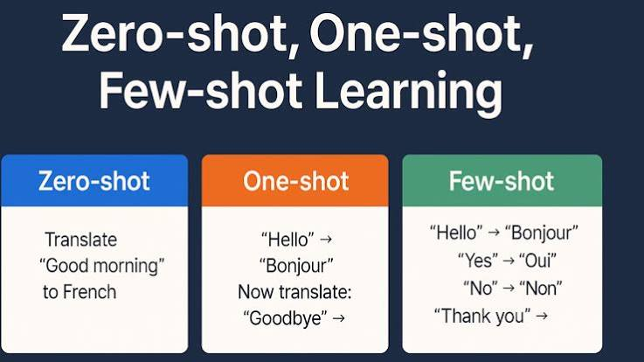
- Few-Shot Prompt (Multiple examples showing a specific pattern)
"Review these examples of high-converting LinkedIn posts for educators:Example 1:
Title: 📚 Grading Reimagined
Body: Stop taking grading home over the weekend! 🛠️ Learn how automated rubrics can give students instant feedback while giving you your time back.
CTA: 👉 Secure your free spot here: [Link]Example 2:
Title: 🔬 Virtual Labs, Real Results
Body: Want to run physics experiments safely online? 🧪 Discover how sandbox simulations keep students engaged without the cleanup.
CTA: 👉 Click to register for Wednesday's session: [Link]Now, write a short, engaging LinkedIn post inviting K-12 teachers to an upcoming webinar about using Agentic AI in classrooms. Include a title, key benefits, and a call to action. Match the tone, formatting, and emoji usage of the examples above."

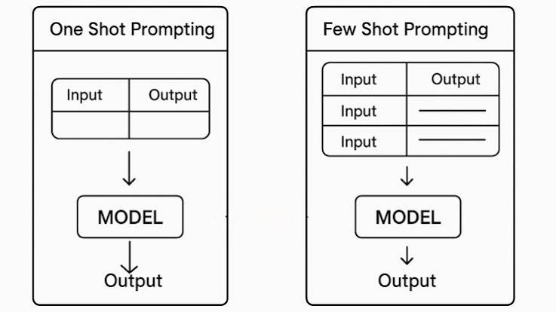

2. Direct Comparison of Generated Outputs
The table below breaks down the structural differences, predictability, and styling variations across the three approaches.

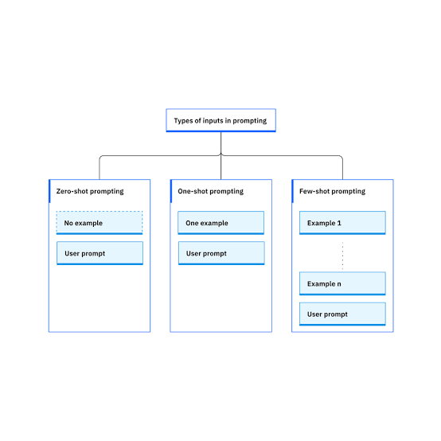
Prompt Type | Generated Output Style | Tone & Formatting | Predictability / Control
Zero-Shot | Title: Unlock the Power of Agentic AI in Your Classroom!  Are you an educator looking to innovate? Join our upcoming webinar where we discuss the shift from basic chatbots to autonomous learning assistants. You will discover how to save time on administrative tasks, personalize study paths for students, and introduce proactive tutoring methods.  Don't miss out! Register for the webinar now using the link in our bio. | Standard, generic text block. Lacks visual anchors like emojis or distinct formatting unless explicitly requested. | Low control. The AI guesses the layout, length, and style. Good for brainstorming but highly variable.
One-Shot | Title: 🚀 Meet Your New AI Teaching Assistant  Body: Ready to upgrade your classroom workflow? Join our upcoming webinar to see how Agentic AI goes beyond answering questions to actively grading, planning, and supporting your students 24/7.  CTA: Register today at the link below! | Mimics the simple layout and initial emoji usage of the single example provided. | Medium control. The model aligns its structural format to the template but might miss subtle stylistic patterns.
Few-Shot | Title: 🤖 The Proactive Classroom Is Here  Body: Imagine an assistant that builds custom study guides and runs safe coding sandboxes for your students automatically! 💡 Discover how Agentic AI takes over the administrative heavy lifting so you can focus entirely on teaching.  CTA: 👉 Secure your free spot here: [Link] | Highly structured, rhythmic emoji usage, short punchy sentences, and exact bracketed placeholder syntax. | High control. The AI locks into the precise pattern, length, formatting, and branding guidelines shown in the examples.

Summary of Trade-offs
- Use Zero-Shot when you need quick, creative variations and don't care about a strict formatting layout.
- Use One-Shot when you have a general template or structure you want the AI to loosely follow.
- Use Few-Shot when you need predictable, production-ready copy that perfectly matches a specific corporate voice, strict length constraints, or exact aesthetic branding.



