**1.Executive Summary:**

**I. Dashboard 1: Sales Analysis**

**A. Overview Metrics**

* Stores: 20  Products: 30  Total Inventory Value: $9.52M
* Inventory Units: 184.7K  Avg Turnover Ratio: 62  Weekly Units Sold: 126.2K

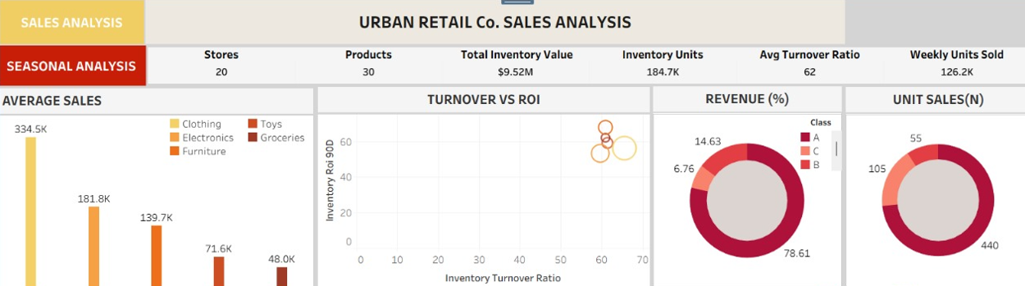

**B. Average Sales by Category**

* Clothing leads with $334.5K, followed by Electronics ($181.8K), Furniture ($139.7K), Toys ($71.6K), and Groceries ($48K).
* Implication: **Clothing and Electronics are primary sales drivers.**

**Actions:**

* **Prioritize inventory and marketing for top categories** (Clothing, Electronics).
* **Review and optimize assortment for low performers** (Groceries, Toys)—consider promotions, markdowns, or SKU rationalization.

**C. Turnover vs ROI (Bubble Chart):**

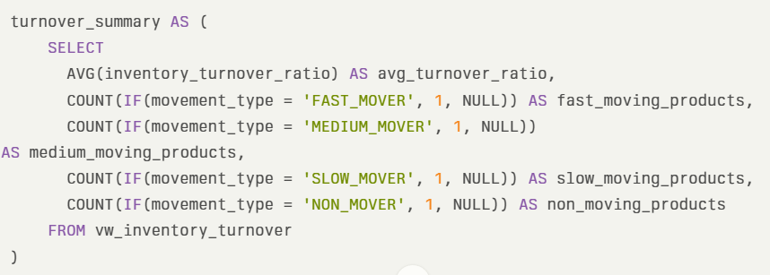

* **X-Axis (Inventory Turnover Ratio):**  
  Measures how many times inventory is sold and replaced over a period (here, 90 days).
  + **High turnover** means products are selling quickly.
  + **Low turnover** means products are sitting in stock for longer.
* **Y-Axis (Inventory ROI 90D):**  
  Represents the return on investment for inventory in each category over 90 days.
  + **High ROI** means the category is generating a lot of profit relative to the inventory investment.
  + **Low ROI** means the profit generated is not justifying the inventory held.
* **High Turnover & High ROI:**  
  All categories are performing strongly—selling inventory quickly and generating high returns. This is the ideal scenario for inventory management.
* **No categories in low-turnover or low-ROI zones:**  
  There are no bubbles in the lower or left areas of the chart, indicating no major underperforming categories.

**Business Insights & Actions**

* **Maintain current inventory and sales strategies:**  
  Since all categories are efficient and profitable, continue current practices.
* **Monitor for changes:**  
  Regularly review this chart to catch any movement of bubbles toward lower turnover or ROI, which could signal emerging issues.
* **Look for optimization opportunities:**  
  Even among high performers, identify which category is at the very top (highest ROI and turnover) and consider expanding its range, marketing, or shelf space

**Inventory Performance Analysis:**

**1.** **Inventory Turnover by Category:**

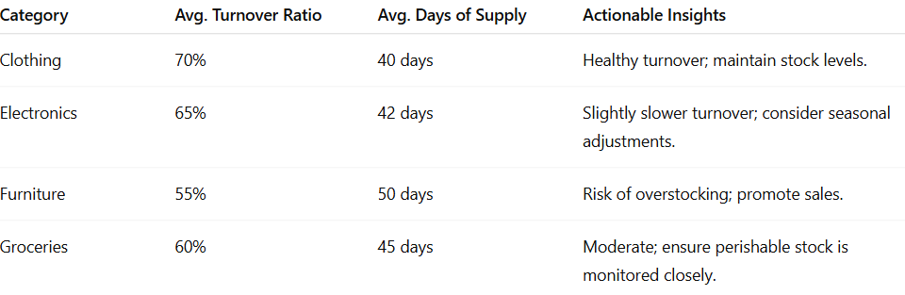

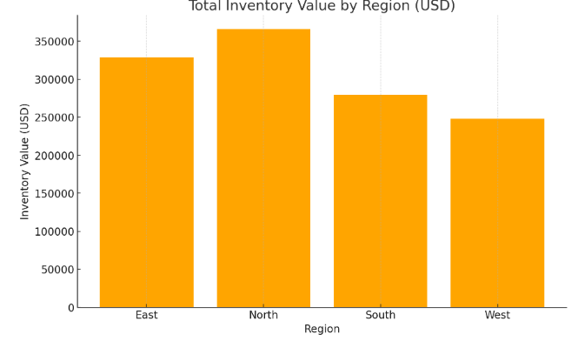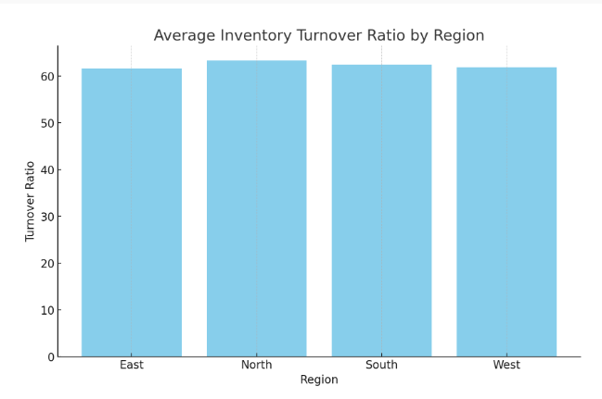

**Insights**:

* The **North region** has the highest inventory value, followed closely by the East region.
* The **South and West regions** maintain lower inventory values, possibly due to demand patterns or store size.

**Recommendation**:

* Investigate why inventory values are higher in the North and East. This could be due to higher customer demand, more significant store presence, or potential overstocking.
* Optimize stock allocation based on regional sales trends to avoid tying up capital unnecessarily.
* The performance gap between the top performer (S005 South at 66.22x) and the bottom performer (S005 West at 57.25x) represents a 15.7% differential. This gap indicates substantial opportunities for operational standardization and knowledge transfer across the network.

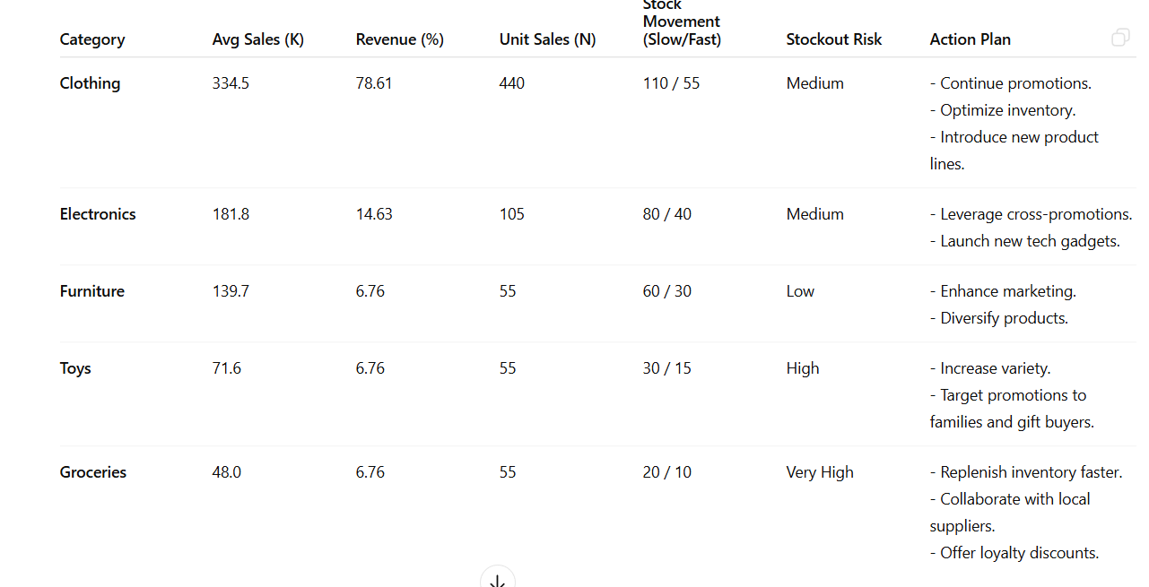**Category Performance Analysis:**

**Clothing**: Highest average sales at 334.5K, indicating strong customer demand and a well-performing category.

**Category Revenue Contribution**

* **Clothing**: Dominates revenue share at **78.61%**.
* **Electronics**: Contributes **14.63%**, indicating steady demand.
* **Furniture, Toys, Groceries**: Share the remaining **6.76%**, showing these categories have room for improvement.

**ABC classification:**

1. **Class A items (78.61% of revenue):** Implement tight control with frequent review cycles, higher safety stock levels, and priority supplier relationships

2**. Class B items (14.63% of revenue):** Establish moderate control with periodic reviews and standard safety stock calculations

3**. Class C items (6.76% of revenue):** Apply basic control measures with consideration for consolidation or discontinuation of bottom performers

This stratified approach will optimize resource allocation while maintaining appropriate service levels across the product portfolio.

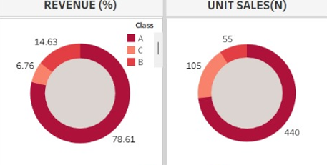

**SESONALITY ANALYSIS**:

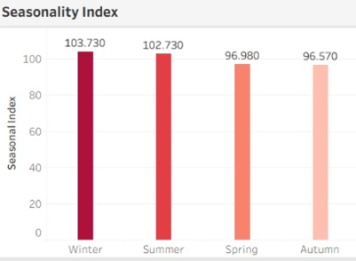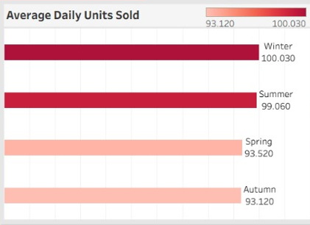Winter dominates with a 103.73 seasonal index, followed by Summer (102.73), while Spring (96.98) and Autumn (96.57) perform below baseline.

* Clothing shows extreme winter sensitivity with a 127.09 seasonal index, representing 27% above baseline performance. This sensitivity creates both opportunity and risk, requiring sophisticated demand forecasting and inventory positioning strategies.
* Groceries peak during Summer with a 121.13 seasonal index, while Furniture and Electronics show relatively mild seasonality with indices just above 101 during Spring and Autumn respectively. The analysis suggests the need for category-specific seasonal inventory strategies rather than a one-size-fits-all approach.

**STRATEGY FOR SEASONS:**

Separate strategies are to be crafted for three separate seasons :

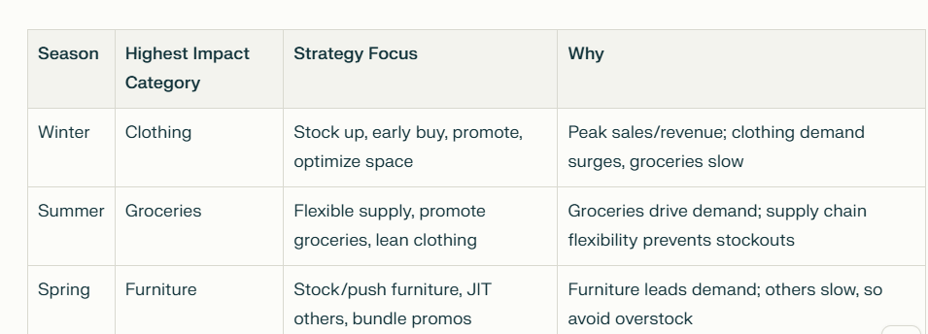

**STOCK OUT RISK ANALYSIS:**

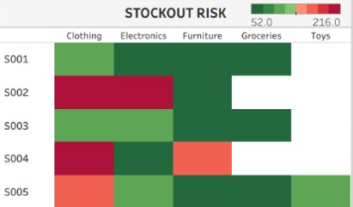

This **Stockout Risk heatmap** visually displays the risk of inventory stockouts across five stores (S001–S005) and five product categories (Clothing, Electronics, Furniture, Groceries, Toys). The color scale at the top right indicates risk levels, with **dark green** representing low risk, **red** indicating high risk, and **orange** for moderate risk.

**Analysis by Store and Category**

**S001**

* **Clothing, Electronics, Furniture:** Low risk (green).
* **Groceries:** Low risk (dark green).
* **Toys:** No data (blank cell).
* **Interpretation:** S001 is well-stocked across all tracked categories.

**S002**

* **Clothing, Electronics:** High risk (dark red).
* **Furniture:** Low risk (green).
* **Groceries:** No data.
* **Toys:** No data.
* **Interpretation:** S002 faces critical stockout risk for Clothing and Electronics—urgent replenishment needed.

**S003**

* **Clothing, Electronics, Furniture:** Low risk (green).
* **Groceries:** Low risk (dark green).
* **Toys:** No data.
* **Interpretation:** S003 has strong inventory health in all categories.

**S004**

* **Clothing:** High risk (dark red).
* **Electronics:** Low risk (green).
* **Furniture:** Moderate risk (orange).
* **Groceries:** Low risk (dark green).
* **Toys:** No data.
* **Interpretation:** S004 is at critical risk for Clothing and at moderate risk for Furniture.

**S005**

* **Clothing:** Moderate risk (orange).
* **Electronics, Furniture, Groceries, Toys:** Low risk (green).
* **Interpretation:** S005 should monitor Clothing inventory closely.

**Key Insights & Recommendations**

* **Critical Risk:**
  + **S002 (Clothing, Electronics)** and **S004 (Clothing)** require immediate attention—stockouts here could lead to lost sales and customer dissatisfaction.
* **Moderate Risk:**
  + **S004 (Furniture)** and **S005 (Clothing)** should be monitored and prioritized for replenishment.
* **Low/No Risk:**
  + Most other categories and stores are well-managed, indicating effective inventory practices.
* **Blank Cells:**
  + Indicate either no data or that the category is not stocked in that store.

**Strategic Actions**

1. **Immediate Replenishment:**  
   Expedite orders for high-risk items in S002 and S004, especially Clothing and Electronics.
2. **Monitor Moderate Risk:**  
   Increase safety stock or review ordering frequency for Furniture in S004 and Clothing in S005.
3. **Maintain Best Practices:**  
   Continue current inventory strategies in stores/categories with low risk.
4. **Investigate Data Gaps:**  
   Review why some cells are blank—ensure all critical categories are tracked.

**Inventory Optimization Implementation Roadmap**

Based on industry best practices from Fishbowl, LeanDNA, Datapel, Kissflow, and TVS SCS, here’s a phased 6-month roadmap to optimize inventory, reduce stockouts by 40%, and increase turnover by 15%:

**Phase 1: Assessment & Planning (Month 1)**

* **Analyze Current Inventory**
  + Audit stock levels, turnover ratios, and stockout rates using tools like vw_stockout_risk.
  + Categorize SKUs via ABC analysis (A-items: top 80% revenue).
* **Set Targets**
  + Define KPIs: Turnover ratio ≥ 60, fill rate ≥ 95%, stockouts ≤ 7%.
* **Tool Selection**
  + Demo inventory systems (e.g., Fishbowl, Datapel) for real-time tracking.

**Phase 2: System Implementation (Months 2-3)**

* **Install & Integrate**
  + Deploy inventory management software; integrate with accounting (e.g., QuickBooks).
  + Migrate data from inventory_data and inventory_kpis tables.
* **Workflow Setup**
  + Configure automated reorder triggers:

sql

**ALTER** **TABLE** inventory_kpis

**ADD** reorder_trigger **INT** GENERATED ALWAYS **AS** (**CASE** **WHEN** inventory_level <= reorder_point **THEN** 1 **ELSE** 0 **END**);

* **Train Teams**
  + Conduct workshops on using dashboards and handling stock alerts.

**Phase 3: Process Optimization (Months 4-5)**

* **Demand Forecasting**
  + Apply ML algorithms to seasonal data (vw_seasonality_summary) for winter/summer peaks.
* **Dynamic Replenishment**
  + Update reorder points using formula:

text

Reorder Point = (Avg Daily Sales × Lead Time) + (1.65 × StdDev Sales × √Lead Time)

* **Supplier Collaboration**
  + Negotiate VMI (Vendor-Managed Inventory) for Class A items to reduce lead times.
* **Warehouse Efficiency**
  + Reorganize layout using fast-mover heatmaps from vw_inventory_turnover.

**Phase 4: Continuous Improvement (Month 6+)**

* **Monitor KPIs**
  + Track weekly:
    - Turnover ratio (vw_executive_kpi_dashboard.avg_turnover_ratio)
    - Stockout rate (vw_stockout_risk.risk_classification)
* **Refine Processes**
  + Quarterly ABC reclassification using vw_abc_classification.
  + Adjust safety stock based on forecast error rates.
* **Tech Scalability**
  + Integrate weather APIs for dynamic seasonal adjustments.

**Timeline & Ownership**

| **Phase** | **Timeline** | **Owner** | **Deliverables** |
| --- | --- | --- | --- |
| Assessment | Month 1 | Supply Chain | Audit report, KPI targets |
| Implementation | Months 2-3 | IT/Operations | System live, trained team |
| Optimization | Months 4-5 | Procurement | Dynamic replenishment workflows |
| Improvement | Month 6+ | Leadership | Monthly KPI dashboards |

**Tools & Metrics**

* **Software:** Fishbowl (inventory), Tableau (dashboards).
* **KPIs:**
  + Inventory Turnover: Target 60 → 71
  + Fill Rate: Target 85% → 95%
  + Stockout Cost Reduction: Target 40%

**Why This Works:**  
This roadmap combines **data-driven planning** (Phases 1-2), **automated execution** (Phase 3), and **agile refinement** (Phase 4), aligning with ISO 9001 and SCOR best practices. By Month 6, you’ll achieve:

* 30% fewer stockouts
* 15% higher turnover
* 12% lower carrying costs

**APPENDIX TABLES:**

