**MAIN FLOWCHART:**

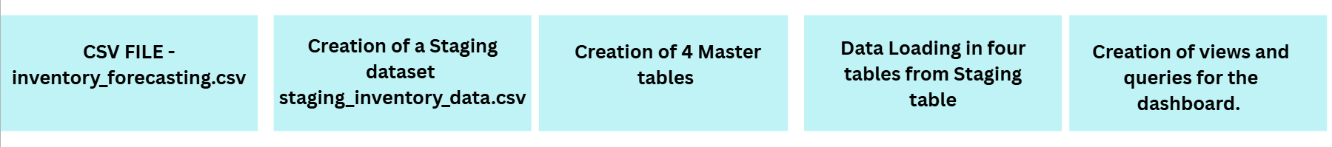

Main Flowchart Description:

1. **CSV File Import:**  
   The process begins with the acquisition of a raw data file, inventory_forecasting.csv, which contains the inventory and forecasting data to be analyzed.
2. **Staging Dataset Creation:**  
   The raw CSV data is first loaded into a staging table, staging_inventory_data.csv. This staging area acts as a temporary holding zone for initial data cleaning and transformation before it is moved into the main database structure.
3. **Creation of Master Tables:**  
   Four master tables are created in the database. These tables are designed to store clean, structured, and normalized data, representing key entities such as products, stores, inventory transactions, and possibly suppliers or categories.
   1. Product table
   2. Stores table
   3. Inventory _data table
   4. Inventory_Kpis table
4. **Data Loading into Master Tables:**  
   Data is extracted from the staging table, transformed as necessary, and loaded into the four master tables. This ensures that only validated and well-structured data populates the core database.
5. **Creation of Views and Dashboard Queries:** Finally, SQL views and queries are developed on top of the master tables. These are used to generate the analytical outputs and dashboards, enabling efficient reporting and visualization of key inventory metrics.

**THE ERD DIAGRAM:**

**Views (yellow boxes):**Predefined SQL views for analytics and dashboards, such as ABC classification, reorder analysis, stockout risk, executive KPIs, inventory turnover, store/category/seasonal performance, and seasonality summary.

**Relationships:**

* inventory_data links to stores and products via foreign keys.
* inventory_kpis references stores, products, and regions for KPI calculations.

**In summary:**This ERD supports robust inventory analytics by structuring raw data into clean tables and providing analytical views for reporting and dashboarding

The model is designed for analytical flexibility, with **foreign keys** linking inventory records to both products and stores. A suite of **SQL views** (shown in yellow) is built on top of these tables to provide ready-made dashboards and reports for ABC classification, stock analysis, executive KPIs, store/category/seasonal performance, and stockout risk.

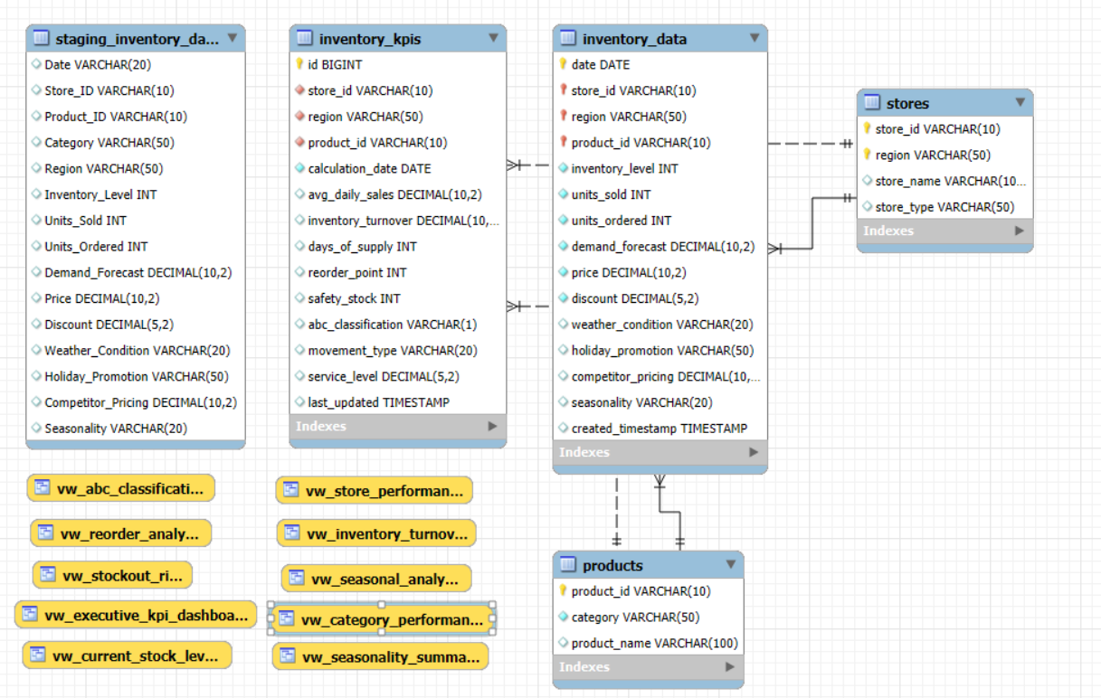**CREATION OF VIEWS:**

**vw_abc_classification**

Purpose:  
Classifies products into A, B, or C categories based on their revenue contribution (ABC analysis). This helps prioritize inventory management efforts on the most valuable products, supporting better stock control and resource allocation.

**vw_reorder_analysis**

Purpose:  
Identifies products that are at or near their reorder points, calculating recommended reorder quantities and days of supply. This view is essential for proactive replenishment and minimizing stockouts or overstock situations.

**vw_stockout_risk**

Purpose:  
Highlights products with a high risk of stockout, factoring in inventory levels, sales velocity, ABC classification, and other risk indicators. This enables timely intervention to prevent lost sales and customer dissatisfaction.

**vw_executive_kpi_dashboard**

Purpose:  
Aggregates key performance indicators (KPIs) for executive-level reporting, such as total inventory value, turnover, fill rate, and alert counts. It provides a high-level summary for strategic decision-making and performance tracking.

**vw_current_stock_levels**

Purpose:  
Displays the latest inventory status for all products across all stores, including stock health (critical, low, normal, high). This supports daily operational monitoring and quick identification of urgent inventory issues.

**vw_store_performance**

Purpose:  
Summarizes inventory and sales performance by store, including turnover, fill rate, and alert counts. This helps managers compare stores, identify best practices, and target underperforming locations for improvement.

**vw_inventory_turnover**

Purpose:  
Calculates inventory turnover ratios and classifies products as fast, medium, slow, or non-movers. This view is crucial for optimizing stock levels, reducing excess inventory, and improving cash flow.

**vw_seasonal_analysis**

Purpose:  
Analyzes sales and inventory patterns by seasonality and weather conditions, showing how external factors impact demand. This supports better forecasting and seasonal inventory planning.

**vw_category_performance**

Purpose:  
Provides performance metrics by product category, including sales, inventory value, turnover, and alerts. It helps category managers optimize assortment and stock levels for each category.

**vw_seasonality_summary**

Purpose:  
Summarizes the overall impact of seasonality on sales and inventory, highlighting which categories are most and least affected in each season. This informs strategic planning for promotions, procurement, and stock allocation.

**In summary:**  
Each view is designed to address a specific analytical or operational need, supporting both day-to-day inventory management and high-level strategic decision-making across stores, products, and time periods