

**VISVESVARAYA TECHNOLOGICAL UNIVERSITY**

## “JNANA SANGAMA” BELAGAVI-590 014, KARNATAKA



**MINI-PROJECT REPORT ON**

**“FOOD FOR NEEDY”**

SUBMITTED IN PARTIAL FULFILLMENT OF THE REQUIREMENT

FOR THE VII SEMESTER, BE, WEB TECHNOLOGY LAB WITH MINI PROJECT-17CSL77

Submitted By

1. **KIRAN M**

**[1CG17CS044]**

1. **LOKESH K**

**[1CG17CS047]**

|  |  |
| --- | --- |
| **Under the guidance of:** | **HOD:** |
| **Mrs. Jyothi K S, M.Tech.**  Asst. Prof., Dept. of CSE,  CIT, Gubbi, Tumkur. | **Dr. Shantala C P, Ph.D**  Prof & Head, Dept. of CSE,  CIT, Gubbi, Tumkur. |

**Channabasaveshwara Institute of Technology**

(NAAC Accredited & ISO 9001:2015 Certified Institution)

### NH 206 (B.H. Road), Gubbi, Tumkur– 572 216. Karnataka.

(Affiliated to Visvesvaraya Technological University, Belagavi & Recognized by AICTE New Delhi)

2020-21



# Channabasaveshwara Institute of Technology

(NAAC Accredited & ISO 9001:2015 Certified Institution)

### NH 206 (B.H. Road), Gubbi, Tumkur – 572 216. Karnataka.

(Affiliated to Visvesvaraya Technological University, Belagavi & Recognized by AICTE New Delhi) 2020-21

**DEPARTMENT OF COMPUTER SCIENCE ENGINEERING CERTIFICATE**

This is to certify that the mini project work entitled **“FOOD FOR NEEDY”** has been successfully carried out by **KIRAN M [1CG17CS044]** and **LOKESH K [1CG17CS047]** bonafide students of **CHANNABASAVESHWARA INSTITUTE OF TECHNOLOGY, GUBBI, TUMAKURU,** under our supervision and guidance and submitted in partial fulfillment for VII Semester Bachelor of Engineering, by **Visvesvaraya Technological University, Belagavi,** Web Technology Laboratory Mini-project [17CSL77] during the academic year of 2020–2021. It is certified that all corrections/suggestions indicated for internal assessment have been incorporated in the report deposited in the departmental library. The mini project report has been approved as it satisfies the academic requirements for the above said degree.

## Guide: H.O.D:

**Mrs. K S JYOTHI M.Tech. Dr. Shantala C P, Ph.D**

Asst. Prof., Dept. of CSE, Prof & Head, Dept. of CSE,

CIT, Gubbi, Tumkur. CIT, Gubbi, Tumkur.

**Principal: Examiners:**

1.

**Dr. Suresh D S Ph.D**

CIT, Gubbi, Tumkur. 2.

**ACKNOWLEDGEMENT**

A great deal of time and lot of effort has gone into completing this mini project report and documenting it. The number of hours spent in getting through various books and other materials related to this topic chosen by us have reaffirmed its power and utility in doing this lab work.

Several special people have contributed significantly to this effort. First of all, we are grateful to our institution **Channabasaveshwara Institute of Technology, Gubbi**, which provides us an opportunity in fulfilling our most cherished desire of reaching the goal.

We acknowledge and express our sincere thanks to our beloved Director and Principal **Dr. Suresh D S** for his many valuable suggestions and continued encouragement and support in the academic endeavors.

We wish to express our deep sense of gratitude to **Dr. Shantala C P**, Prof & Head, Dept of CSE, CIT, for all the guidance and who still remains a constant driving force and motivated through innovative ideas with tireless support and advice during the course of mini project to examine and helpful suggestions offered.

We express our heartful thanks to our guide **Mrs. Jyothi K S**, Assistant Professor, Dept. of CSE, CIT, for his meticulous attention to details, which has contributed immeasurably to the quality of our project report.

Our sincere and hearty thanks to our beloved parents, Friends and others for their all-time support and co-operation.

**PROJECT ASSOCIATES:**

KIRAN M [1CG17CS044]

LOKESH K[1CG17CS047]

**ABSTRACT**

This project consists of the development of a contributory web application to gather information of Wastage food in parties and utilizes in a good manner for the hungry people.

According to survey Indians produce 10.8% of the world’s food, but we have more people sleeping without food and many people throw the edible food to the landfills or dustbins and many people don’t know how to utilize these types of wastage food.

The main aim of developing this application is to supply the untouchable edible surplus food to the needy people, “Food for Needy” is a web-based application. where donors can fill the remaining excess food in this website, our active volunteers can know the details of it and as per there transportation facility they travel to the donor’s region and collects the untouchable surplus food and they check the quality of the food, if the quality of the food is good means they transport to the needy people, if the quality of food is not good means the food will transport to the Farming purpose and also to raise awareness about food loss and food waste amongst citizens and bring about behavioral change in them to prevent food waste at home, school or at workplace through guidance and sharing of good practices.

**CONTENTS**

**1. Introduction 6-6**

1.1. Problem Statement 6

1.2. Overview of the Project 6

**2. Literature Survey 7**

2.1. Existing System 7

2.2. Proposed System 7

**3. System Requirements 7-8**

3.1. Hardware Configurations 8

3.1. Software Configurations 8

**4. System Design 8-11**

4.1. Schema Diagram 9

4.2. Technologies 9

**5. System Implementation 12**

5.1. Function Description 12

**6. Snapshots 13-16**

**7. Conclusion 17**

**8. Bibliography 18**

**CHAPTER 1**

**INTRODUCTION**

**Food For Needy** is an web based project which aims to redistribute excess food from weddings, parties, events to those who are hungry. The project objective is to bring benefits across the spectrum of society and help provide access to food to those who don’t have adequate means to access it.

This project mainly useful to, those who are daily sleeping empty stomach in our surrounding. We collect the excess food from weddings, parties and events then distribute the food to those who are hungry. The donor’s can easily contact us using this website through online.

The objective of the project is to make an application in web platform to gather information of Wastage food in parties and utilizes in a good manner for the hungry people. In order to build such an application complete web support, need to be provided. A complete and efficient web application which can provide the online platform to donor’s to donate a excess food for needy

people’s is the basic objective of the project.

**1.1 PROBLEM STATEMENT**

The term project is to design and implement for, feed the needy and hungry with untouchable edible surplus food. To raise awareness about food loss and food waste amongst citizens and bring about behavioral change in them to prevent food waste at home, school or at workplace through guidance and sharing of good practices. To raise awareness among Food businesses by encouraging them to adopt good practices to reduce food loss and food waste in their supply chains and sharing good practices

**1.2 OVERVIEW OF THE PROJECT**

The central concept of the application is to bring a social change in every individual in-order to reduce food waste and to make the World Hunger Free. To raise awareness about food loss and food waste amongst citizens and bring about behavioral change in them to prevent food waste at home, school or at workplace through guidance and sharing of good practices.

**CHAPTER 2**

**LITERATURE SURVEY**

**2.1 EXISTING SYSTEM**

The currently in our system the excess food or wasted food is reaches the landfills, dumpsites or dustbins.

**2.2 PROPOSED SYSTEM**

Our main aim of this project to feed the needy and hungry with untouchable edible surplus food. To raise awareness about food loss and food waste amongst citizens and bring about behavioral change in them to prevent food waste at home, school or at workplace through guidance and sharing of good practices.

**CHAPTER 3**

**SYSTEM REQUIREMENTS**

Requirement specification plays an important role to create quality software solution; requirements are refined and analyzed to access the clarity. Requirements are represented in manner that ultimately leads to successful software implementation. Each requirement must be consistent with overall objectives.

These are the necessary specification of computer must have in order to use the software or hardware. Here we would explain hardware and software requirements. A database management system (DBMS) consists of several components. Each component plays very important role in database management system environment. The major components of database management system are:

* Software
* Hardware
* Data
* Procedures
* Database Access Language

Here we would be explaining hardware and software requirements of our database project.

**3.1 HARDWARE CONFIGURATION:**

RAM : 1 GB and above

Hard Disk : 60 GB and above

**3.2 SOFTWARE CONFIGURATION:**

Operating System : Windows XP/2000/98

Front end : PHP, HTML, CSS, Javascript

Back end : My SQL

Server : XAMPP

Editor : Notepad++

**CHAPTER 4**

**SYSTEM DESIGN**

System design is the solution for the creation of a new system. This phase focuses on the detailed implementation of the feasible system. This phase focuses on the detailed implementation of the feasible system specification. System design has two phases of development

* Logical design
* Physical design

During logical design phase the analyst describes inputs (sources), outputs (destinations), databases (data source) and procedures (data flows) all in a format that meets the user requirements. The analyst also specifies the needs of the user at a level that virtually determines the information flow in and out of the system and the data resources

The physical design is followed by physical design or coding. Physical design produces the working system by defining the design specifications, which specify exactly what the candidate system must do. The programmers write the necessary programs that accept input from the user, perform necessary processing on accepted data and produce the required report on a hard copy or display it on the screen

**4.1.1 Schema diagram:**

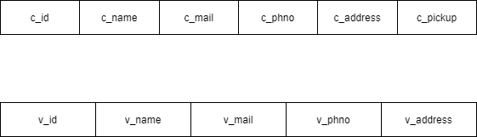

**4.2 TECHNOLOGIES**

**4.2.1 HTML (Hyper Text Markup Language)**

* **Hypertext Markup Language** (**HTML**) is the standard markup language for documents designed to be displayed in a web browser. It can be assisted by technologies such as cascaded style sheets (CSS) and scripting language such as Java script.
* Web browser receive HTML documents from a web server or from local storage and render the documents into multimedia web pages. HTML describes the structure of a web page semantically and originally included cues for the appearance of the document.

**4.2.2 JS (Java Script)**

* **JavaScript**, often abbreviated as **JS**, is a high-level, interpreted scripting language that conforms to the ECMA script specification. JavaScript has curly -bracket syntax, dynamic-type, prototype based, object-oriented, and first-class functions.
* Alongside HTML and CSS, JavaScript is one of the core technologies of the World Wide Web JavaScript enables interactive web page and is an essential part of web application. The vast majority of website use it, and major web browser have a dedicated Java Script Engine to execute it.
* Java Script is used to create popup windows displaying different alerts in the system like “User registered successfully”, “Product added to cart” etc
  + 1. **CSS (Cascading Style Sheet)**

• CSS is a style sheet language used for describing the look and formatting of a document

written in a markup language.

• CSS describes how HTML elements are to be displayed on screen, paper.

• CSS saves a lot of work. It can control the layout of multiple web pages all at once.

**4.2.4 PHP (Hypertext Pre-Processing)**

* **PHP** is a general-purpose programming language originally designed for web development. It was originally created by Rasmus Lerdorf in 1994 the PHP reference implementation is now produced by The PHP Group. PHP originally stood for *Personal Home Page*, but it now stands for the recursive initialism *PHP:* Hypertext Preprocessor.
* PHP code may be executed with a command line interface (CLI), embedded into HTML code, or used in combination with various web template system, web content management system, and web framework. PHP code is usually processed by a PHP interpreter implemented as a module in a web server or as a Common Getaway Interface (CGI) executable. The web server outputs the results of the interpreted and executed PHP code, which may be any type of data, such as generated HTML code or binary image data. PHP can be used for many programming tasks outside of the web context, such as standalone graphical applications and robotic drone control.

**4.2.5 SQL (Structured Query Language)**

* Sql is a powerful database. It’s very good and free of change. Many developers in the world selected sql and php for developing their website.
* The sql database has become the world’s most popular open-source database because of its consistent fast performance, high reliability and easy to use. It’s used in more than 6 million installations ranging from large corporations to specialized embedded applications on every continent in the world.
* Not only is sql the world’s most popular open source database, it’s also become the database of choice for a new generation of applications built on the LAMP stack(Linux ,Apache, sql , php / Perl / python.) sql runs on more than 20 platforms including Linux, Whether youre new to database technology or an experienced developer or DBA, sql offers a comprehensive range of certified software, support, training and consulting to make you successful. MYSQL is a free, widely used SQL engine. It can be used as a fast database as well as a rock-solid DBMS using modular engine architecture.

**4.2.6 XAMPP**

XAMPP is free open-source software that provides an easy way for web designers and developers to install the necessary components to run PHP based software like Word Press, Drupal, Joomla, and others on Windows, Mac OS X, and Linux.

If you’re a web developer, designer, or a person trying to get into blogging, XAMPP will save you time and frustration having to manually install and configure Apache, MySQL, PHP, and Perl on your computer to create a test environment.

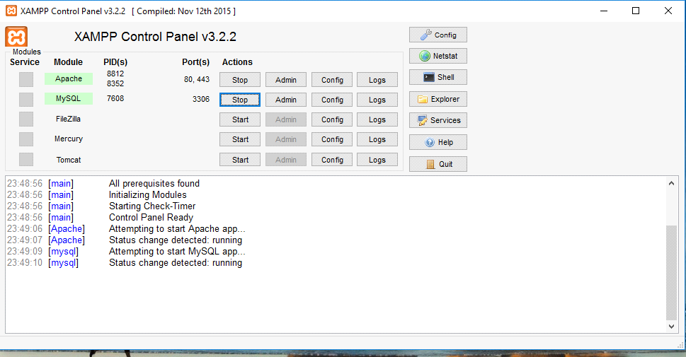

Fig : XAMPP control panel

**CHAPTER 5**

**IMPLEMENTATION**

5.1 **Function Description**

**5.1.1 MODULES:**

The system after careful analysis has been identified to be presented with the following

modules and roles.

The modules involved are:

* Admin
* Donor

**5.1.1.1 ADMIN**

The admin is the super user of this application.

1. Create database

2. View database

**1. Create database**

Admin is the one who use specialized software to store and organize data. The role may include capacity planning, installation, configuration, database design, data monitoring, security, as well as backup and data recovery.

**2. View database**

A database view is a searchable object in a database that is defined by a query. Admin can have the authority to view the data in the database.

**5.1.1.2 DONOR**

Donor’s can access our website through online, when food is wasted they can contact us using our website and also give information about where the excess food wasted spot, using that information we collect the untouched food and fee to the hungry peoples.

**CHAPTER 6**

**SNAPSHOTS:**

**6.1 HOME PAGE:**

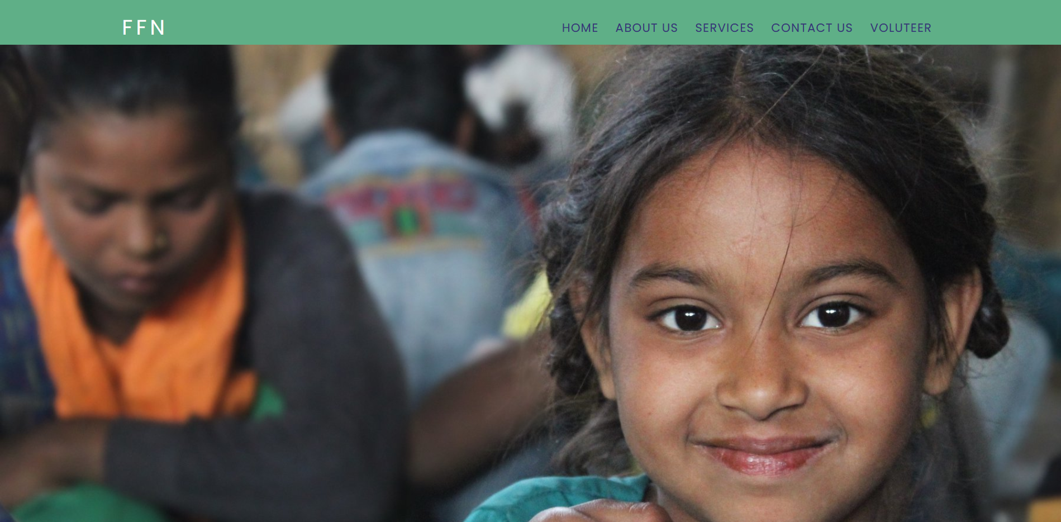

**6.2 ABOUT PROJECT:**

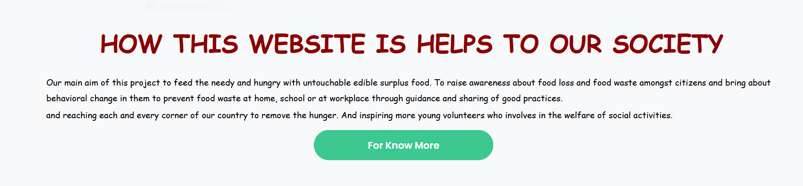

**6.3 DONOR AND VOLUNTEER SECTION:**

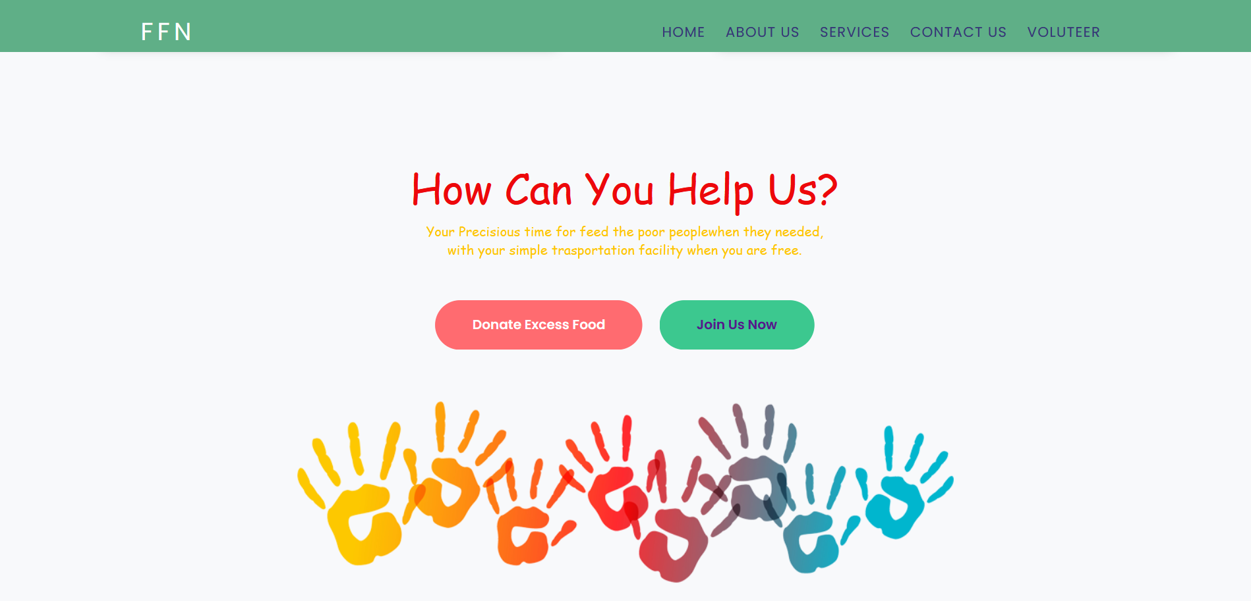

**6.4 SERVICES:**

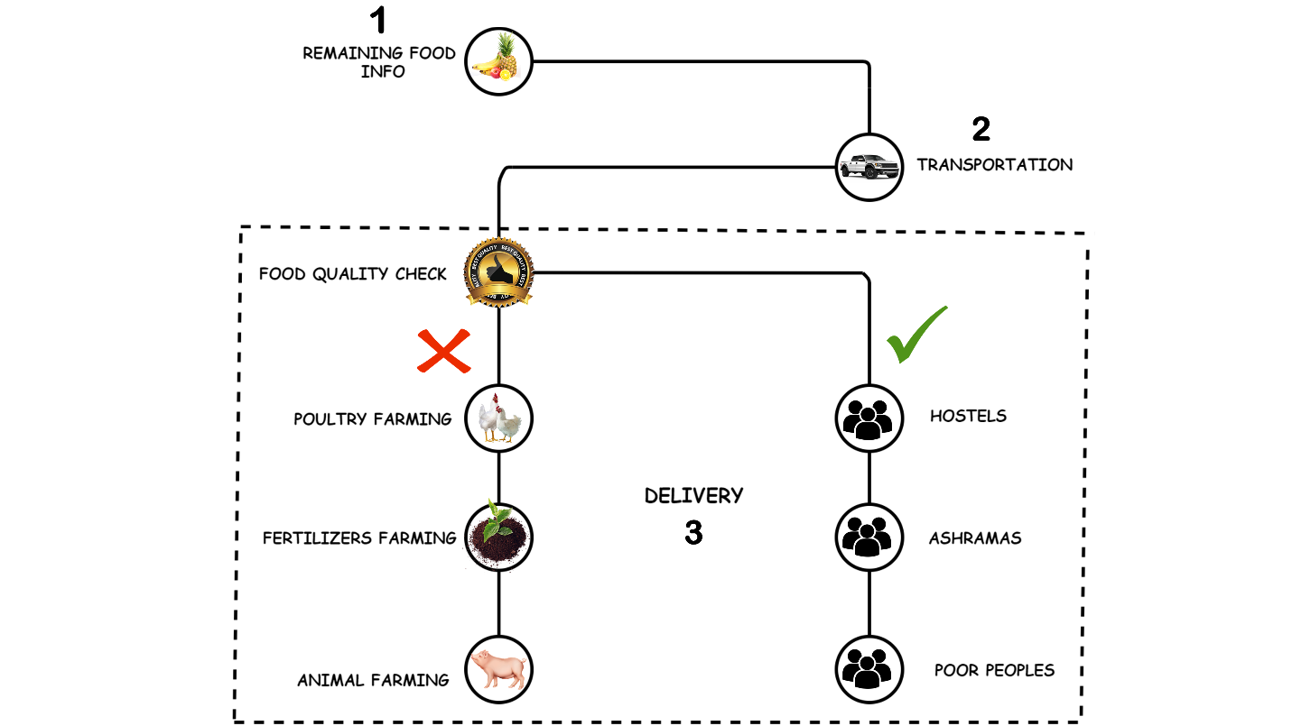

**6.5 CONTACT PAGE:**

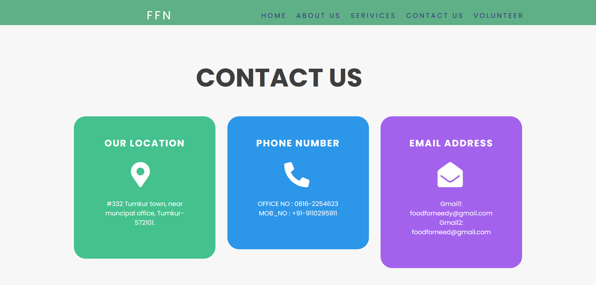

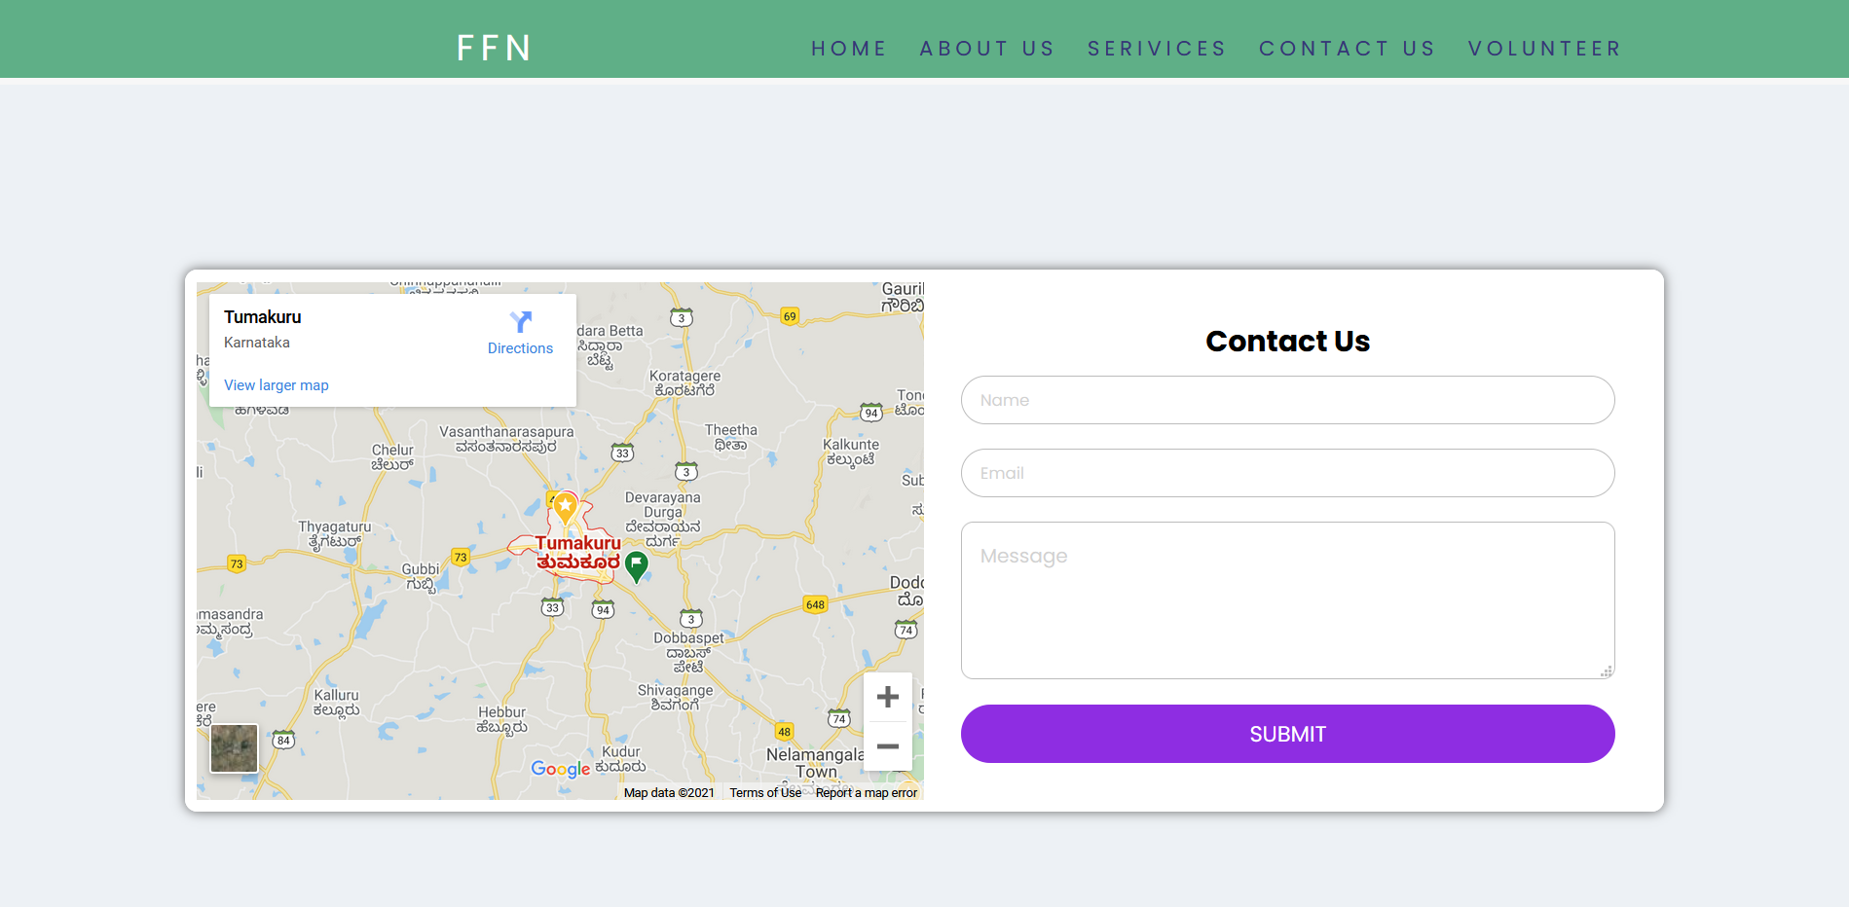

**6.5 OUR TEAM:**



**6.7 FOOTER**

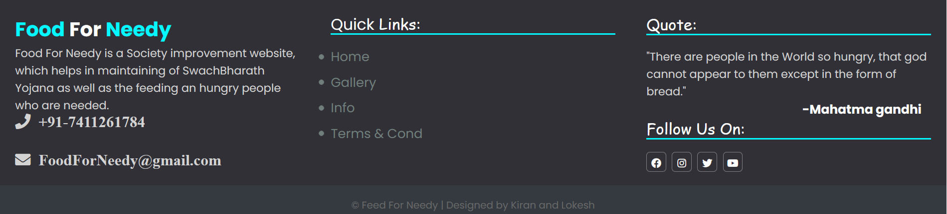

**CHAPTER 7**

**CONCLUSION**

This system overcomes the problem of existing system. The system has been developed with much care and free of errors and at the same time it is efficient. The purpose of this project was to develop a web application to gather information of wastage food and utilize in a proper manner for society and To raise awareness about food loss and food waste amongst citizens and bring about behavioural change in them to prevent food waste at home, school or at workplace through guidance and sharing of good practices.

This project helped us in gaining valuable information and practical knowledge on several topics like designing web pages using HTML & CSS, usage of responsive templates, designing of android applications, and management of database using MySQL. The entire system is secured. Also the project helped us understanding about the development phases of a project and software development life cycle. We learned how to test different features of a project. This project has given us great satisfaction in having designed an application which can be useful for society.

There is a scope for further development in our project to a great extent. A number of features can be added to this system in future like building an application and reaching each and every corner of our country to remove the hunger. And inspiring more young volunteers who involves in the welfare of social activities.

**CHAPTER 8**

**BIBLIOGRAPHY**

1. https://www.w3schools.com/html/
2. https://www.w3schools.com/js/DEFAULT.asp
3. <https://fonts.google.com/>
4. https://fontawesome.com/
5. https://www.w3schools.com/css/default.asp