Playwright + Python /Pytest automation framework

Create New Project in PyCharm IDE.
- Install Required Packages
pytest playwright pytest-xdist pytest-html allure-pytest
pytest-rerunfailures openpyxl
Faker
python-slugify

Option 1: single command to install all the required plugins:
pip install pytest playwright pytest-xdist pytest-html allure-pytest pytest-rerunfailures openpyxl Faker python-slugify

Option 2: Create requirements.txt file under the root directory of the project with all the plugins.

Ex:

playwright pytest-xdist pytest-html allure-pytest
pytest-rerunfailures openpyxl
Faker
python-slugify

Once you have this file in your project root, install all dependencies in one go by running the below command from terminal.

pip install -r requirements.txt

Install playwright browsers
playwright install

Create Folder Structure
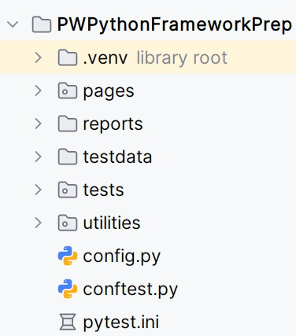

Create Page Object Classes (under pages/) Example files:
home_page.py registration_page.py login_page.py logout_page.py my_account_page.py product_page.py search_results_page.py shopping_cart_page.py

Create Test Data Files (under testdata/) Example:
logindata.json logindata.csv logindata.xlsx
Used for data-driven testing.

Create Utility Files (under utilities/)
  - random_data_util.py → generate random emails, names, etc. using Faker.
  - data_reader_util.py → read test data from JSON/CSV/Excel files.

Create config.py
Store reusable data:

Example:
class Config: email="jyoti@abc.com" password="test@123"
invalid_email="tytyt@abc.com" invalid_password="test@123xyz" product_name = "MacBook" product_quantity = "1"
total_price = "$602.00"

Create pytest.ini
Common CLI options:
-v : verbose - Run tests in verbose mode (shows detailed test names and results)
--browser : Specify browser type (chromium, firefox, or webkit)
--headed : Run browser in headed mode (shows browser UI)
--base-url : Define the base URL for all tests
--video : Record video only if the test fails
--screenshot : Capture screenshot only on failure
--tracing : Save Playwright trace file only if the test fails
--html : Generate HTML report
--self-contained-html : Embed all report assets (CSS, JS, images) inside the HTML
--capture=tee-sys : Display console logs while also capturing them for reports
--alluredir : Generate Allure-compatible results for advanced reporting
-n=1 or --numprocesses :Run tests parallel
--reruns : Retry failed tests up to 2 times
--reruns-delay : Wait time before retrying failed tests

Create conftest.py
  - Handle browser setup/teardown.
  - Manage screenshots, video, and trace recording.
  - Integrate HTML and Allure reporting.

Create Test Files (under tests/) Example tests:
test_user_registration.py test_login.py

test_login_data_driven.py test_product_search.py test_user_logout.py
Use page objects inside tests.
Group tests with @pytest.mark.sanity or @pytest.mark.regression.

Run Tests
Browsers: Chromium, Firefox, webkit Grouping: sanity, regression
Re-run flaky tests Run tests parallel
Run tests headed/headless

Note: If you have noticed errors like below while running the tests.
ValueError: option name {'--base-url'} already added
That means the command-line option --base-url is being registered twice — once by Playwright’s pytest plugin (pytest-playwright), and again by your custom conftest.py.

So, you need to run the below command through terminal to un-install plugin.

pip uninstall pytest-base-url

- Generate and View the Allure Report Run time:
allure serve reports/allure-results

Permanent report:
allure generate reports/allure-results -o reports/allure-report --clean

