1. Design DFA using simulator to accept the input string “a” ,”ac”,and ”bac”.

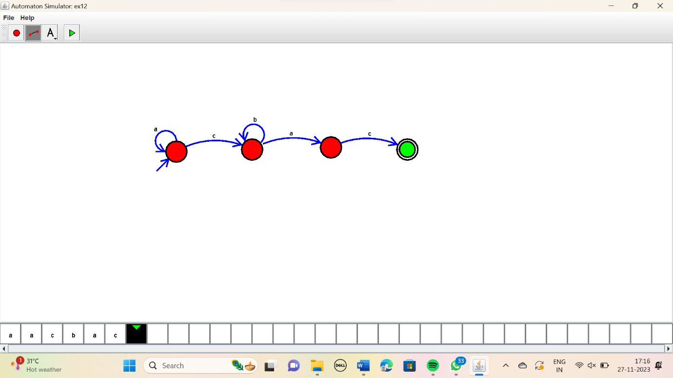

Result:

The siiven simmulator is accepted the given string a,ac,bac using the above DFA diagram