2.Design PDA using simulator to accept the input string aabb

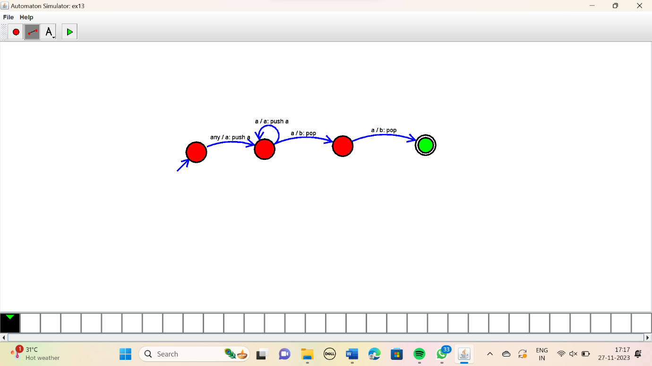Result:

The simulator is accepted the given input string aabb by using the above PDA diagram