1. Design TM using simulator to accept the input string anbn

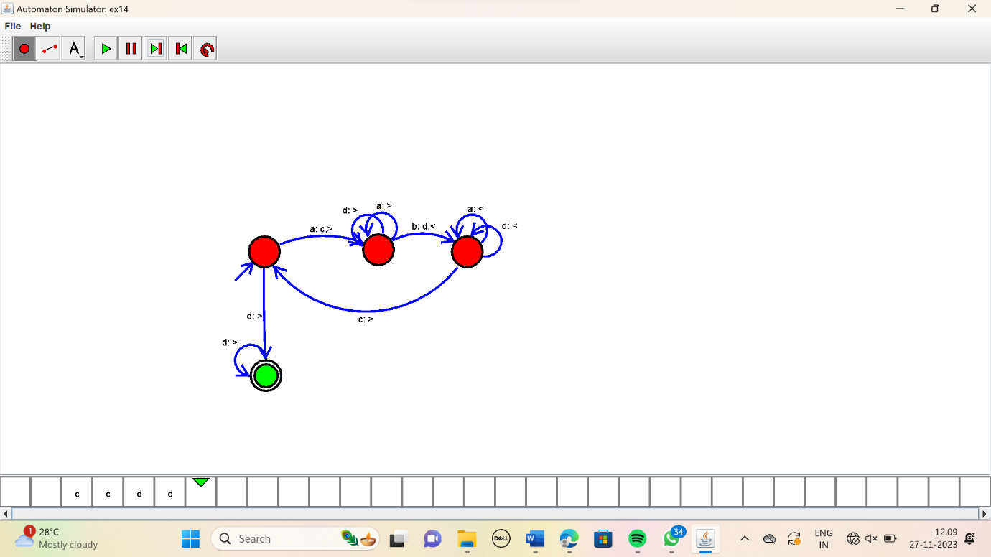

Result :

The simulator is accepted the given input string anbn by using the above TM diagram.