17. Design TM using simulator to accept the input string Palindrome ababa

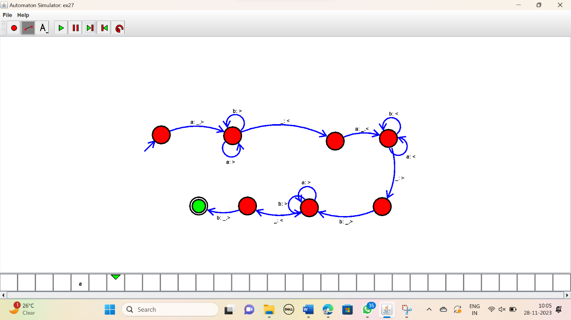

RESULT:

Thus the simulator accepted the palindrome ababa using the TM diagram.