18.Design TM using simulator to accept the input string ww

By using 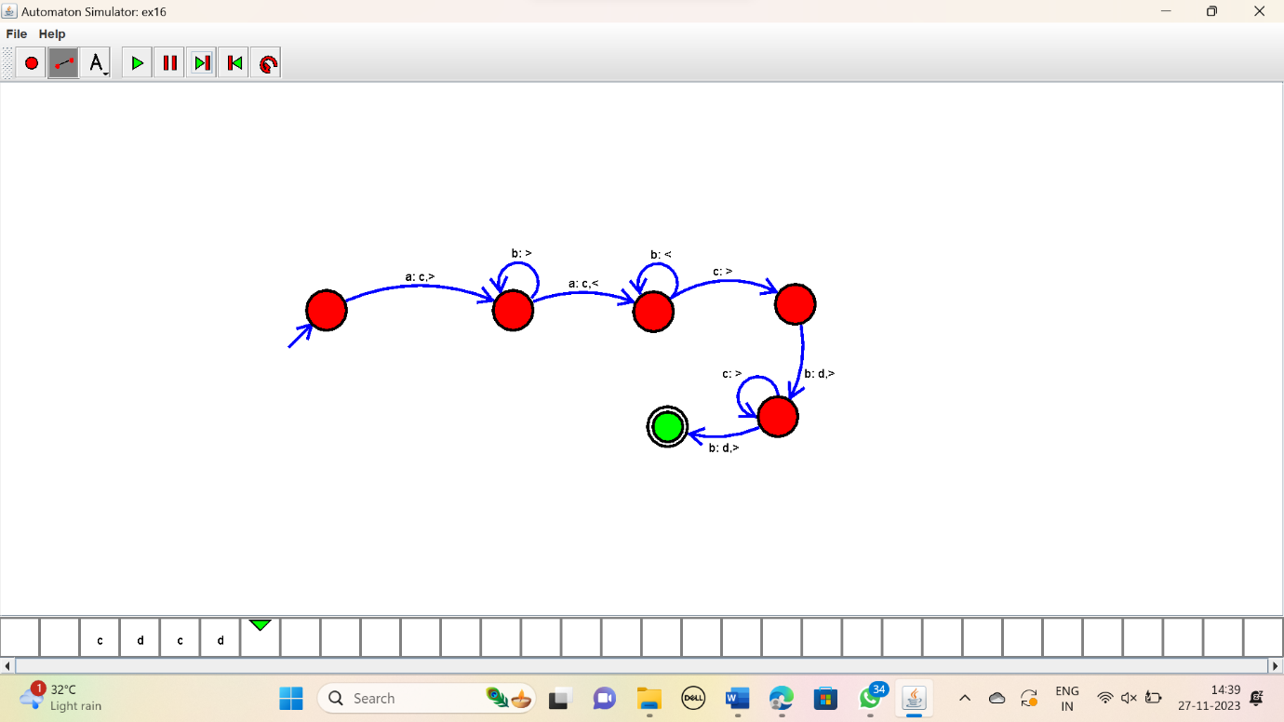

RESULT:

Thus the simulator accepted the input string ww by using the TM diagram.