19.Design TM using simulator to perform addition of ‘aa’ and ‘aaa’

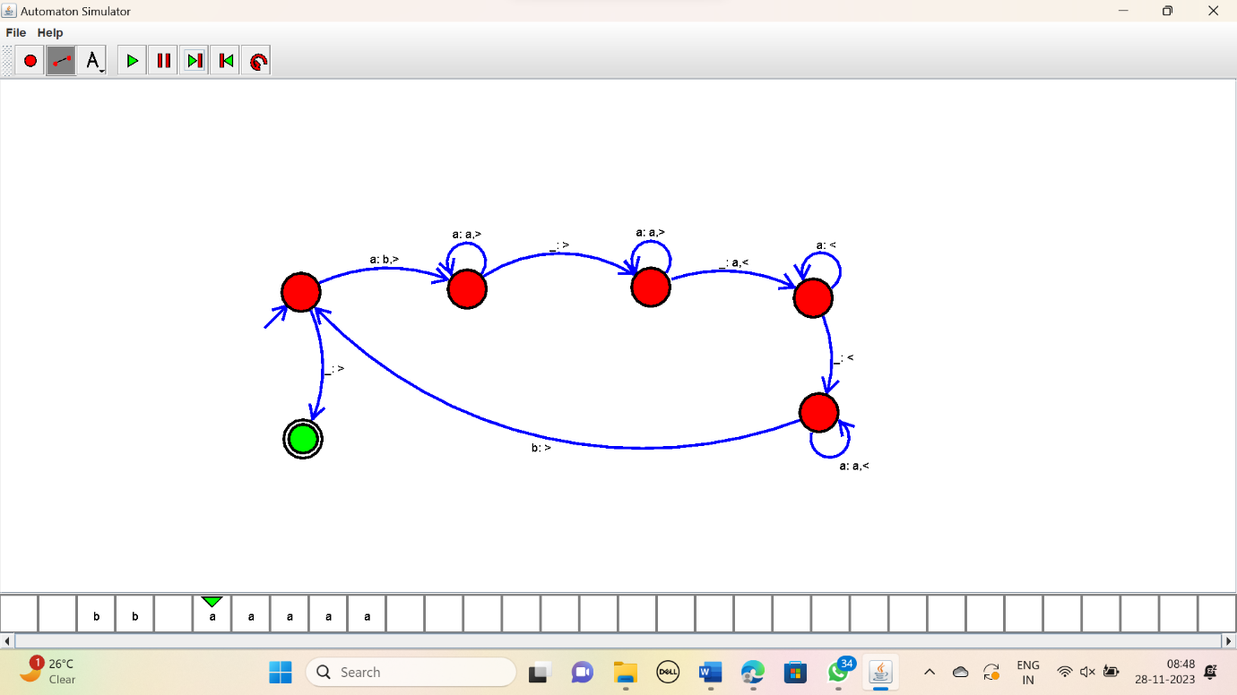

RESULT:

Thus the simulator performed addition of “aa” and “aaa” using the TM diagram