Design TM using simulator to perform subtraction of aaa-aa

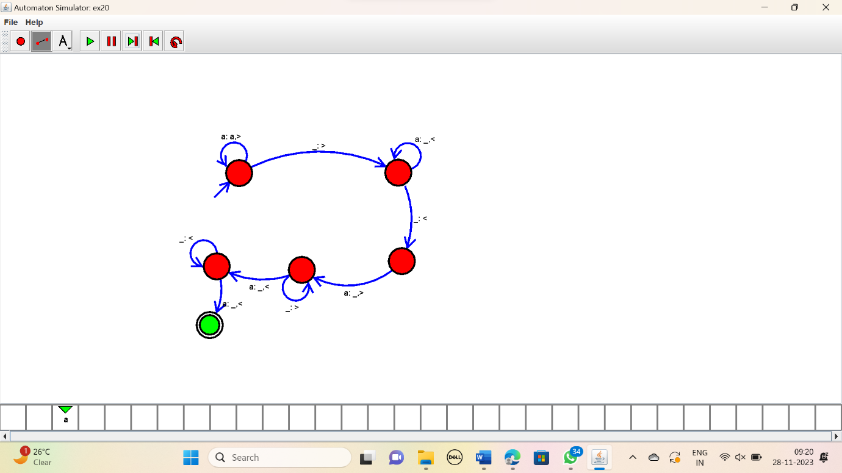

RESULT:

Thus the simulator performed a=subtraction of “aaa” and “aa” using the TM diagram.