21.Design DFA using simulator to accept even number of a’s.

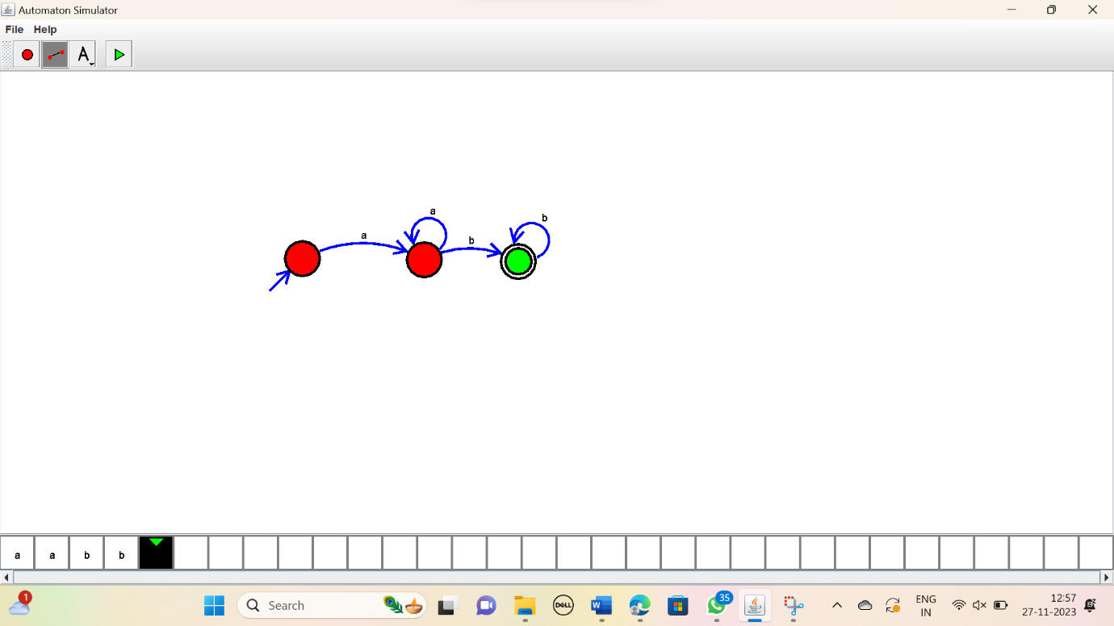

RESULT:

Thus the simulator accepted the string with even number of a’s using the DFA diagram.