1. Design DFA using simulator to accept odd number of a’s

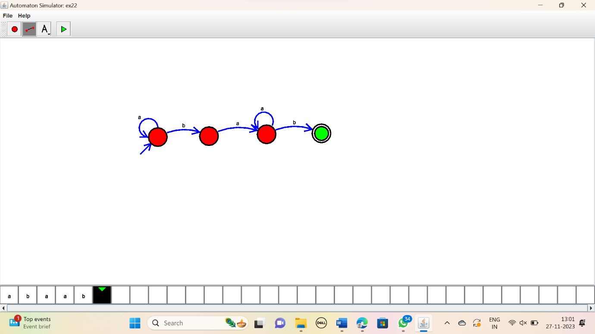

RESULT:

Thus the simulator accepted the string with odd number of a’s using the DFA diagram.