23.Design DFA using simulator to accept the string the end with ab over set {a,b)

W= aaabab

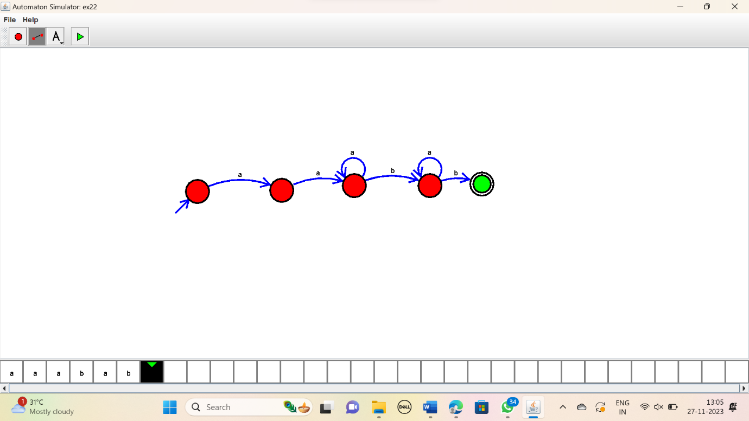

RESULT:

Thus the simulator accepted the input string with “ab” at the end using the DFA diagram.