24.Design DFA using simulator to accept the string having ‘ab’ as substring over the set {a,b}

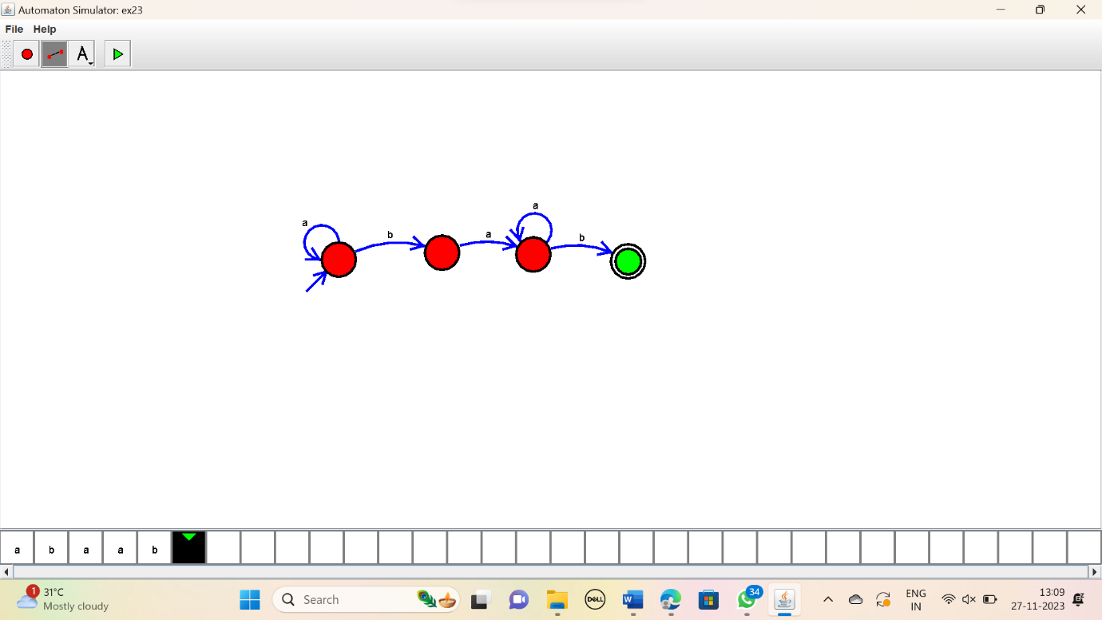

RESULT:

Thus the simulator accepted the given string with ‘ab’ as substring using the DFA diagram.