25.Design DFA using simulator to accept the string start with a or b over the set {a,b}

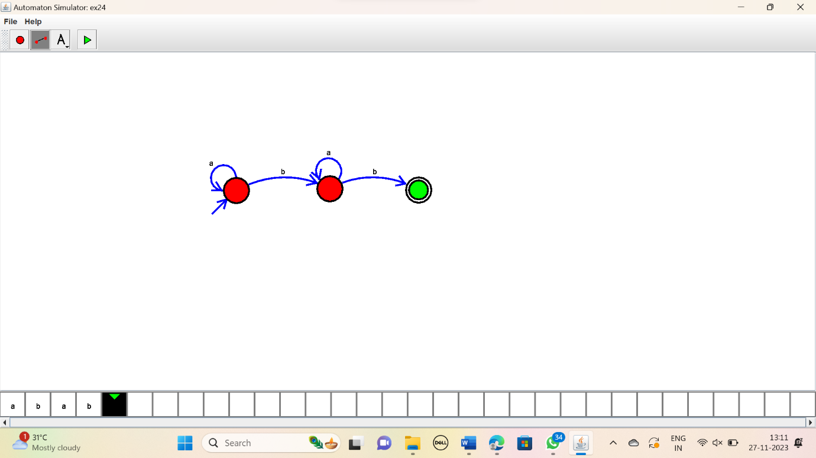

RESULT:

Thus the simulator accepted the string that starts with either ‘a’ or ‘b’ using the DFA diagram.