1. 26. Design TM using simulator to accept the input string Palindrome bbabb

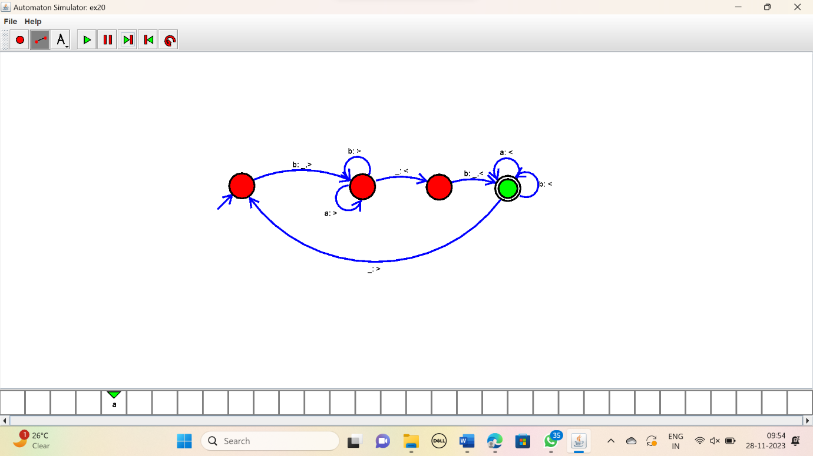

RESULT:

Thus the simulator accepted the string bbabb using the TM diagram.