1. 27. Design TM using simulator to accept the input string wcw

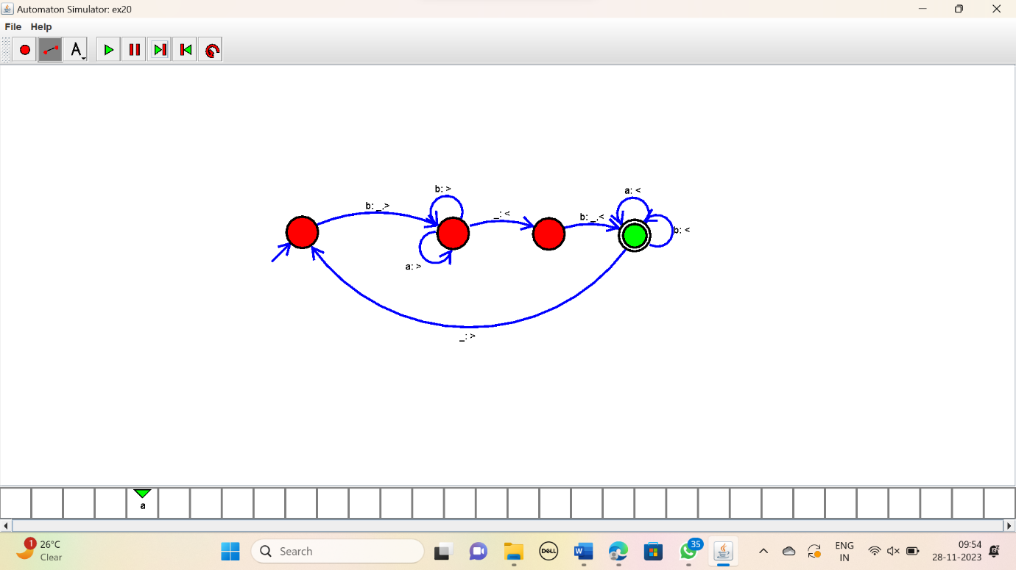

RESULT:

Thus the simulator accepted the string wcw using the TM diagram.