28.DFA using simulator to accept the string the end with ab over set {a,b)

W= abbaabab

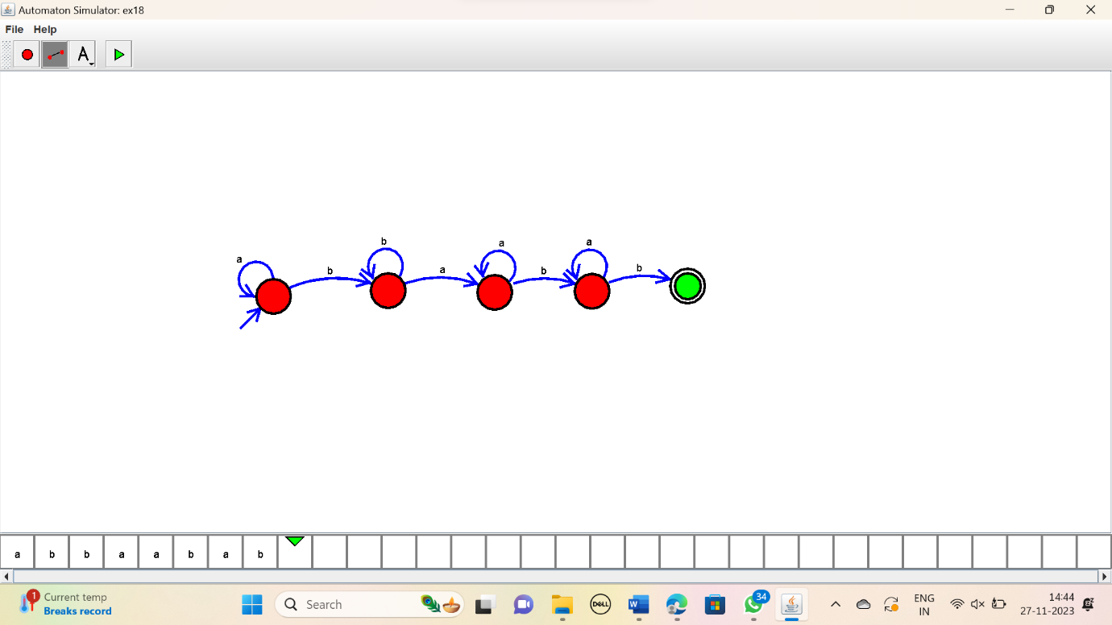

RESULT:

Thus the simulator accepted the input string that end with ab using DFA diagram