1. Design DFA using simulator to accept the input string “bc” ,”c”,and ”bcaaa”.

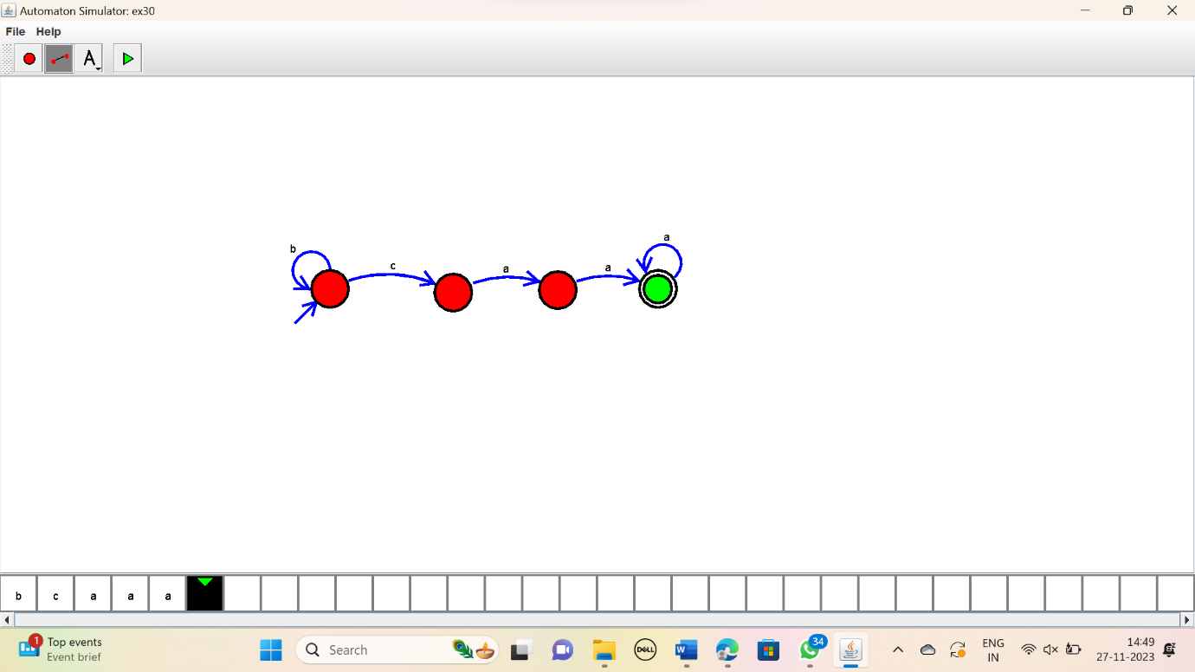

RESULT:

Thus the simulator accepted the input string “bc”,”c”,”bcaaa” using the DFA diagram.