30.Design NFA to accept any number of a’s where input={a,b}.

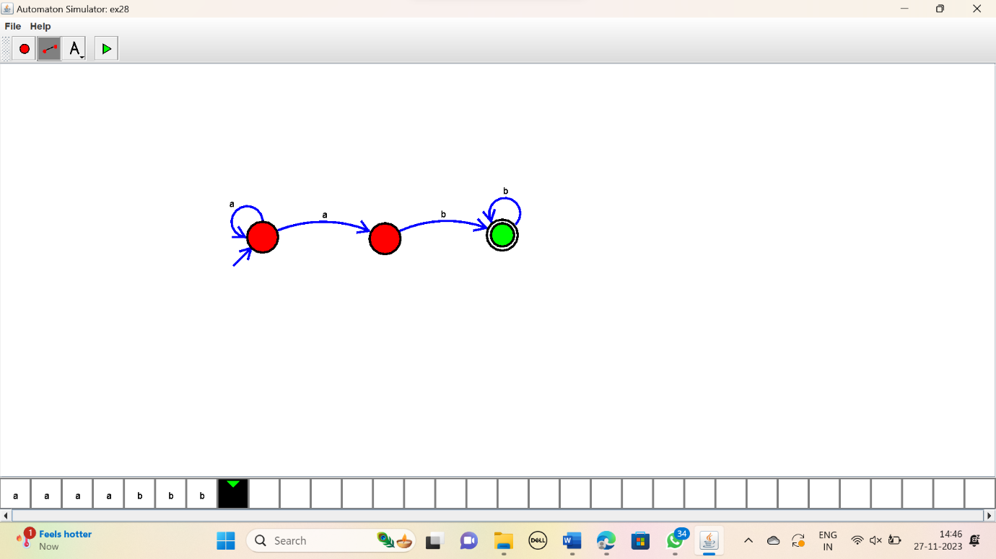

RESULT:

Thus the simulator accepted the string with any number of a’s using the DFA diagram