1. Design PDA using simulator to accept the input string anbn

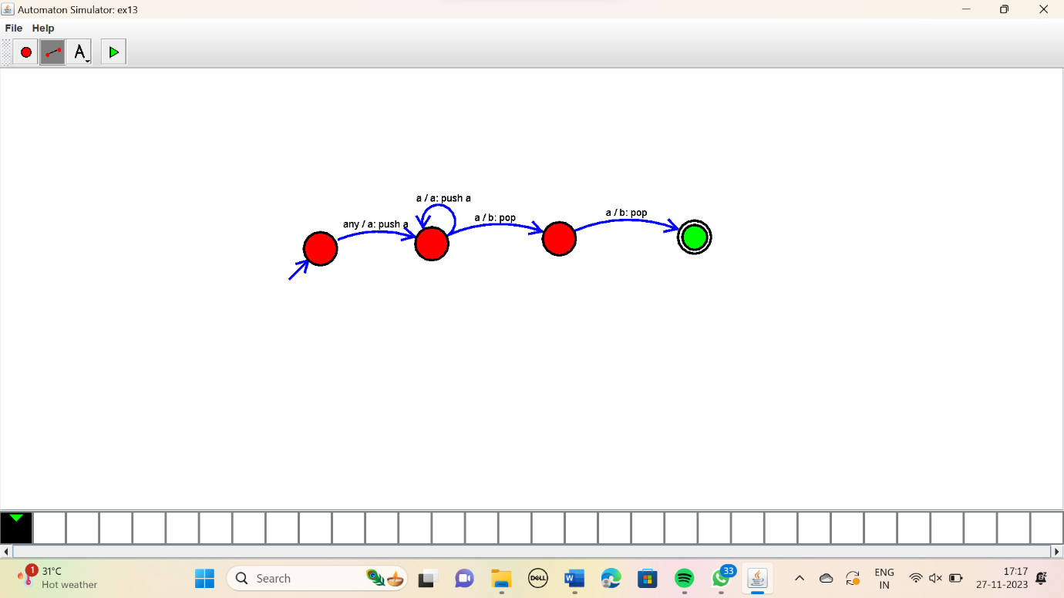

RESULT:

Thus the simulator accepted the input string a^nb^n using the PDA simulator