1. 32. Design TM using simulator to perform string comparison where w={aba aba}

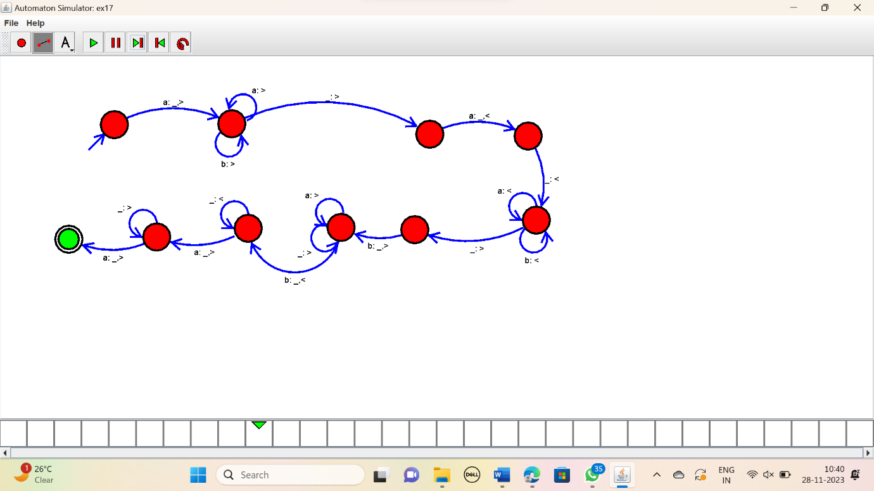

RESULT:

Thus the simulator compared the string {aba aba} using the TM diagram.