1. Design DFA using simulator to accept the string having ‘abc’ as substring over the set {a,b,c}

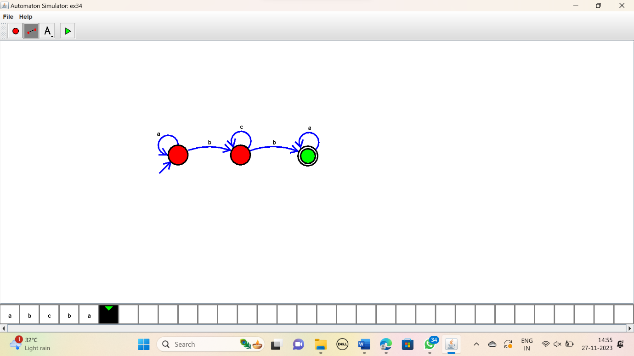

RESULT:

Thus the simulator accepted the input string having’abc’ as substring using DFA diagram.