34.Design DFA using simulator to accept even number of c’s over the set {a,b,c}

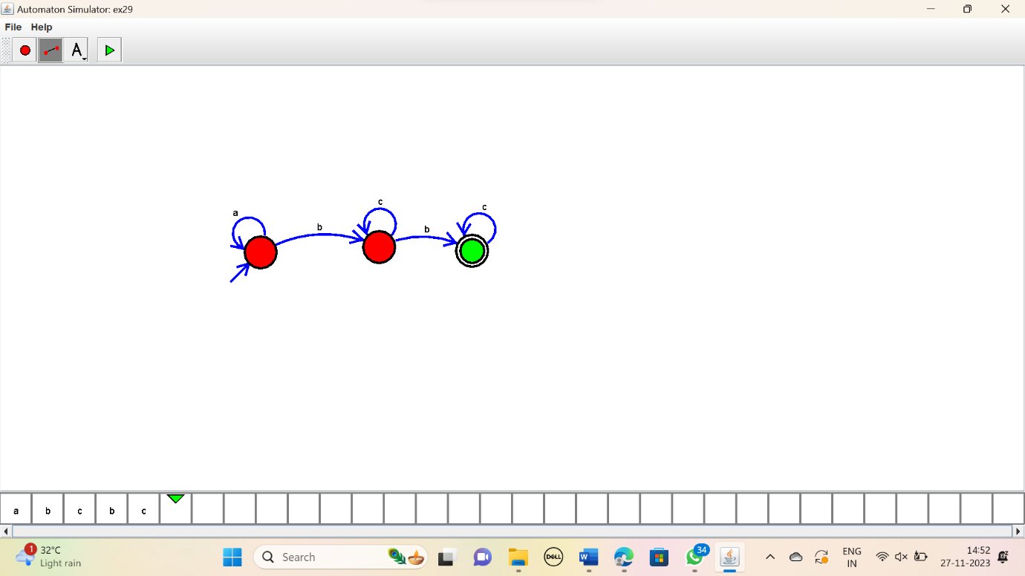

RESULT:

Thus the simulator accepted the input string with even number of c’s using the DFA diagram.