35. Design DFA using simulator to accept strings in which a’s always appear tripled over input {a,b}

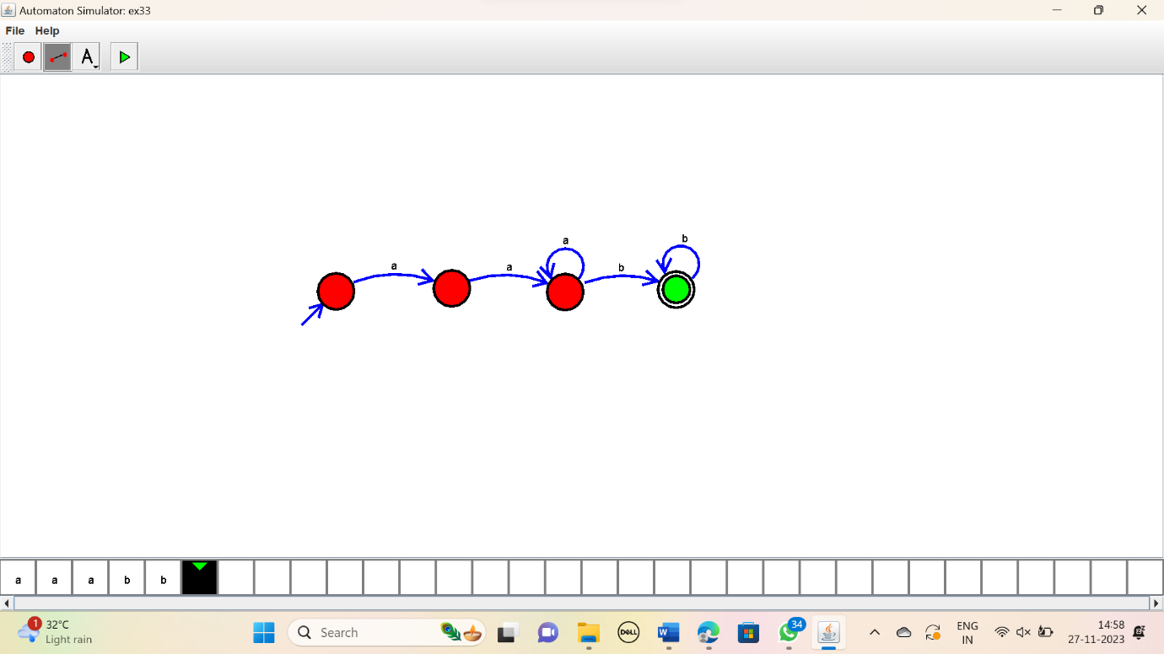

RESULT:

Thus the simulator accepted the input string with triple a’s using the DFA diagram.