38.Design NFA using simulator to accept the input string “bbc” ,”c”,and ”bcaaa”.

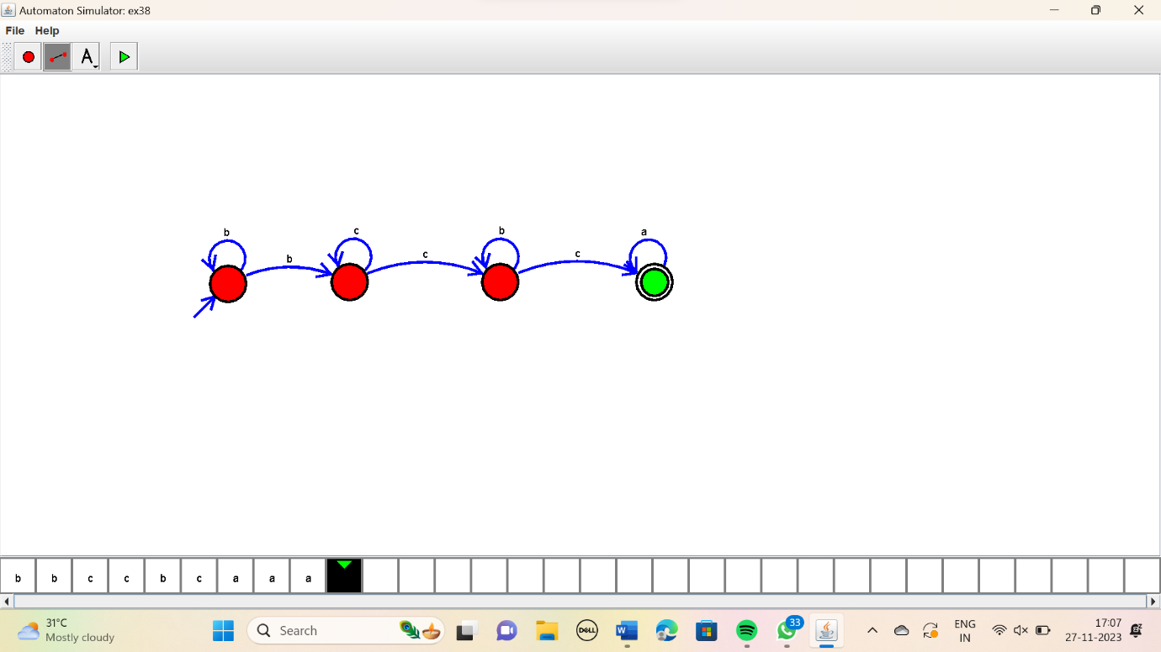

RESULT:

Thus the simulator accepted the input string “bbc”,”c”,”bcaaa” using NFA diagram.