39.Design DFA using simulator to accept the string the end with abc over set {a,b,c)

W= abbaababc

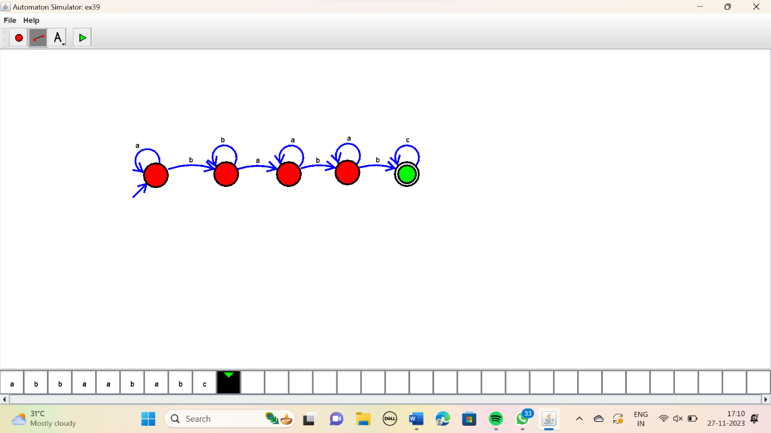

RESULT:

Thus the simulator accepted the string that end with abc using DFA diagram.