40.Design NFA to accept any number of b’s where input={a,b}.

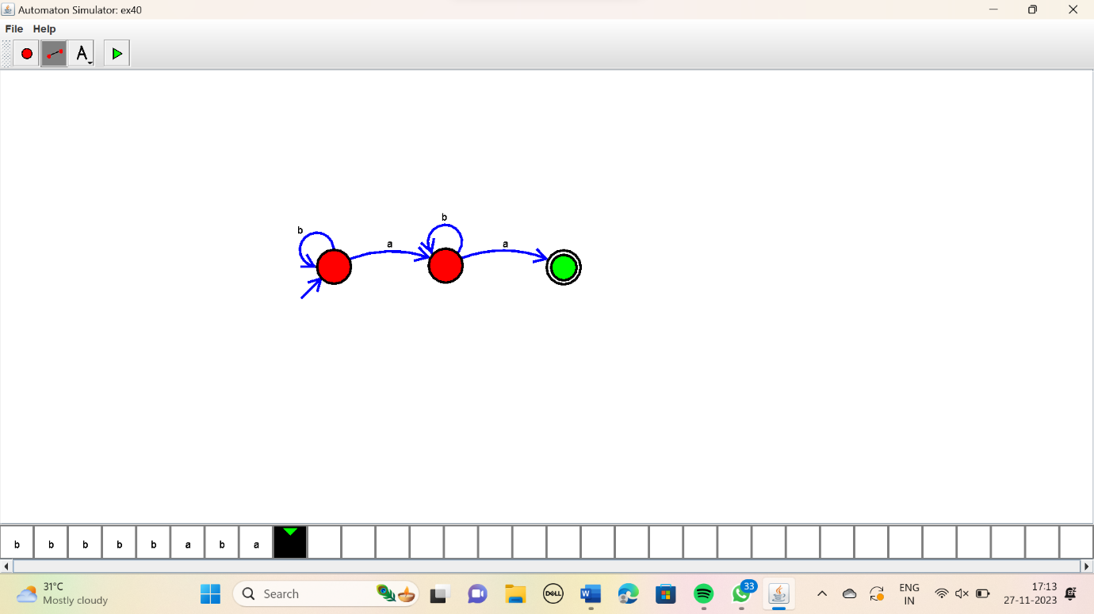

RESULT:

Thus the simulator accepted the input string with any number of b’s using the NFA diagram.