Transformation_Project

Join (JOIN and race_result notebook)
Filter
Aggregation : group by ,window
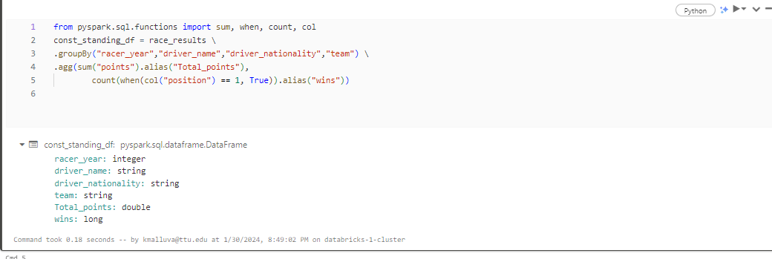
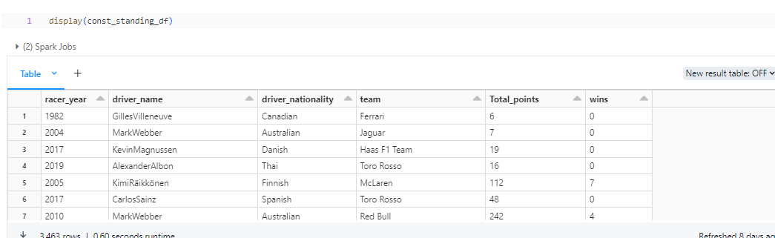

Window:
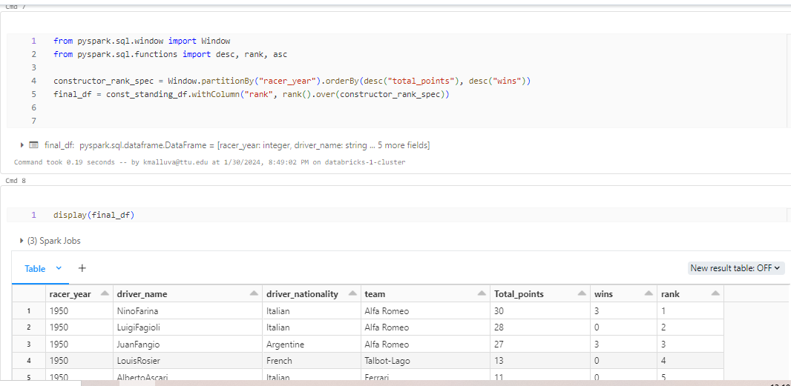

using SQL temp and Global View
In (demo ->5.TempViewAndGlobalView notebook)

- Temp View ‘
=> create
=>Access SQL cell and python cell
- Global Access
=> create
=>Access SQL cell and python cell

SQL - TABLE ,DATABASE,VIEW
SPARK SQL
↓
HIVE META STORE
↓
AZURE DATA LAKE

In Azure data lake we have stored the data (csv,json,folders)
If we want to use spark -> table ,Data base we should use (Hive Meta store)
Hive meta store ,we can store in 2 ways Datbricks Default store and external store (mysql, Azuresql,…)

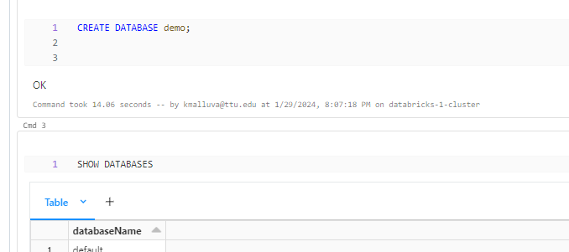

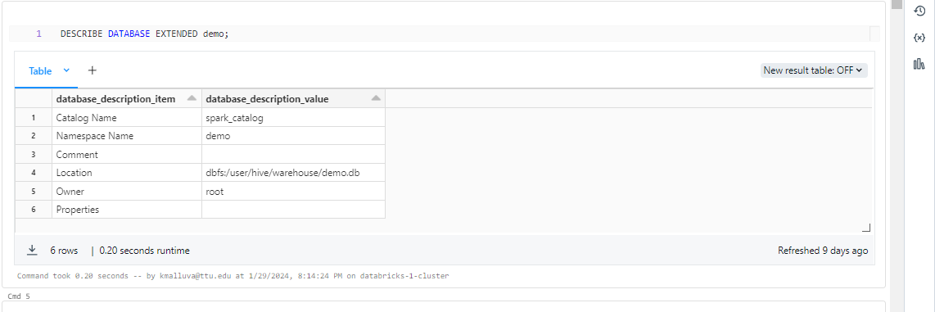

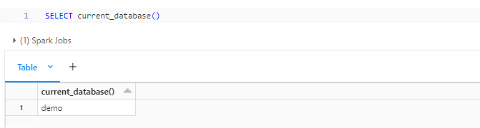

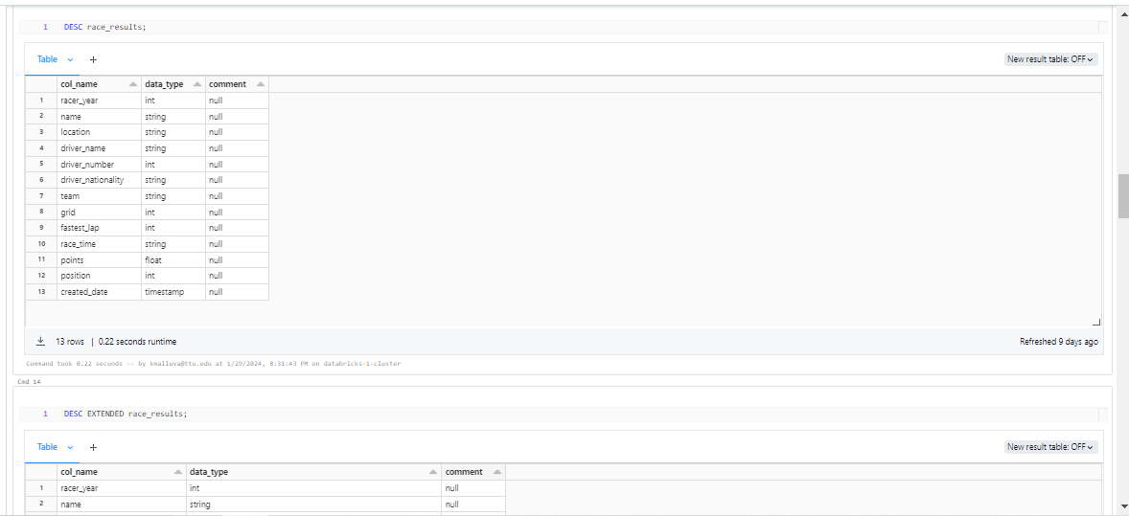

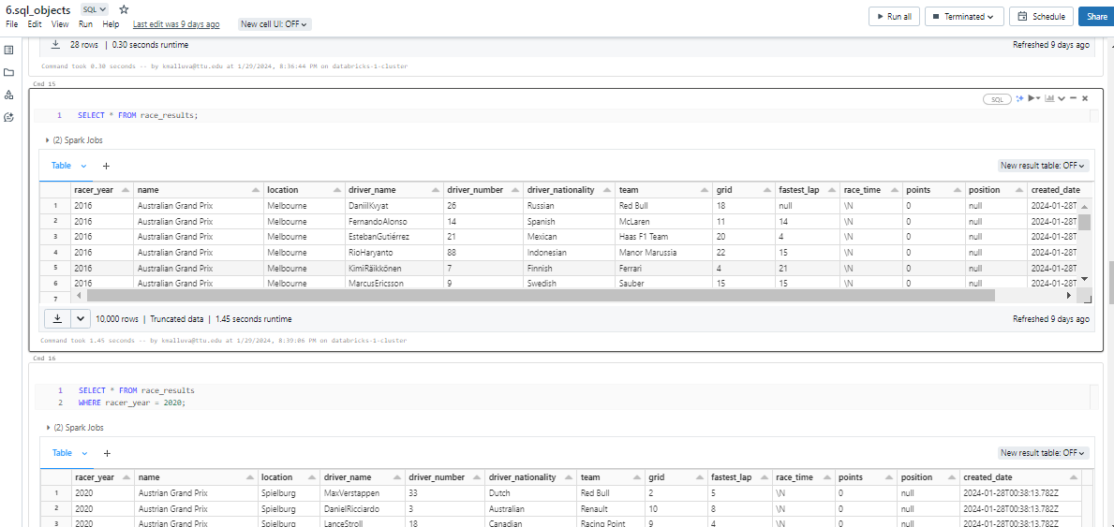

Create a table and insert the columns and data into the table :

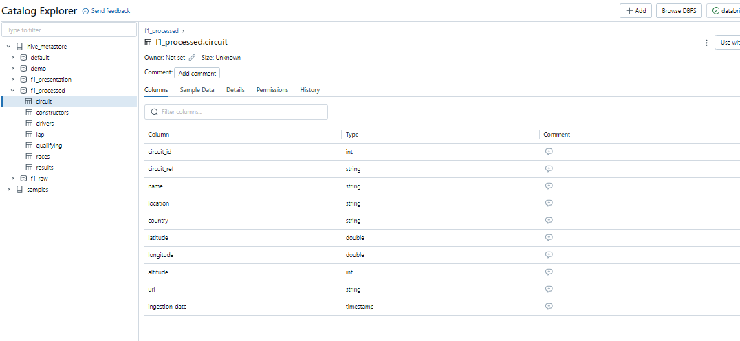
Csv file:
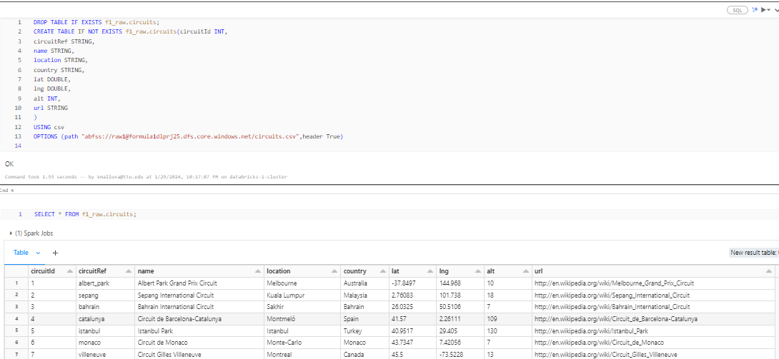

JSON FILE:
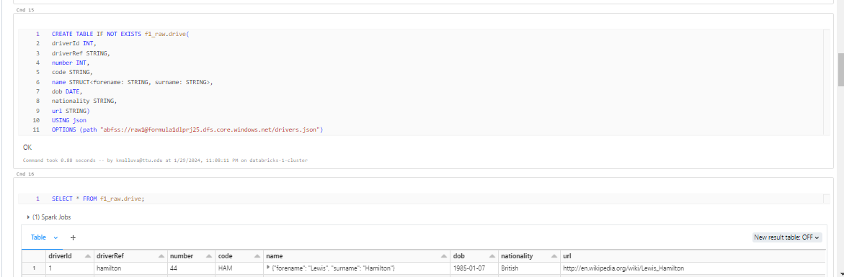

JOIN TABLE:

