PROJECT -DATABRICKS
Cost:
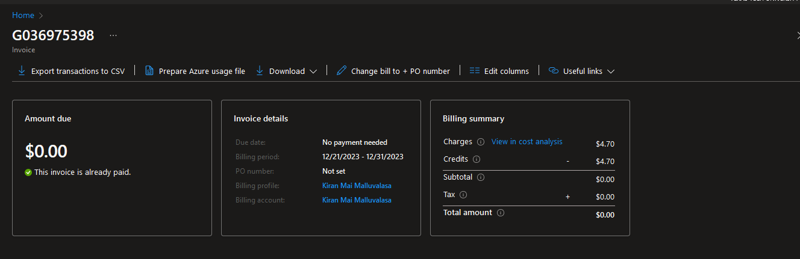

UPLOAD FILES THE DATA IN AZURE STORAGE EXPLORE

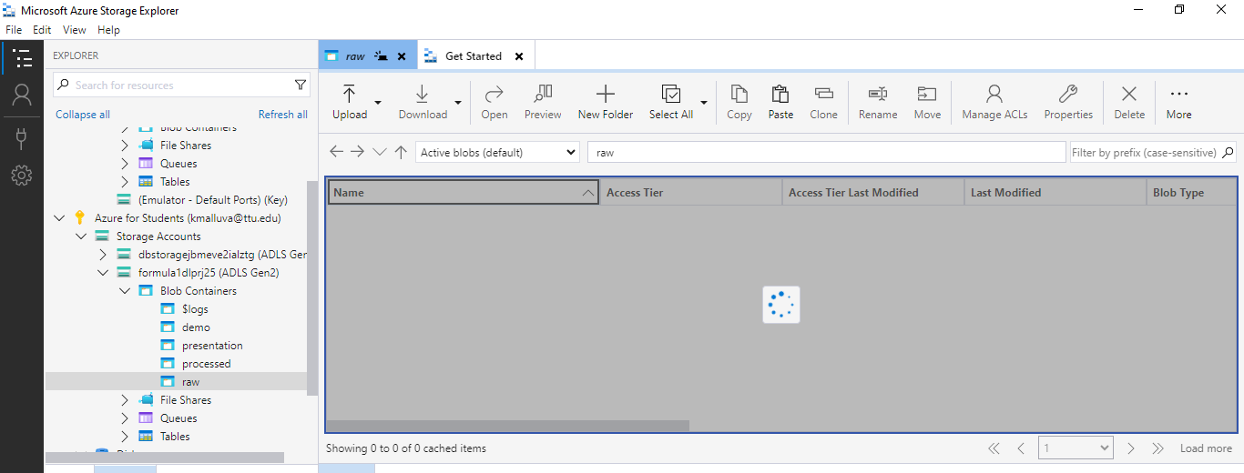
UPLOAD FILES THE DATA IN AZURE STORAGE EXPLORE:
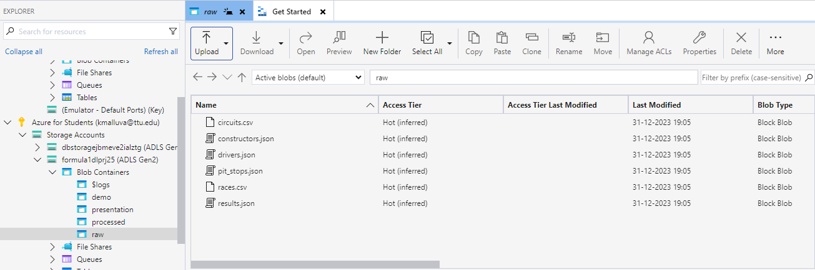
IN SAME WAY UPLOAD THE FOLDERS
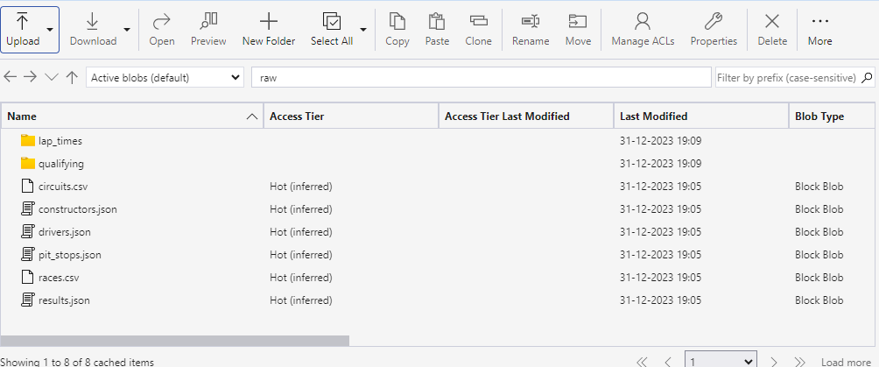

Spark:
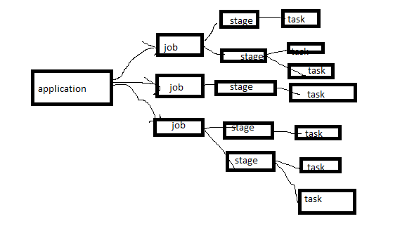

Which identify number of nodes and seperated equally.

(Csv,Json)
Data sink
write
Data Frame
Transform
Data frame
Read
Data source(CSV,JSON …ETC)

Data Integration:

https://spark.apache.org/docs/latest/api/python/reference/index.html
https://spark.apache.org/docs/latest/api/python/index.html

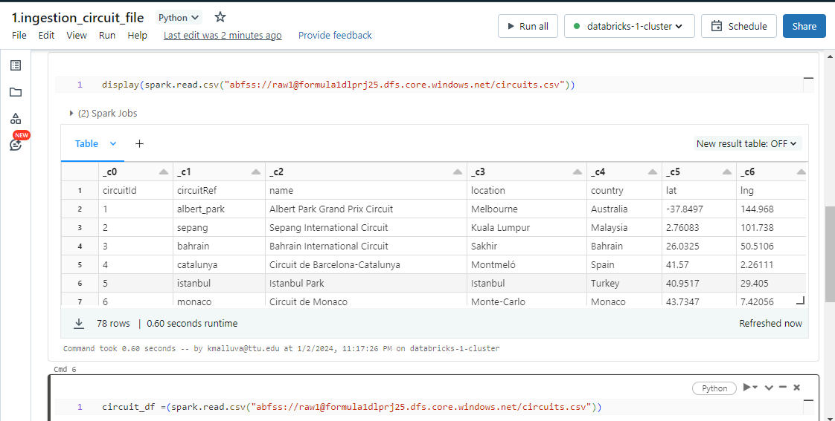

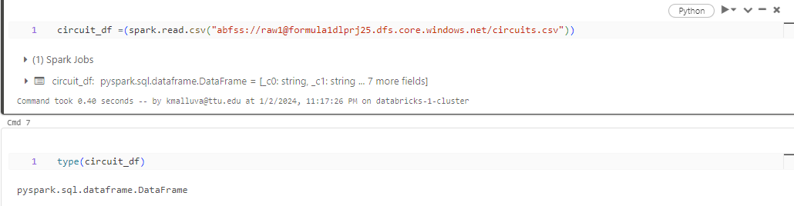
Type = dataframe

.show() -> shows me top 20 tables
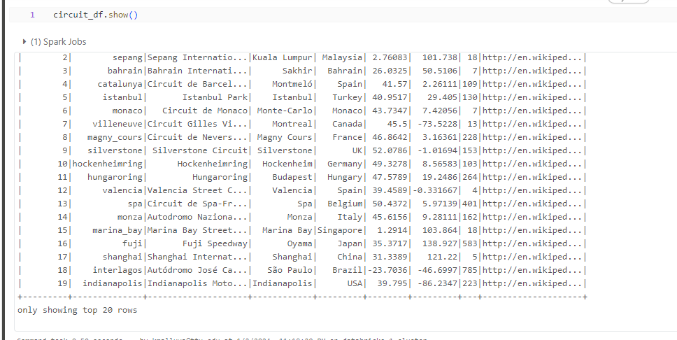

circuit_df =(spark.read.csv("abfss://raw1@formula1dlprj25.dfs.core.windows.net/circuits.csv"))
-> if header comes in 1st row -> then
circuit_df =(spark.read.optins(“header”, True).csv("abfss://raw1@formula1dlprj25.dfs.core.windows.net/circuits.csv"))

Specify Schema:

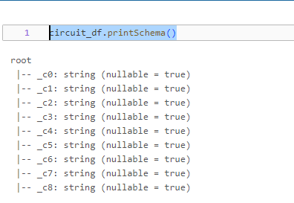
circuit_df.printSchema()

Where this printSchema show the col name ,type and it is nullable or not.

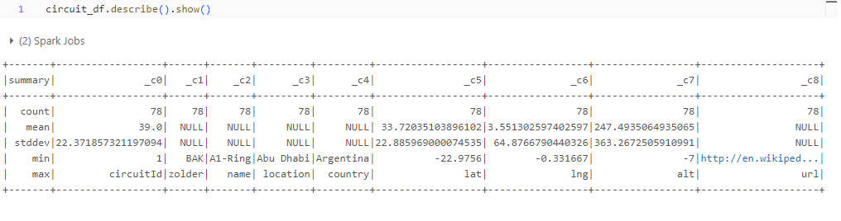

circuit_df.describe(): This function calculates summary statistics for each numerical column in the circuit_df DataFrame. It computes statistics like count, mean, standard deviation, minimum value, maximum value, and percentiles (25th, 50th, and 75th percentiles) for each numerical column. This function will exclude non-numeric columns from the calculation.
.show(): The .show() method in PySpark is used to display the results of the previous operation (describe()) in the console or output window. It prints the computed summary statistics in a tabular format, making it easier for you to visualize and analyze the data.

Where the print schema have an error wheere it shows every column as string

Now we are solving above problem:
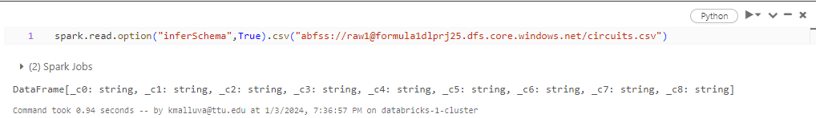

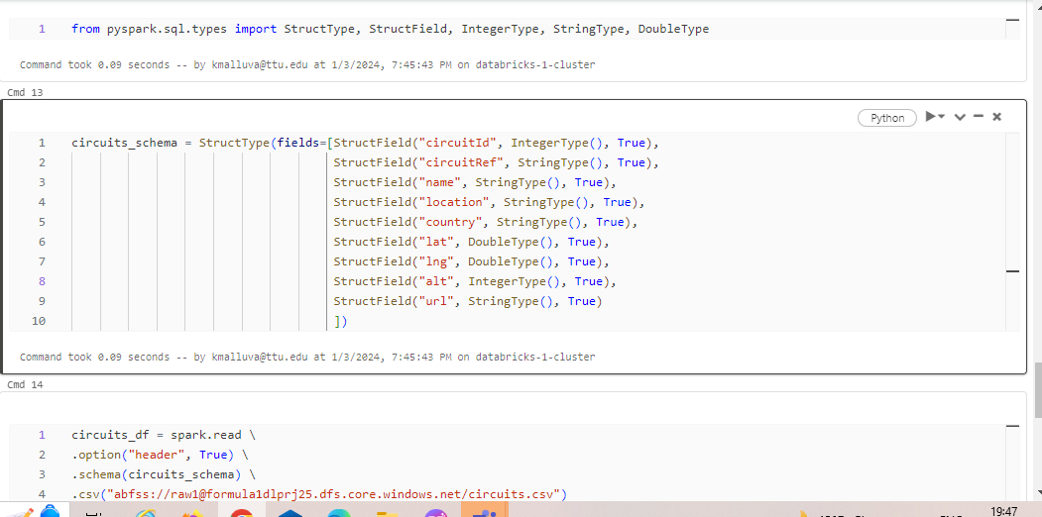

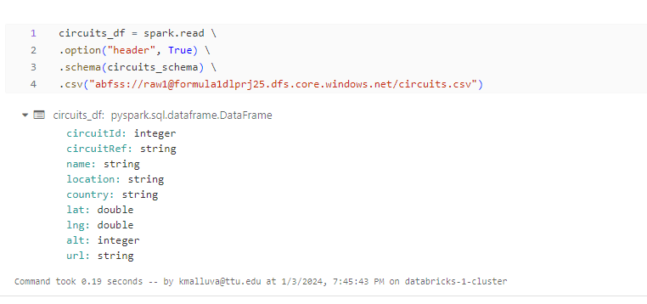2.Select the required col:

Case 1: In case 1 we cannot make any changes like renaming the col,
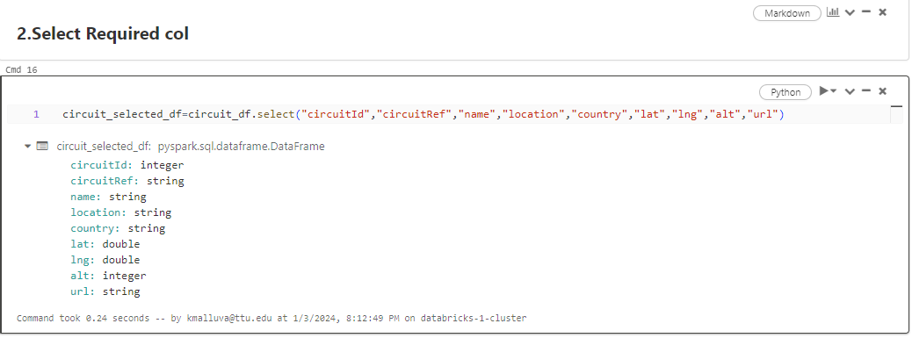

Case 2:

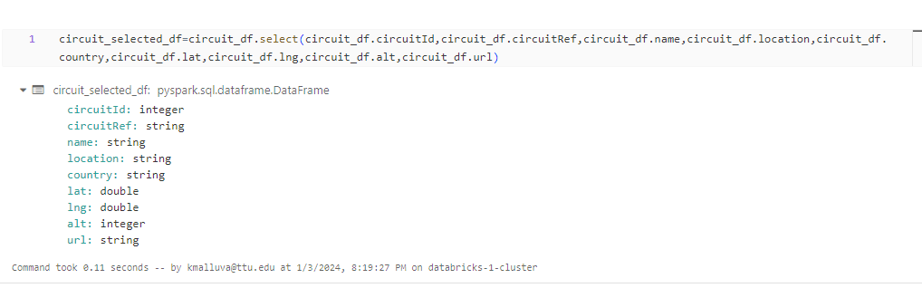

Case 3:

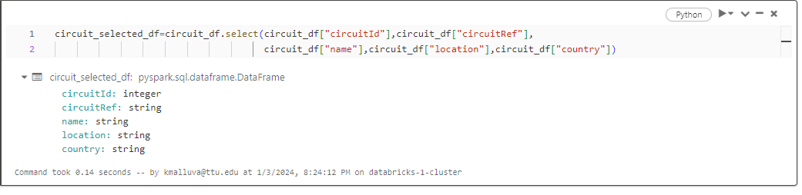

Case 4:
from pyspark.sql.functions import col
circuit_selected_df=circuit_df.select(col("circuitId"),col("circuitRef"),col("name"),col("location"),col("country"))

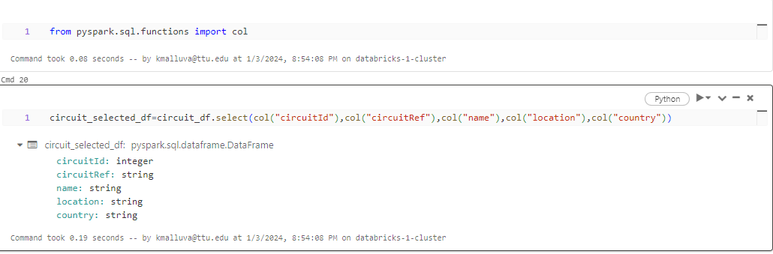

Renamed the col:
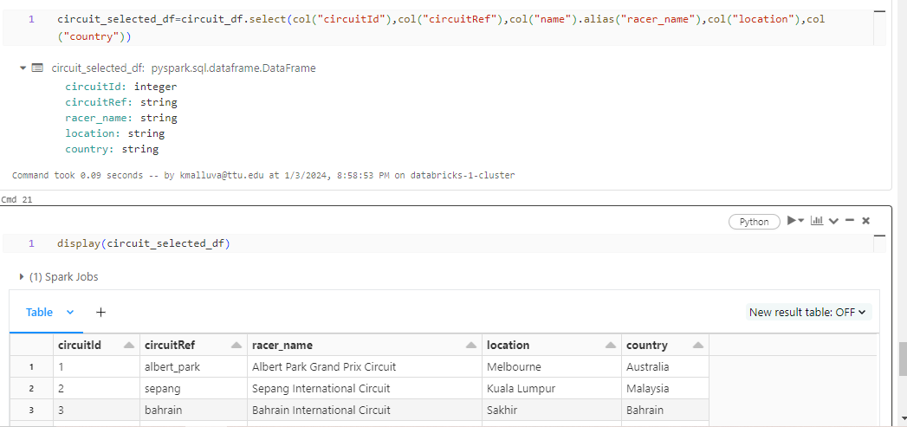

There is other way to rename the col:
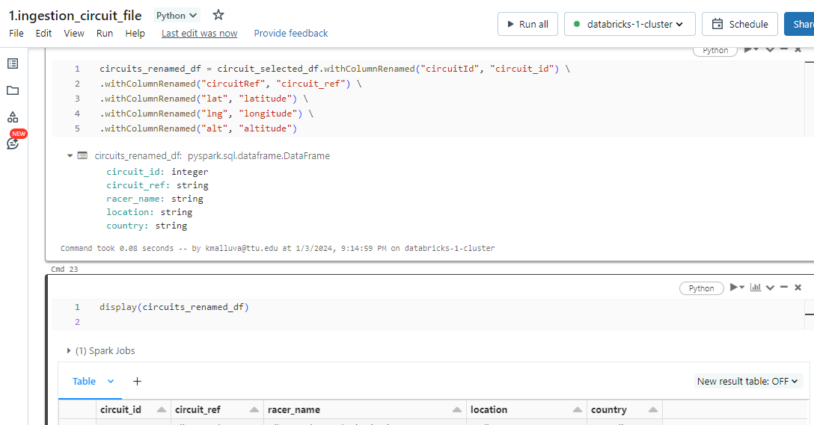

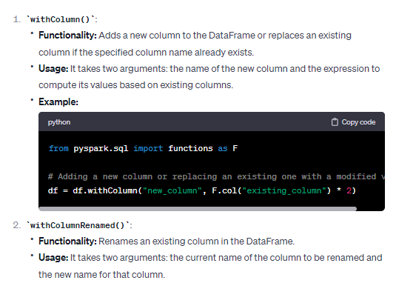

.withColumn():

Adding an "ingestion date" to a DataFrame typically means including a column that indicates the date or timestamp when the data was ingested or loaded into that DataFrame.

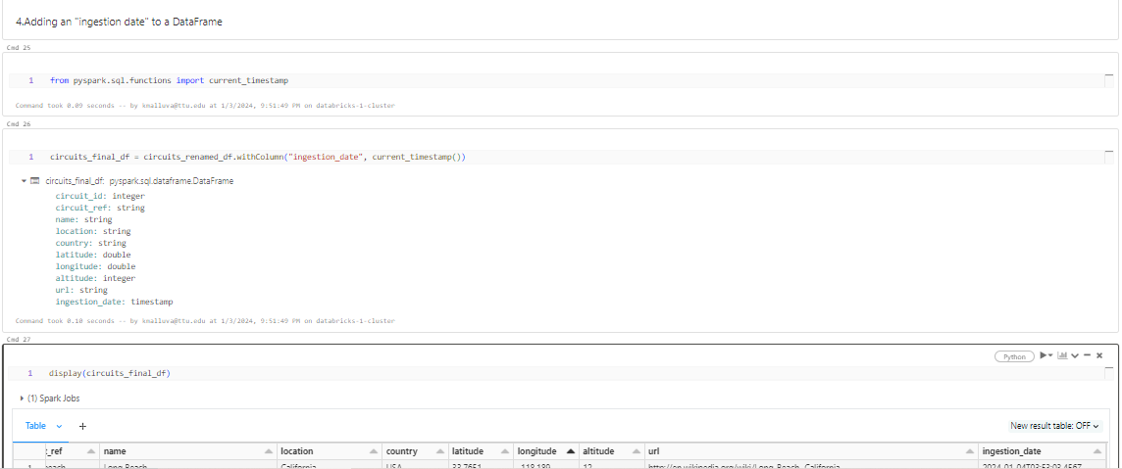

FINAL TASK:
WRITE :
If we execute more than 1 time it’s shows exist so we should set mode in overwrite
Error 2: if we keep raw1 it will insert the other file wiping up the data in the folder.

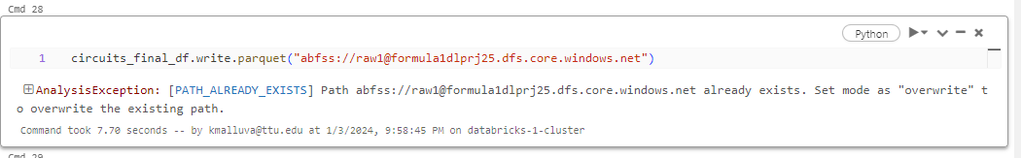

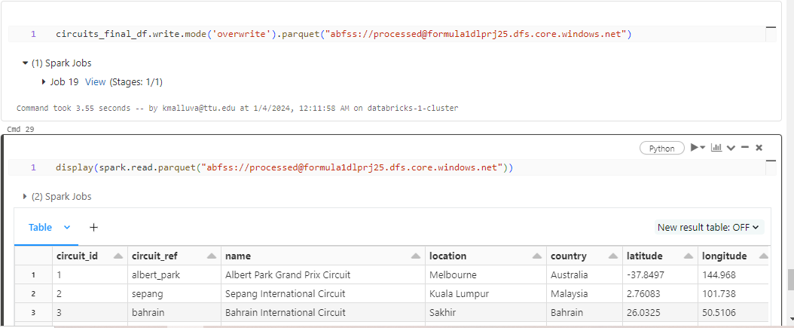

Done with circit.csv changing the requriment (Data Ingesion for racer.csv)
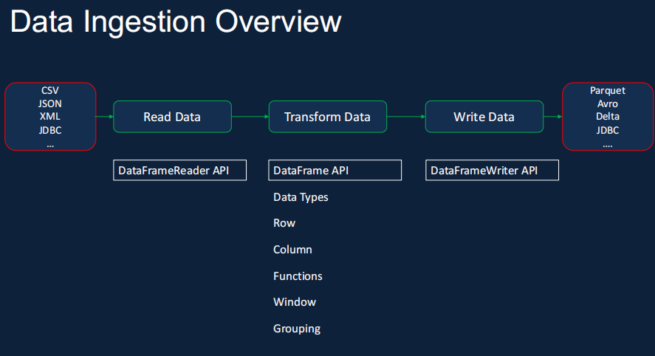

Assignment :
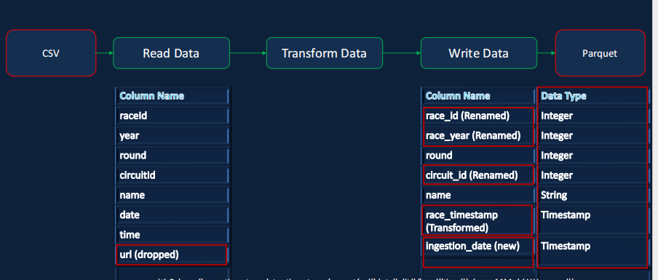

If we are not setting option a (‘header’,True) ,error will occur(the header becomes as frst row)
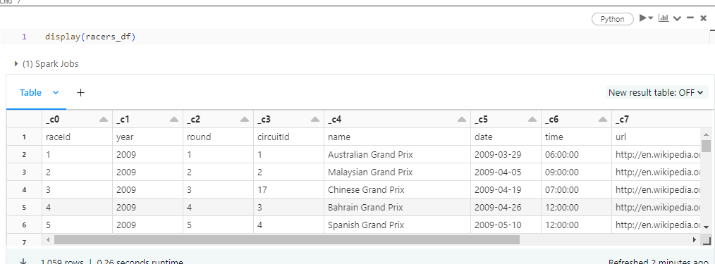

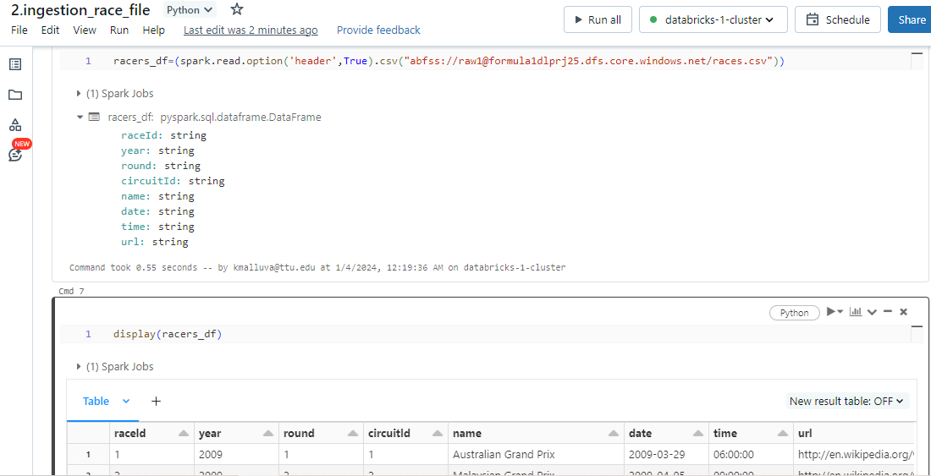

Changing the data types:
1..schema() -> which helps us to display the schema
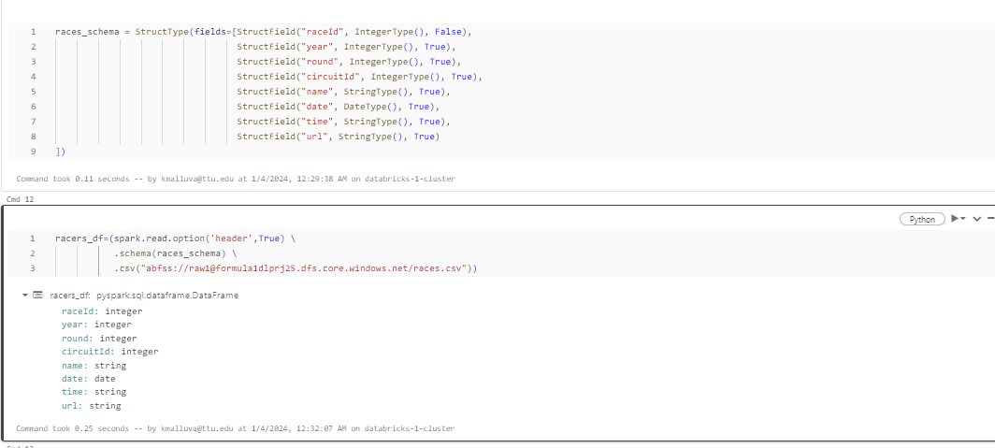

Adding ingestion_date col to the table and concating date and time to one col(racer_timestamp)
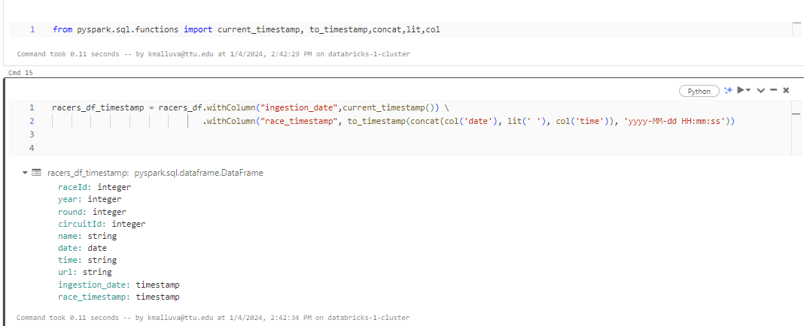

Rename:
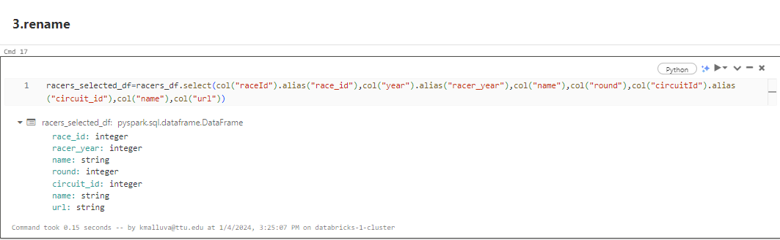

- partition by:
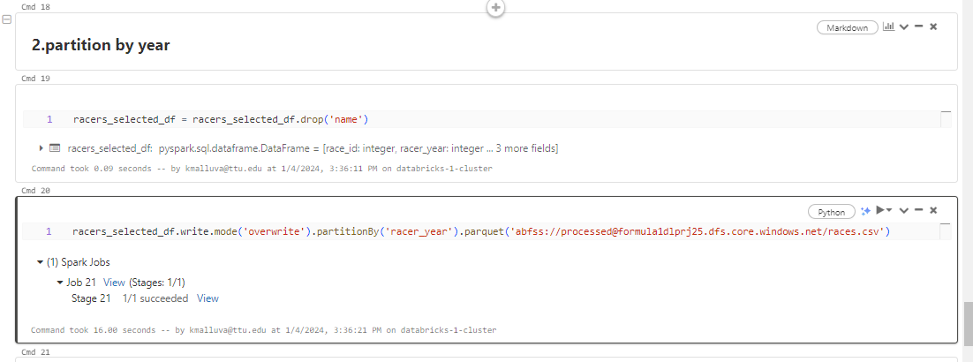

JSON FILE:

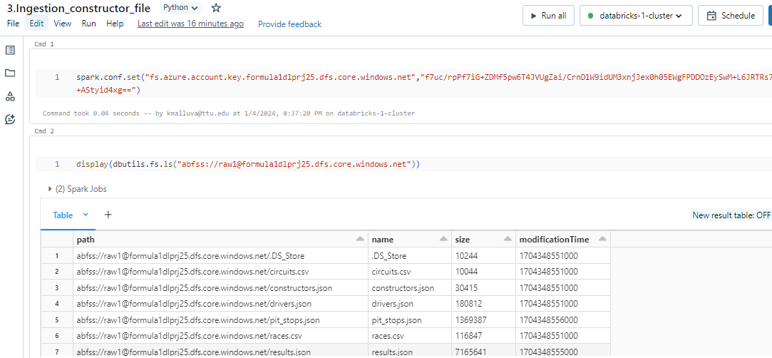

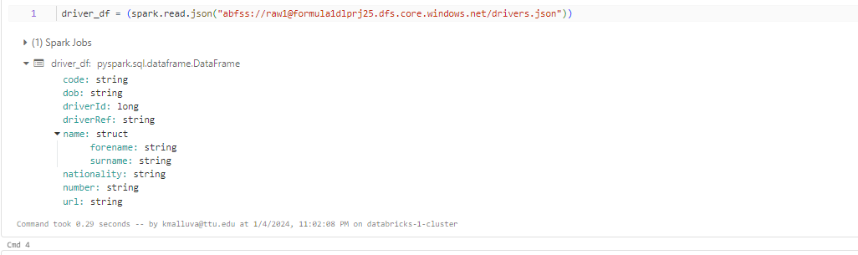
Nested schema inside schema:

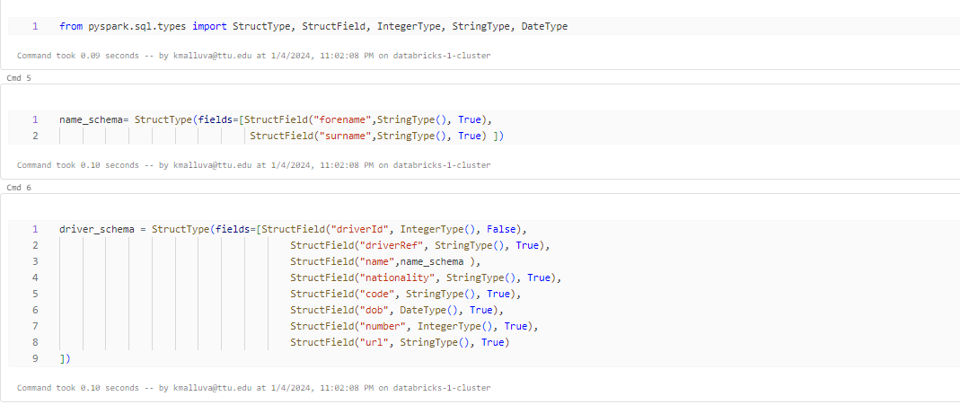

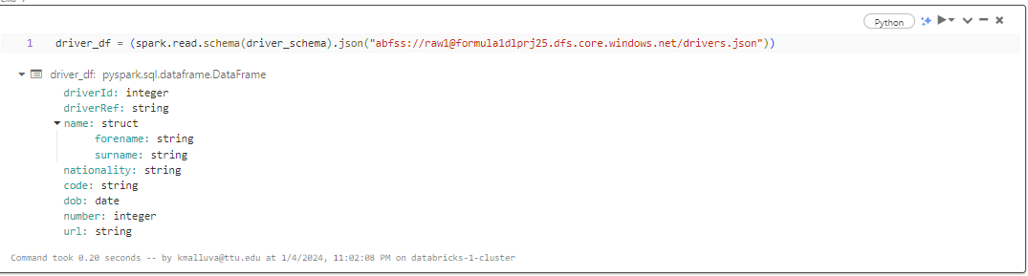
Renaming:
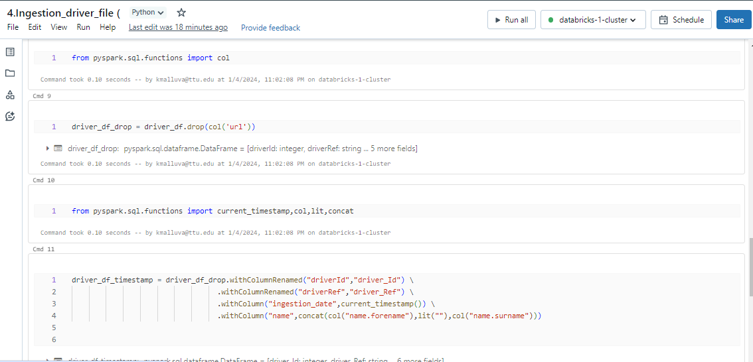

FOLDER (FILE)

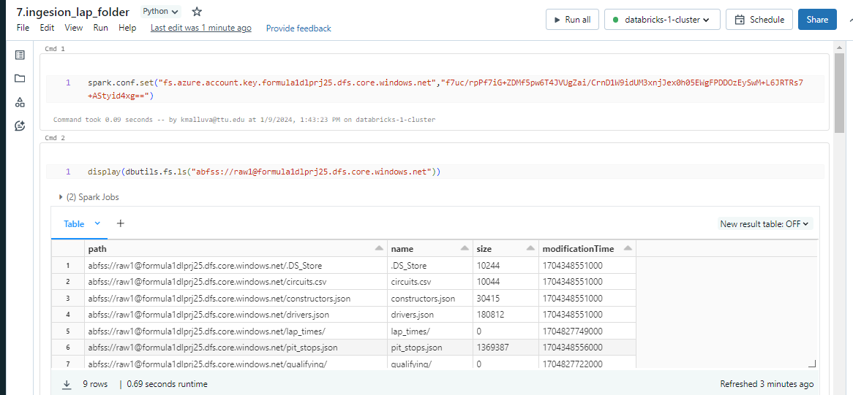

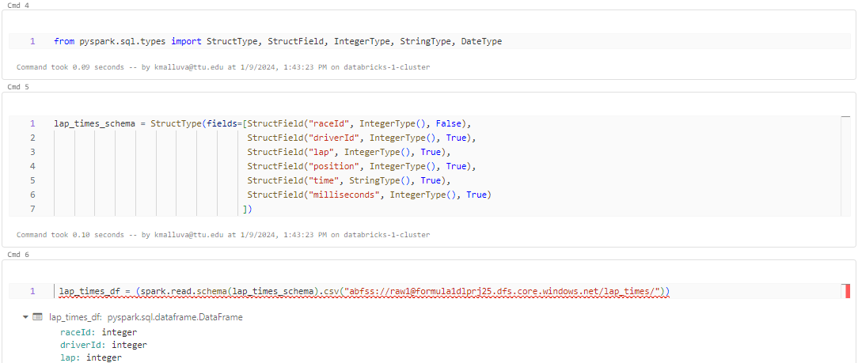

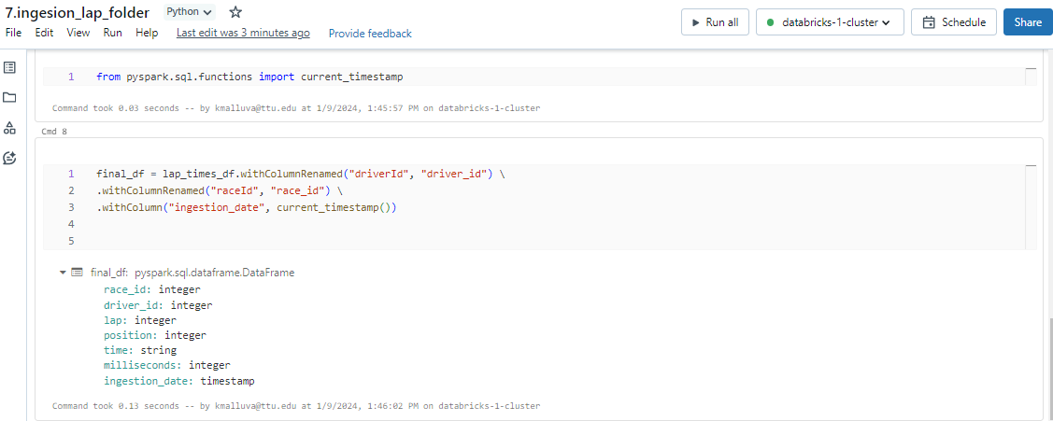

Write:

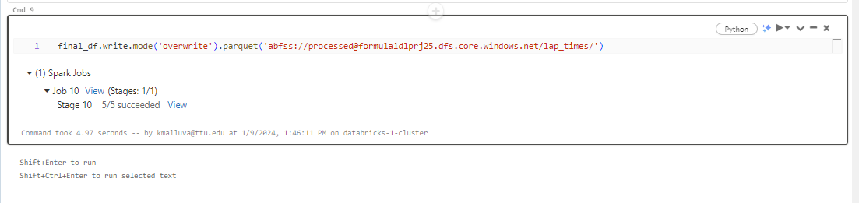

Same as lap folder but qualifying folder is having multi json folders:
This .option(“multiLine”,True) -> must be added
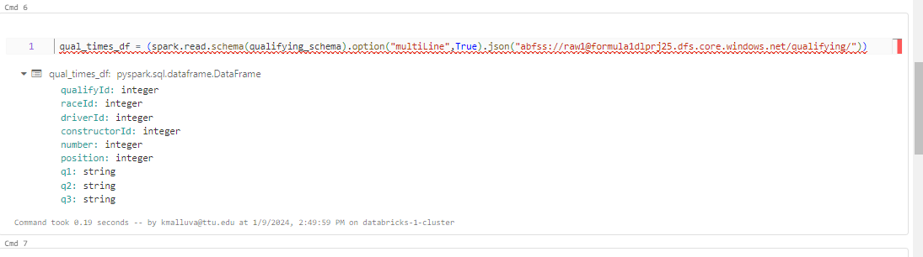

DATA WORKFLOW:

We now have eight notebooks to ingest our data into the Data Lake.

Child Notebook:

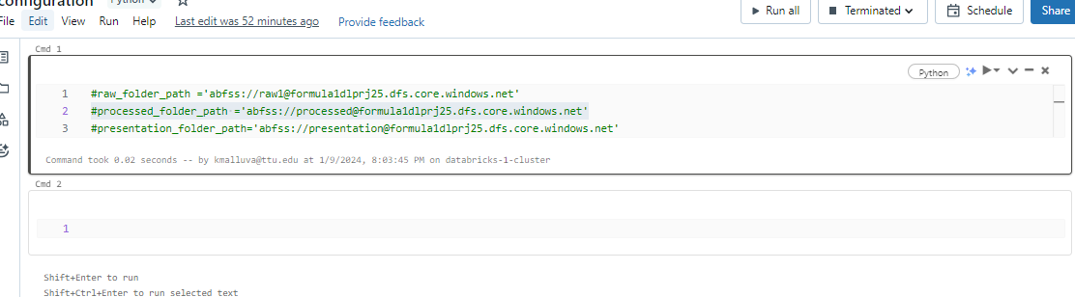

Run the configu ration file

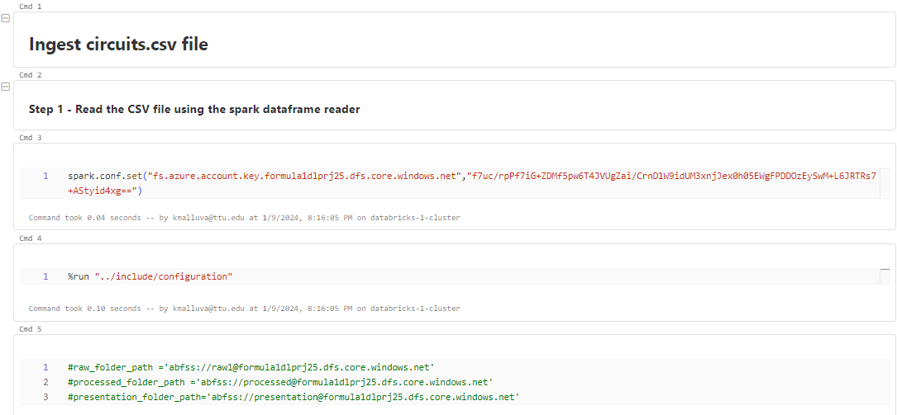

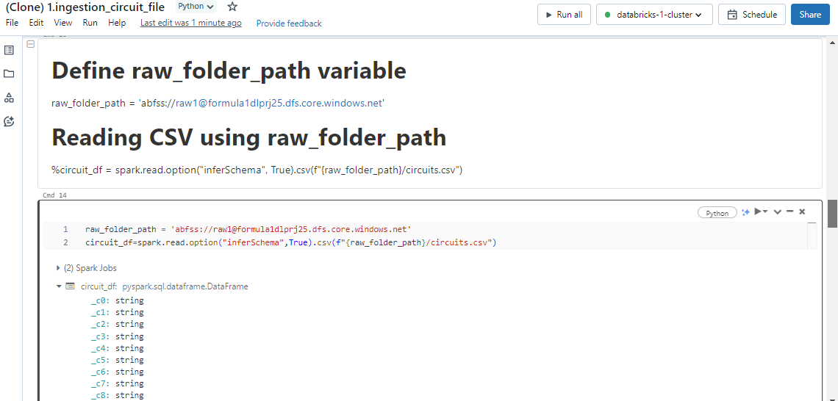

Common functions:

Writing out the function in other notebook:
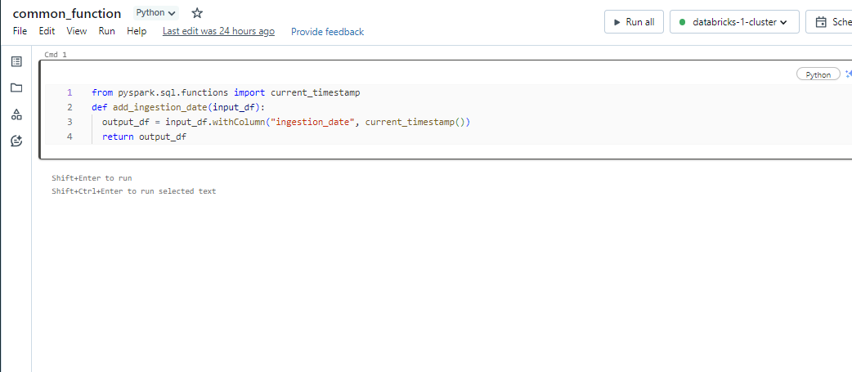

Calling it in:
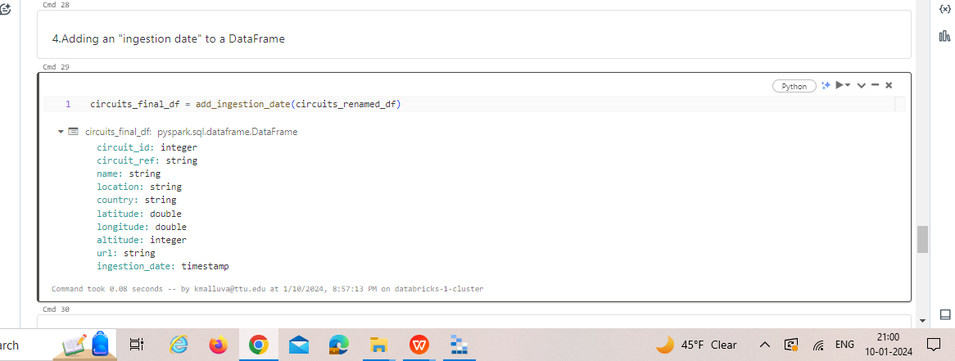

Passing Parameters through notebook:

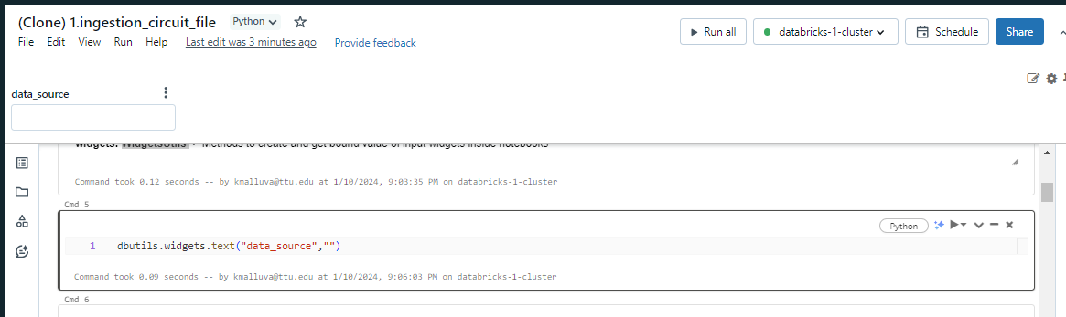

I gave output as testing and name it as v_data_source
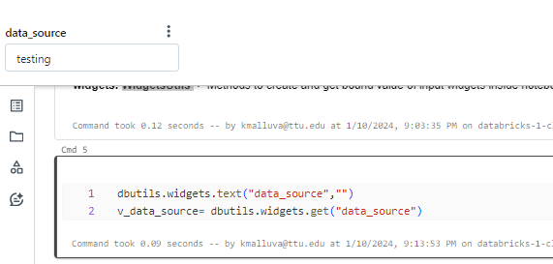

And call it:
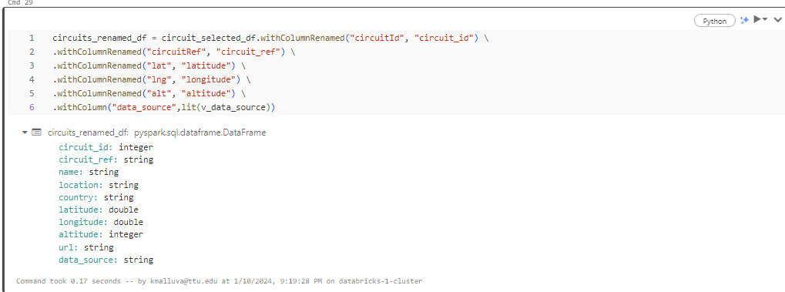

And the output show as:
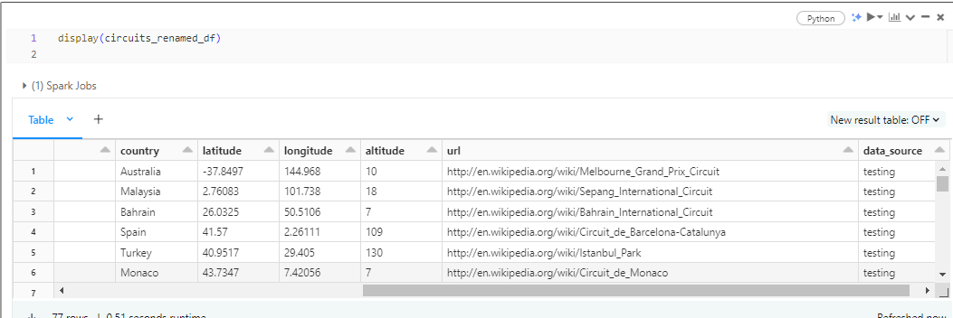

WORKFLOW:

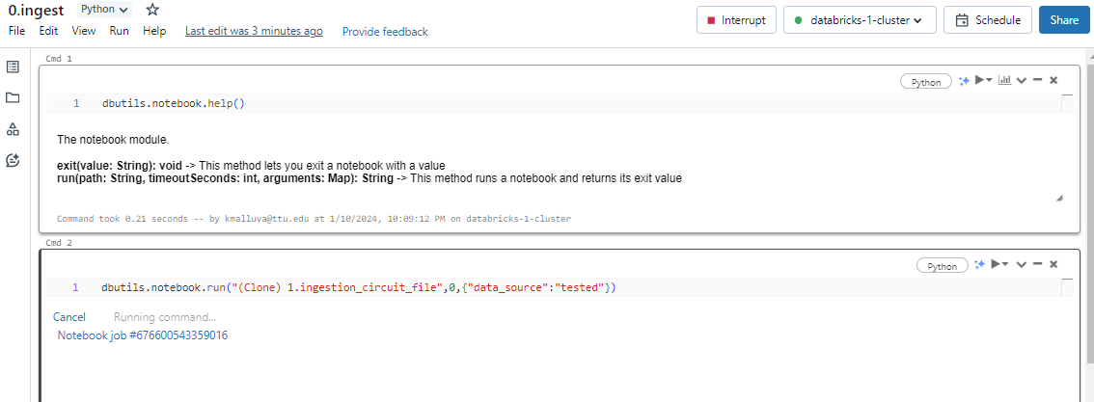

Changed:

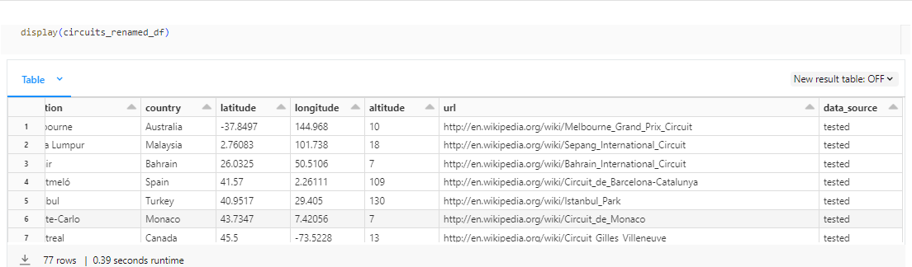

Databricks jobs:

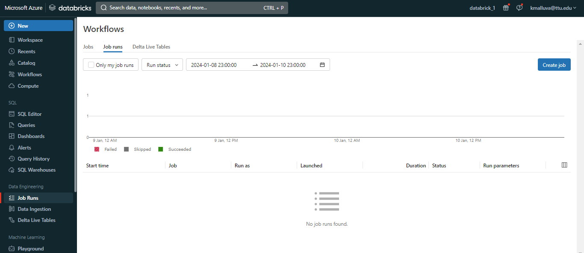

Create a job :

