Apache spark provides clusters,workspace/Notebook ,Adminstration control,optmized spark,database/tables,delta lake,sql analysis,MLFlow.

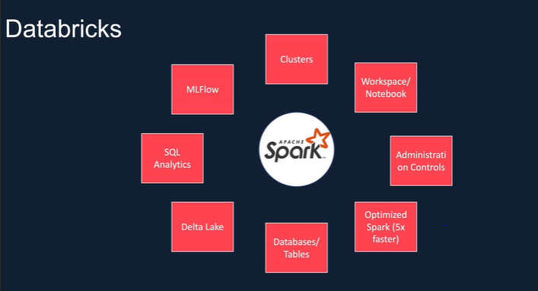

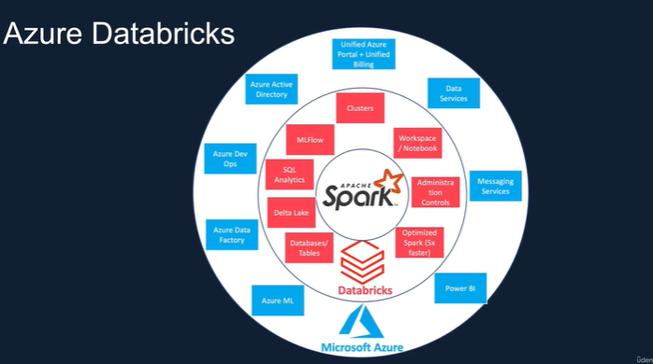

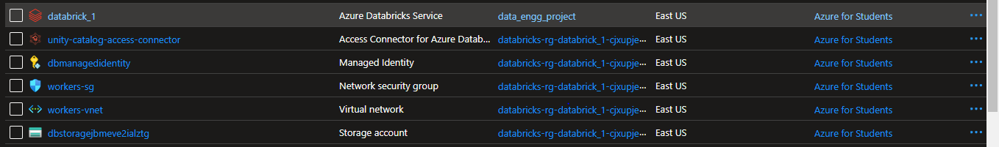

There are two types of cluster

Where all purpose cluster can be created but job cluster cannot be created.

When there a workflow we can create a job cluster ,after end of the job it will get destroied .

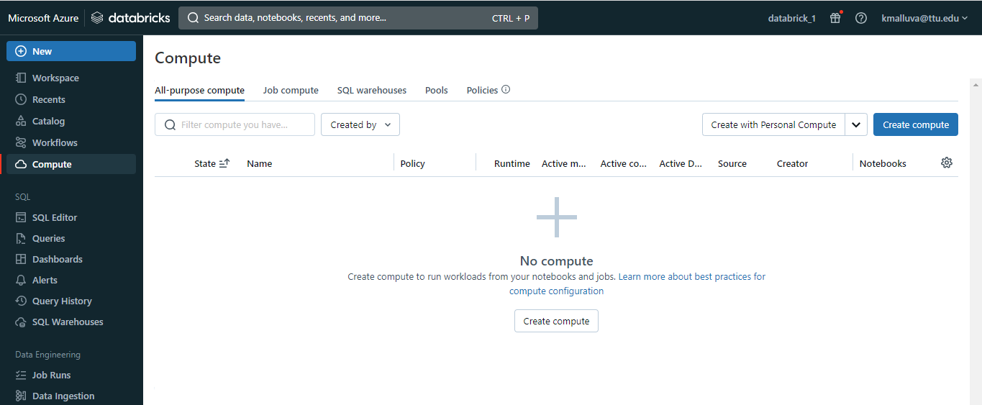

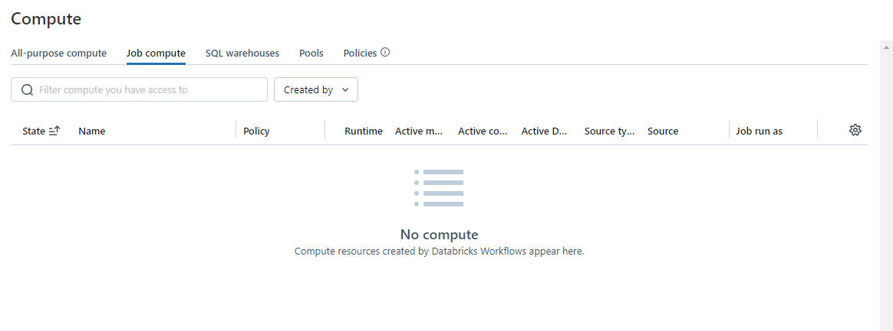

In workflow you can create a job:

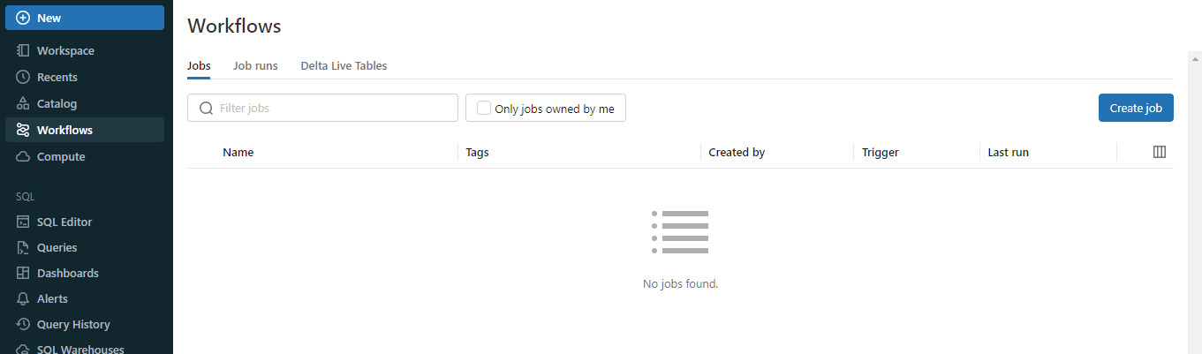

Cluster configuration:

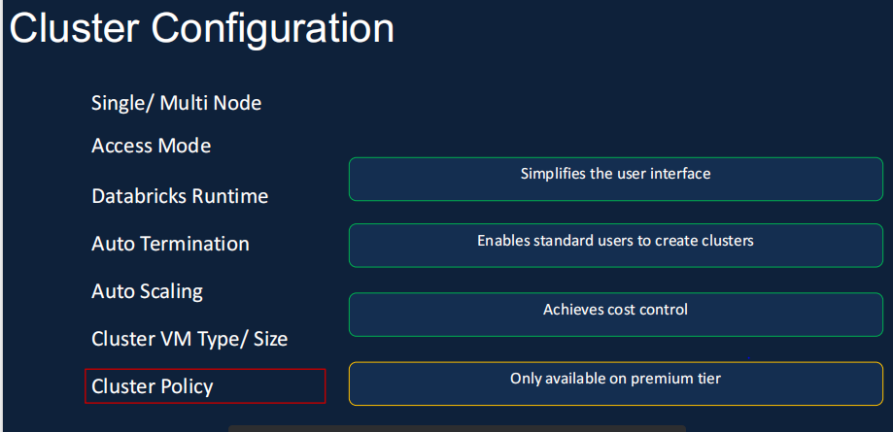

Creating a cluster:

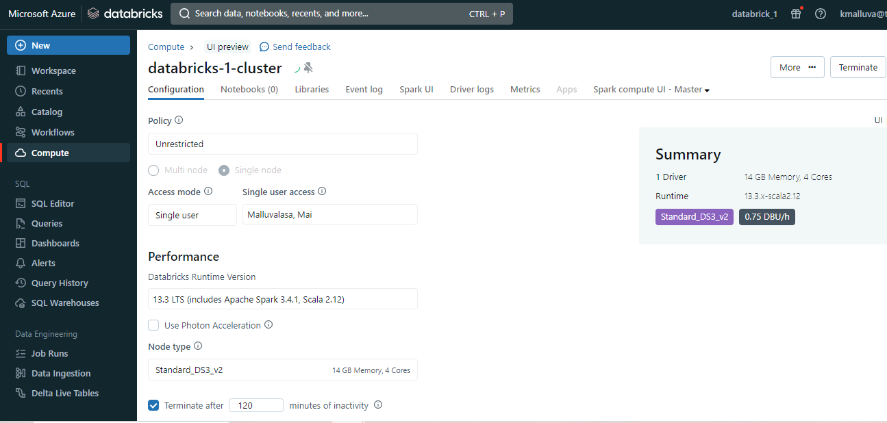

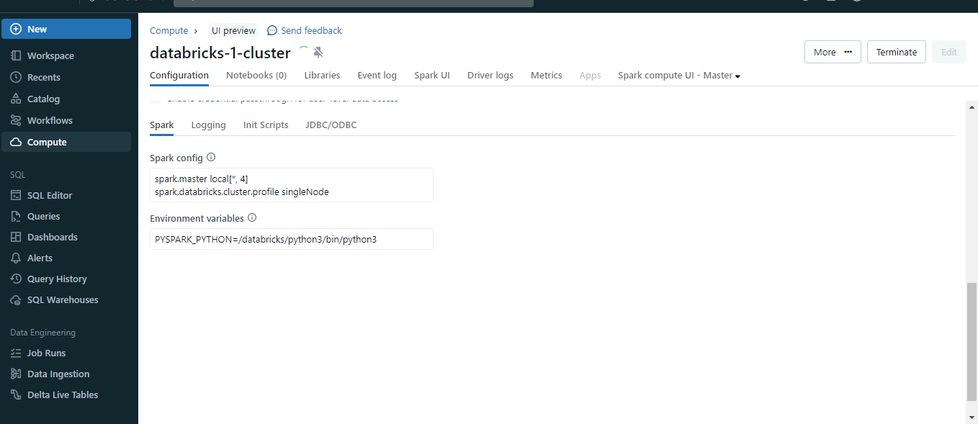

If cluster is created we can see green trick mark

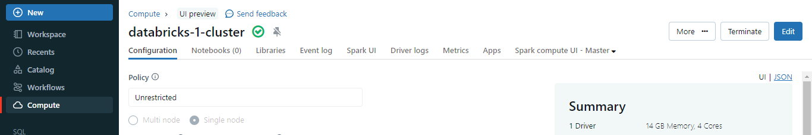

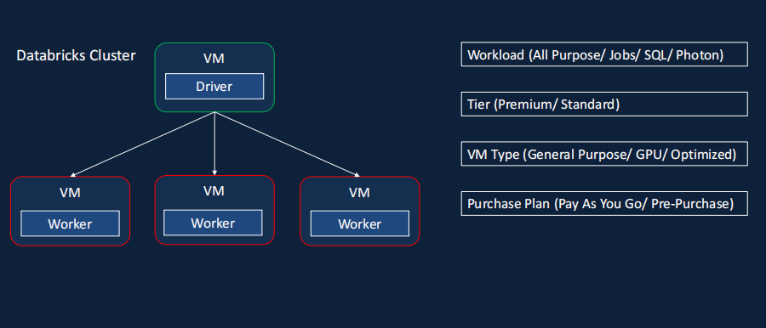

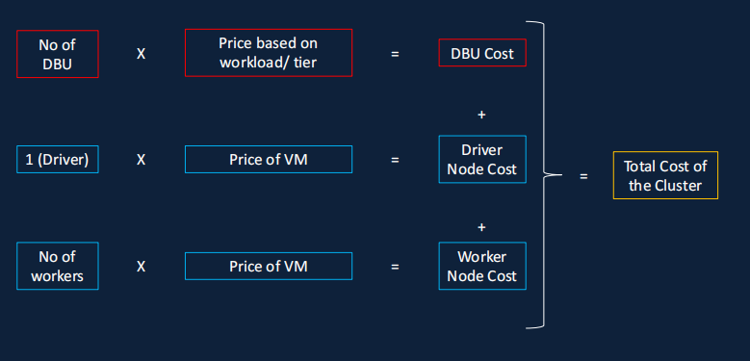

For creating a pool:

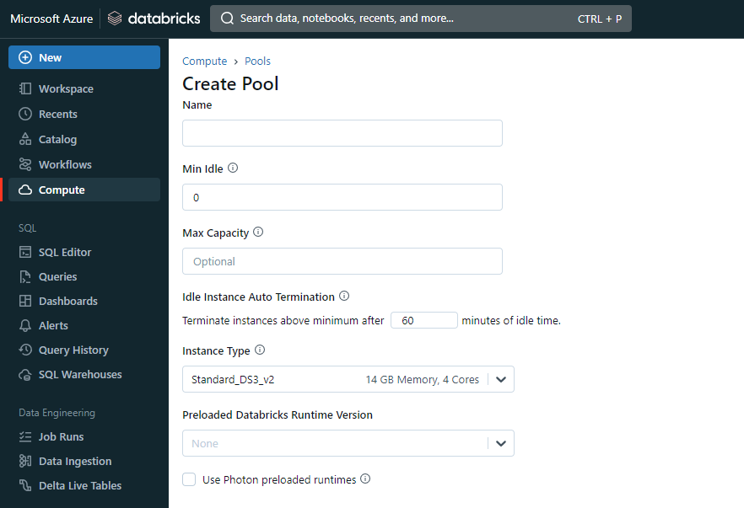

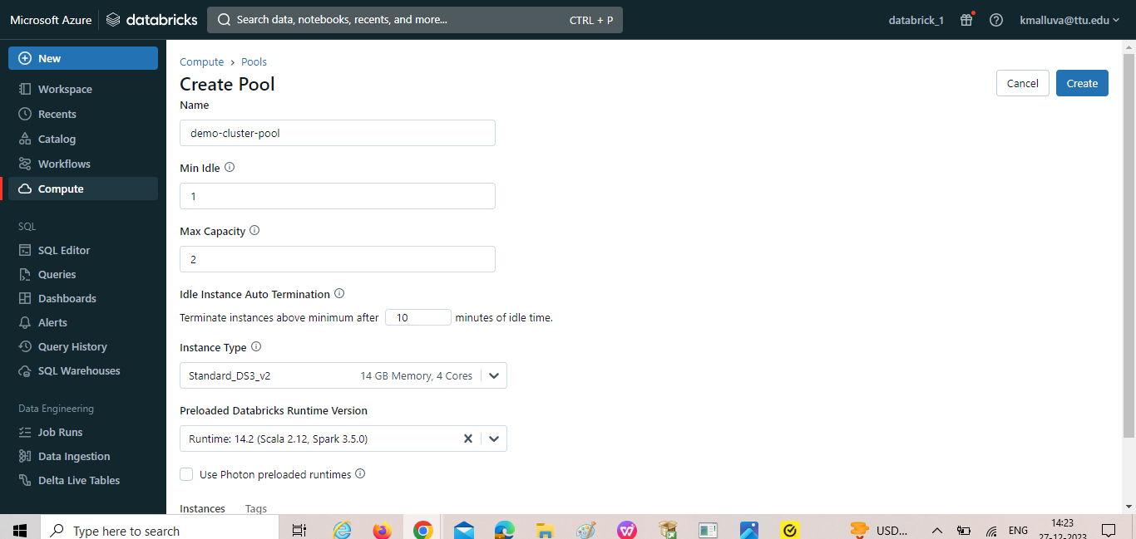

Creating new cluster by adding worker type as demo-cluster 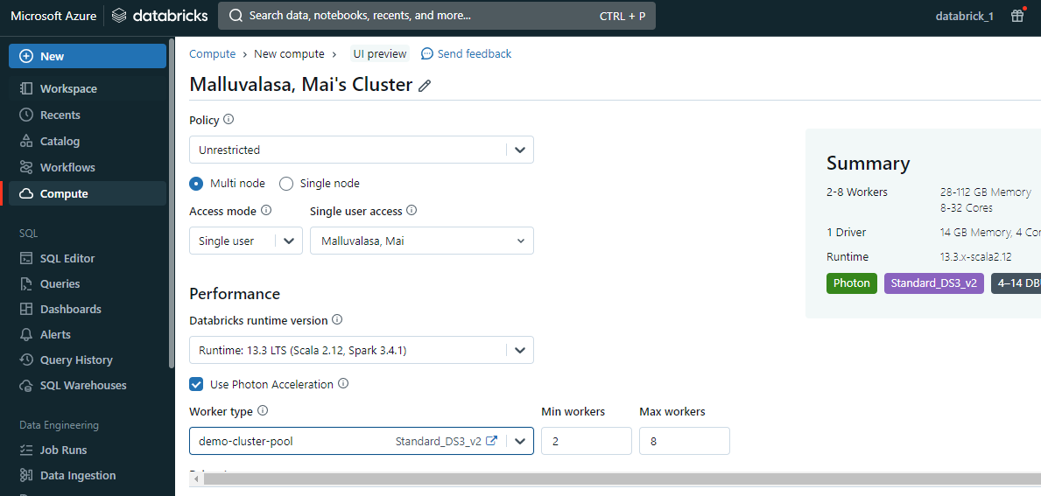

Where the pool speed up the creation of cluster.

Policy:

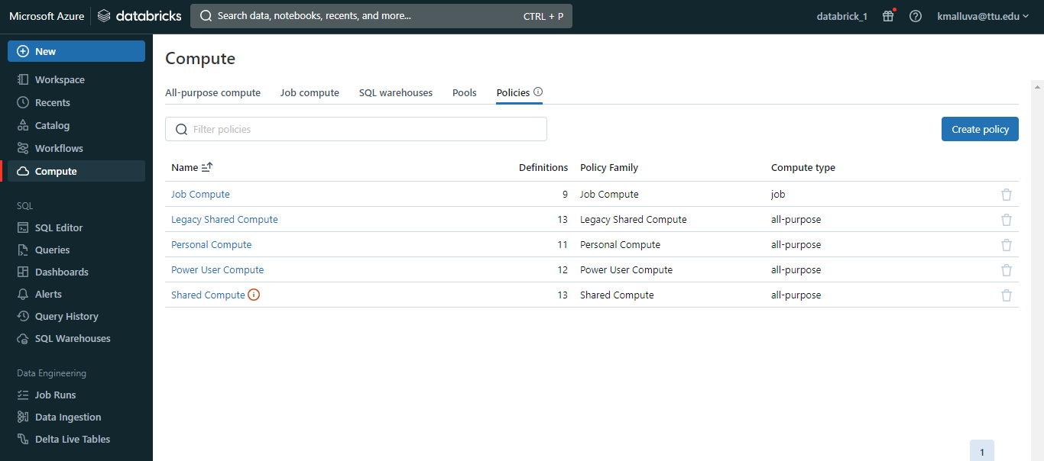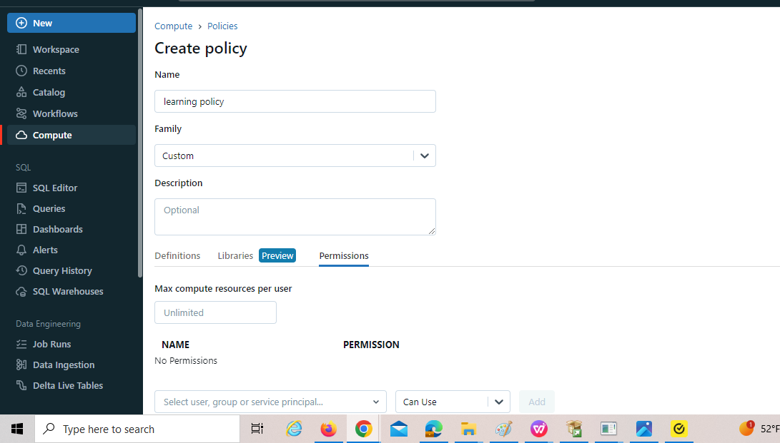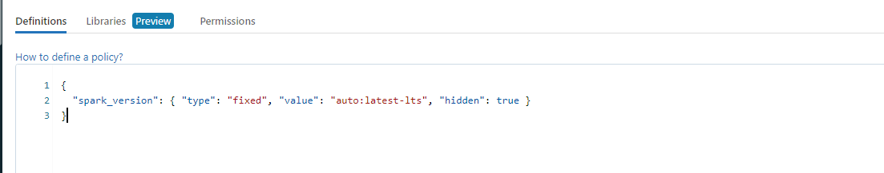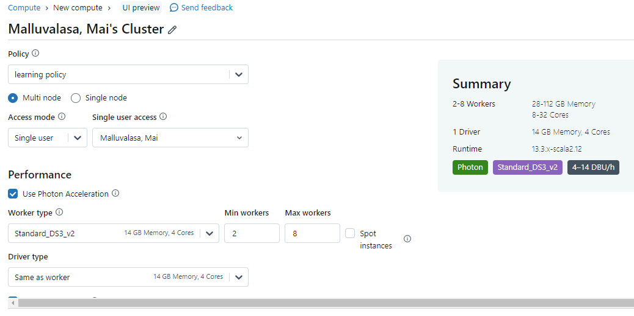{

  "spark_conf.spark.databricks.cluster.profile": {

    "type": "fixed",

    "value": "singleNode",

    "hidden": true

  },

  "node_type_id": {

    "type": "allowlist",

    "values": [

      "Standard_DS3_v2",

      "Standard_D3_v2",

      "Standard_DS12_v2",

      "Standard_D12_v2"

    ],

    "defaultValue": "Standard_DS3_v2"

  },

  "autotermination_minutes": {

    "type": "fixed",

    "value": 20

  },

  "spark_version": {

    "type": "fixed",

    "value": "auto:latest-lts",

    "hidden": true

  },

  "cluster_type": {

    "type": "fixed",

    "value": "all-purpose"

  }

}

Create notebook:

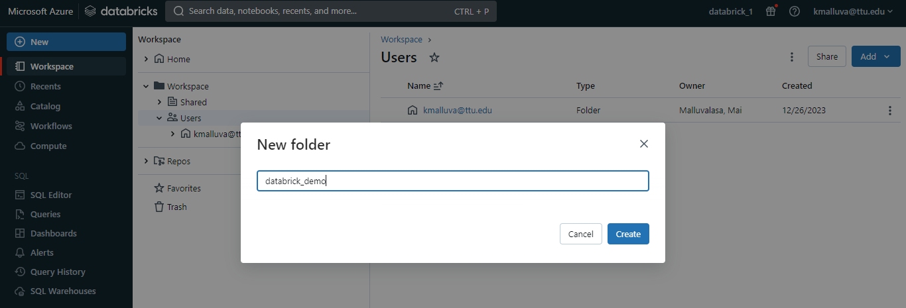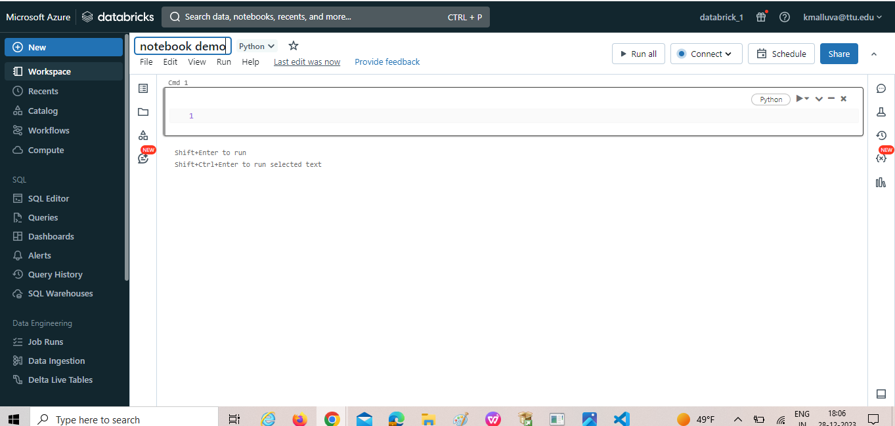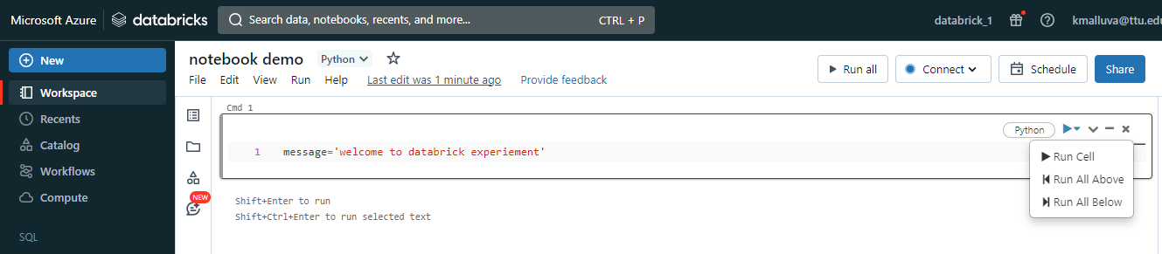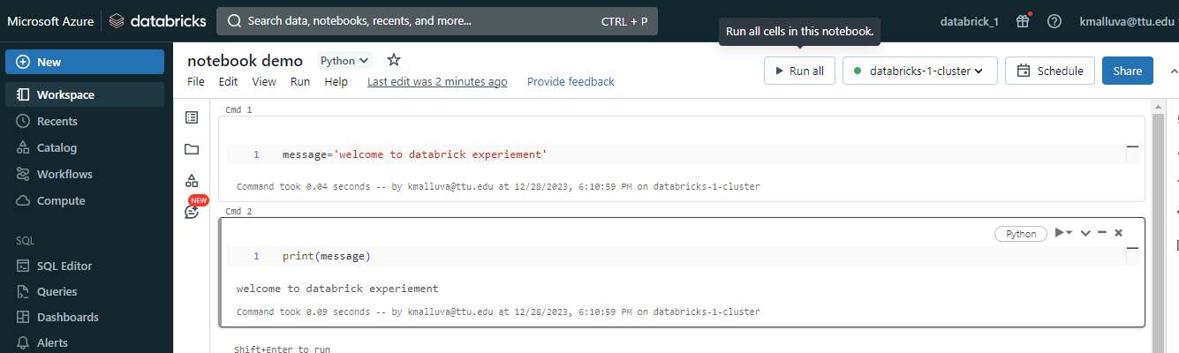to duplicate the notebook:

Click on clone

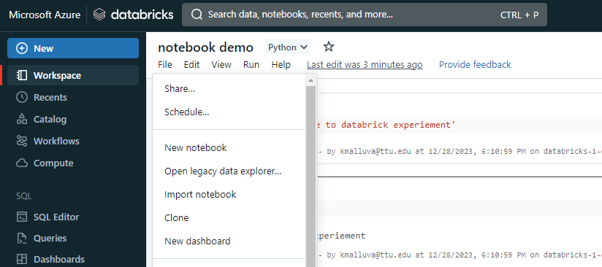duplicate notebook:

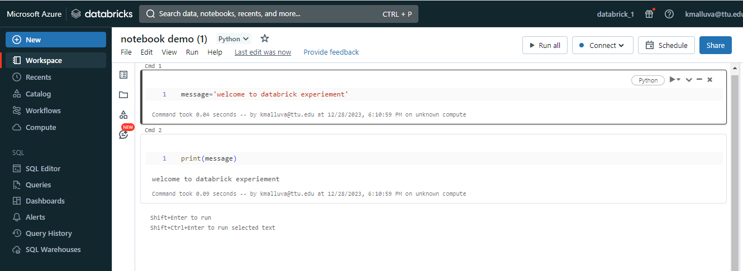

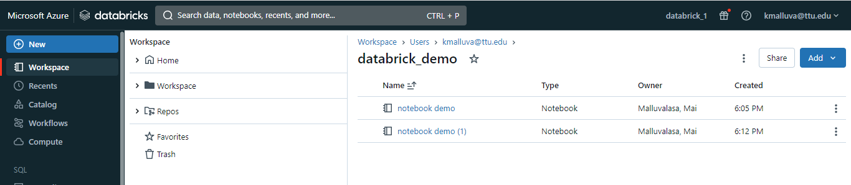

Connected to cluster:



Magic commands:

It is used for moving form one lang to another lang in the notebook (eg: we are using python instead of python you want to move to scala lang this command is used.

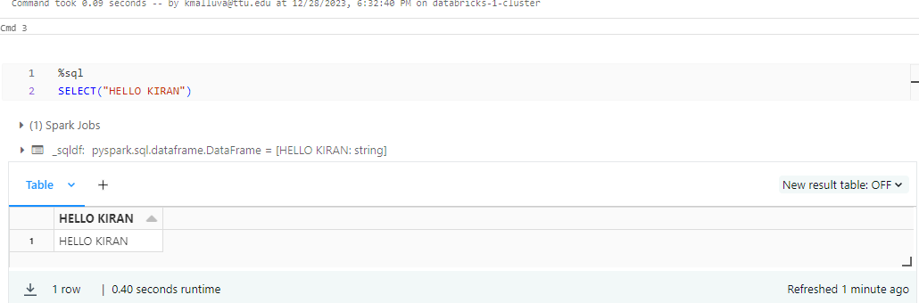

Magic command for listing out file system:

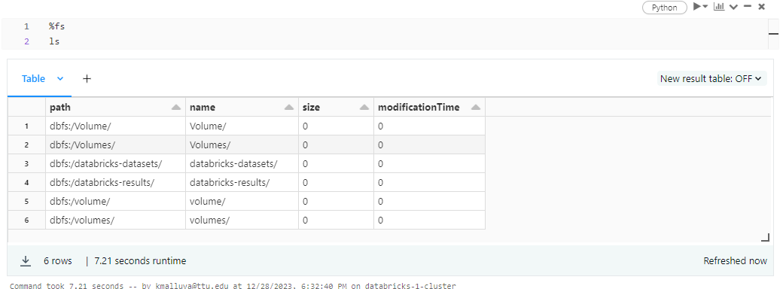

To now what processor are running:

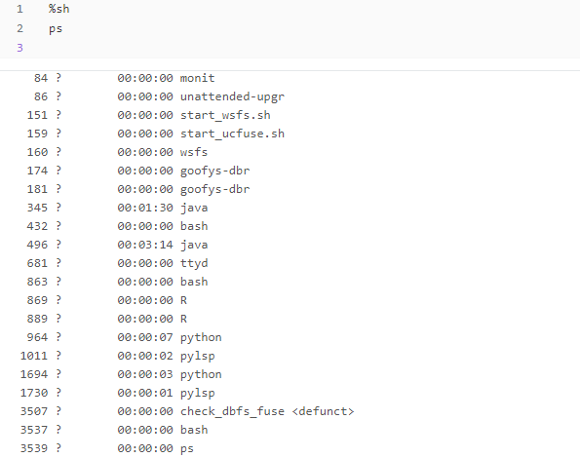

%md

Cell is modified as document

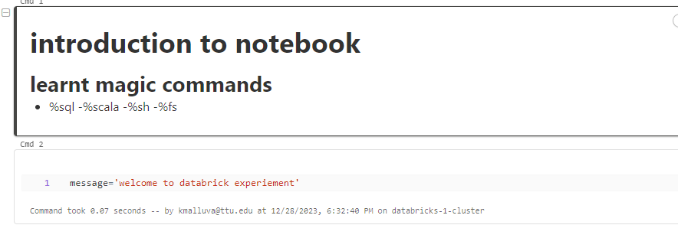

Utilities:

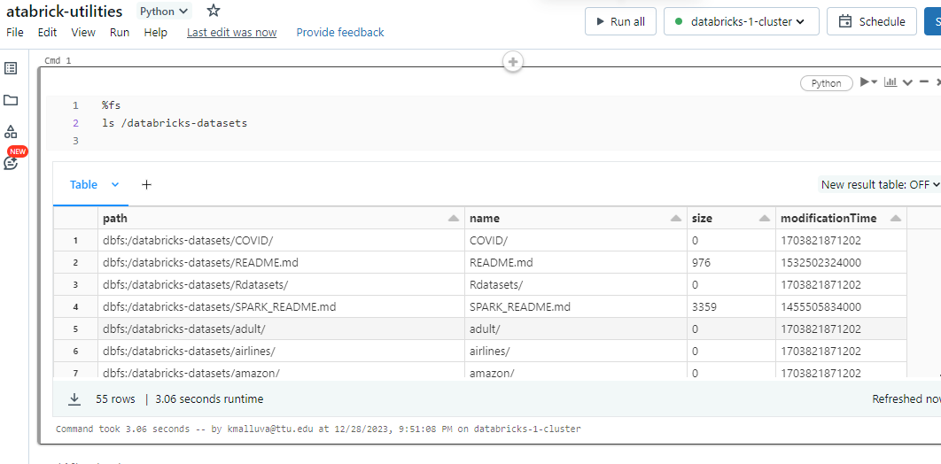

In python:

Dbutils.fs.ls(‘/ ’)

