**OFFICE SEAT BOOKING APP**

**Creating a Web app for Front-end**

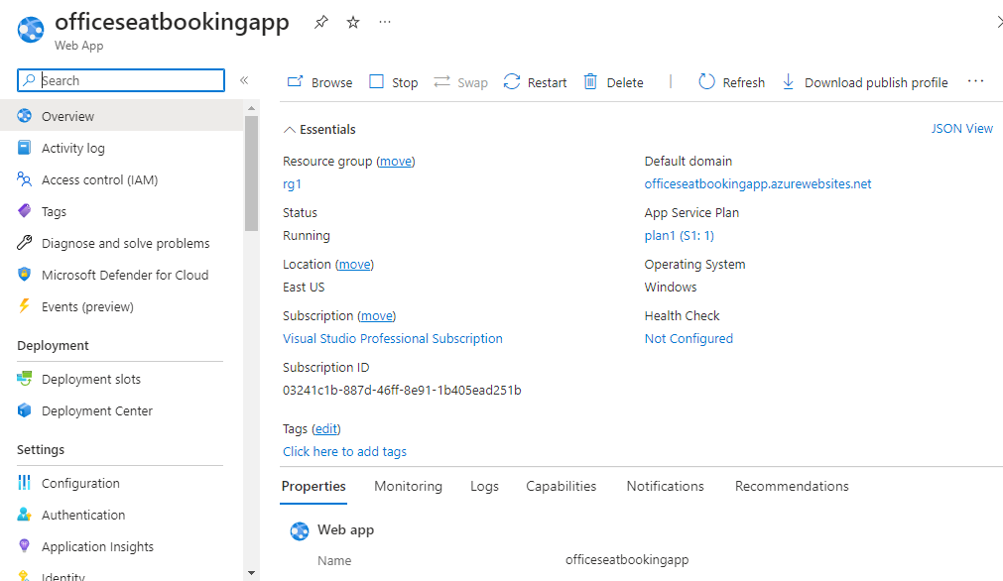

**Creating a Web App for API**

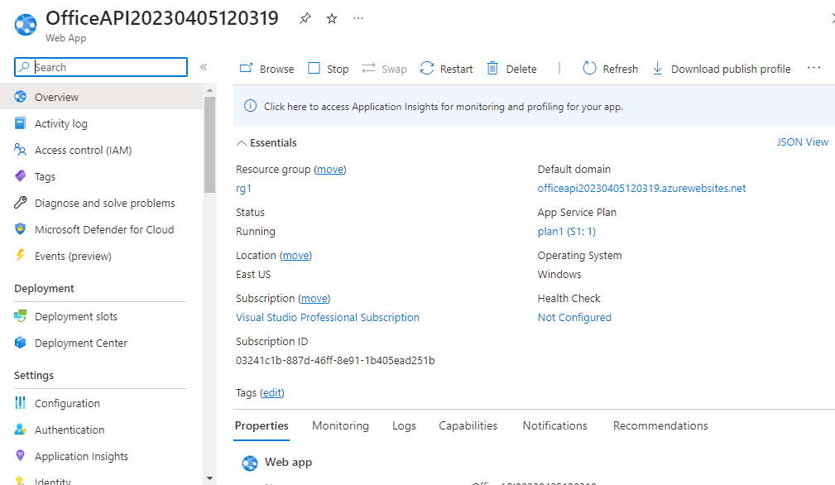

**Azure SQL DataBase and Server**

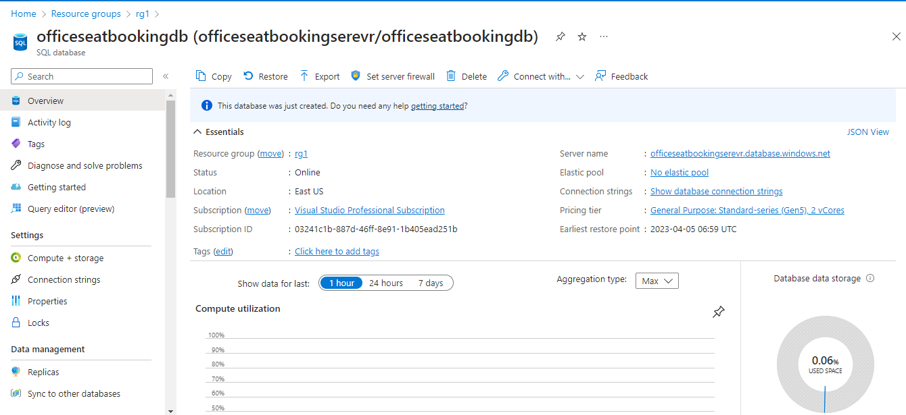

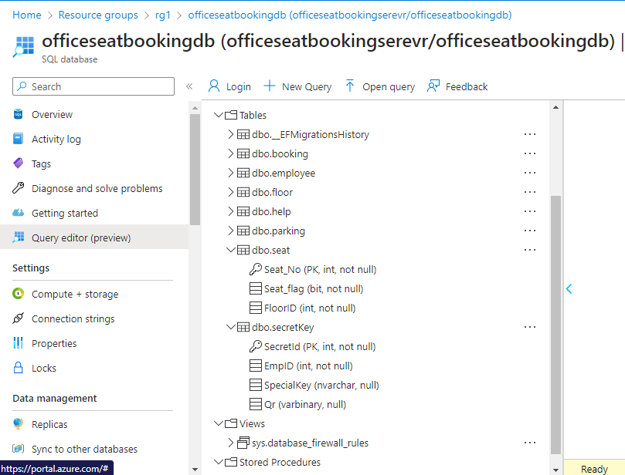

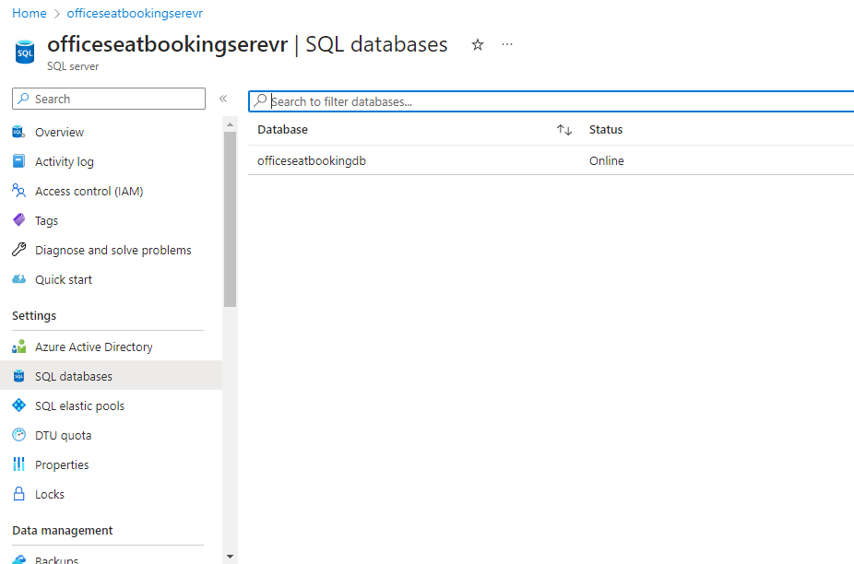

**DevOps:**

**Azure Reops**

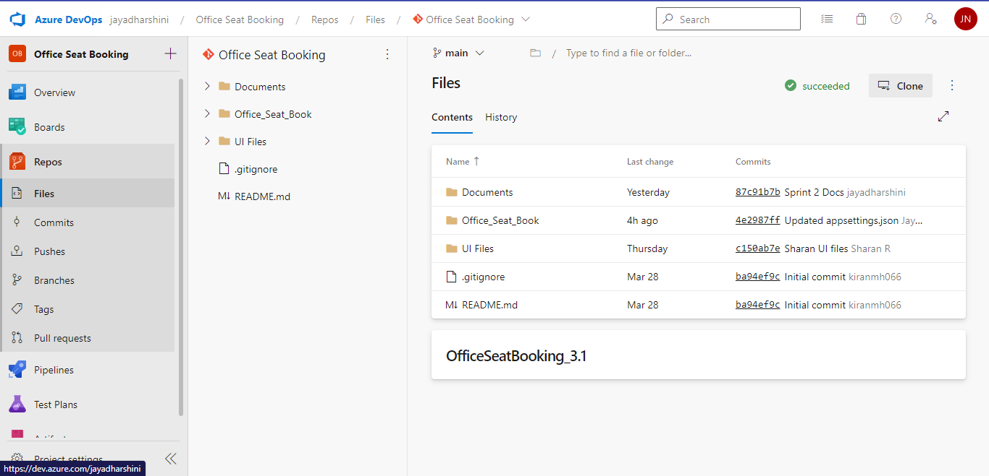

**Build Pipeline**

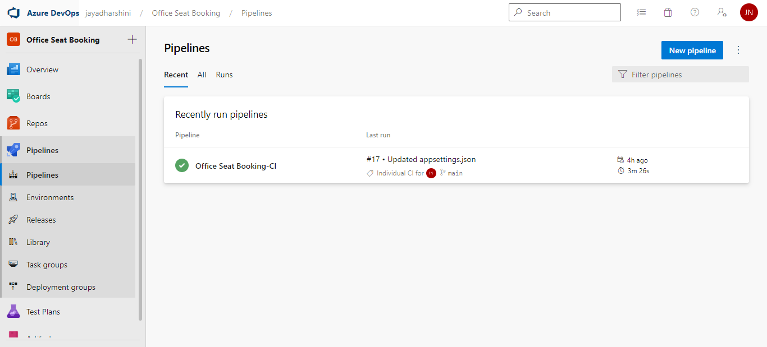

**Release Pipeline**

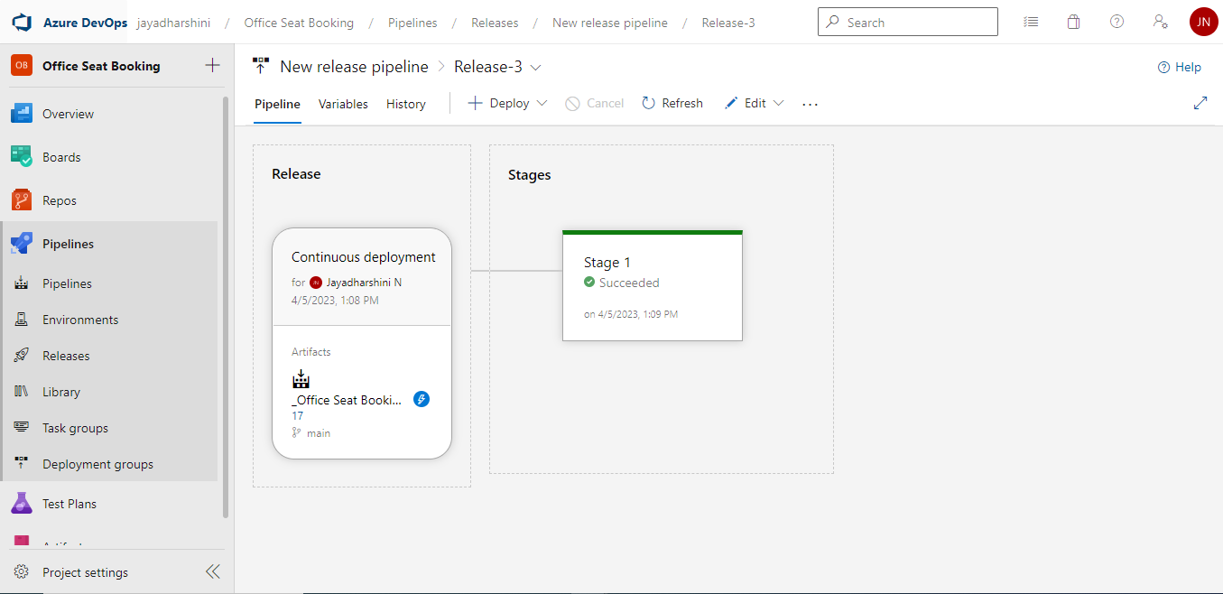

**API**

<https://officeapi20230405120319.azurewebsites.net/swagger>

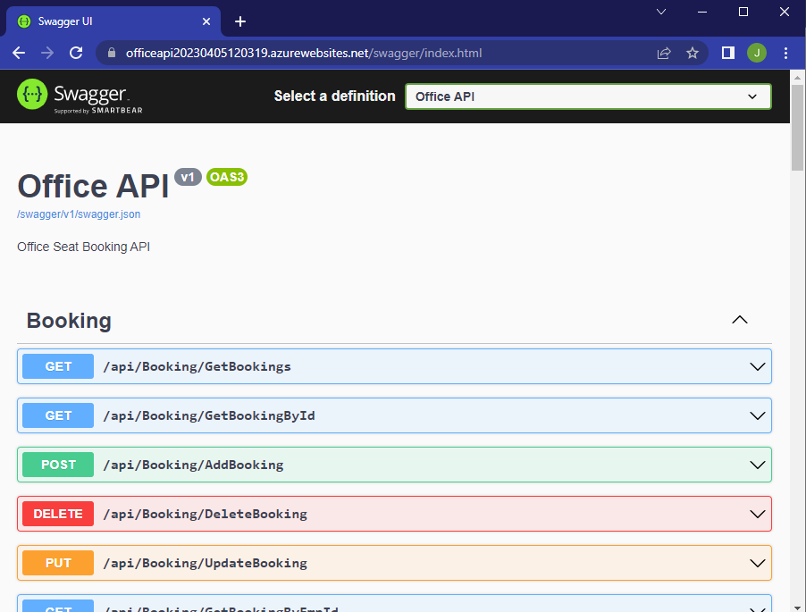

**Deployed web app**

<https://officeseatbookingapp.azurewebsites.net/>

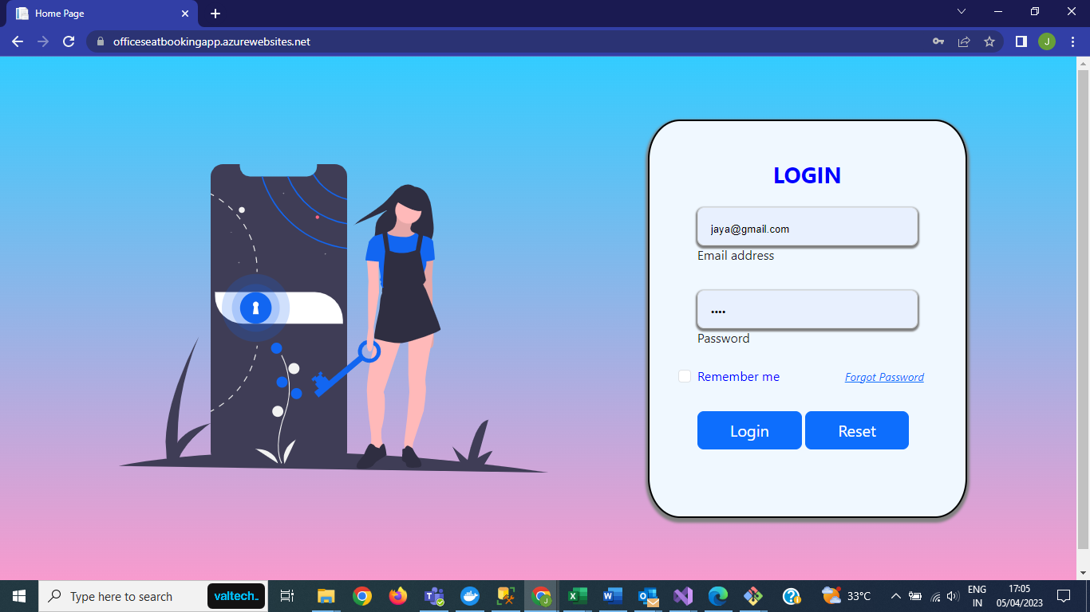

**Working on Kubernetes:**

