**Welcome to Chess!**

CS 3110 Final Project Spring 2024

*Kiran Mitra*

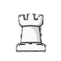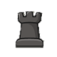

Simply click on a piece to find legal moves and choose one of the highlighted squares to move your piece.

h 🡪 **H**elp b 🡪 back r 🡪 **R**estart

f 🡪 forward q 🡪 **Q**uit

graphics credit: chess.com