Base 2 (binary system) 0 and 1

Binary – Powers of 2

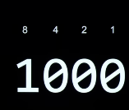

Above example is 4 binary digits or bits

8 Bits = 1 Byte

Like numbers, Alphabets are also assigned numbers….

Examples: A is 65

Computers represent color using a variety of bit patterns, but the core concept revolves around breaking down color into its constituent parts and assigning numerical values to each part

Algorithm: Step by step instructions to solve a problem

Compilers: Convert source code to machine code and vice versa