Data Manipulation Language (DML)

The SQL commands that deals with the manipulation of data present in the database belong to DML or Data Manipulation Language .It is the component of the SQL statement that controls access to data and to the database. Basically, DCL statements are grouped with DML statements.

List of DML commands:

SELECT : It is used to retrieve data from the database.

INSERT : It is used to insert data into a table.

UPDATE: It is used to update existing data within a table.

DELETE : It is used to delete records from a database table.

SELECT: The SELECT command is used to select data from a database. The data returned is stored in a result table, called the result set.

Syntax-
SELECT Column 1,Column 2 FROM Table_name;

Example-
The following SQL statement selects the ‘customer_id’,’first_name’,’last_name’
from the "Customers" table:
SELECT customer_id,first_name,last_name FROM customers;

The following SQL statement selects all the columns from the "customers"
table:
SELECT * FROM customers;

So the asterisk symbol (*) is used in the SELECT statement in SQL to denote that all columns of a table should be selected.

INSERT : The INSERT INTO command is used to insert new rows in a table.

Syntax : The following SQL inserts a new record in the "customers" table.
INSERT INTO customers (first_name, last_name, email) INSERT
VALUES ('John', 'Doe', 'johndoe@email.com');

Example-

Now lets INSERT all our records in customers table.

INSERT INTO customers (customer_id, first_name, last_name, email, address_id) VALUES
(1, 'Mary', 'Smith', 'mary.smith@mailid.com', 5),
(2, 'Patricia', 'Johnson', 'patricia.johnson@mailid.com', 6),
(3, 'Madan', 'Mohan', 'madan.mohan@mailid.com', 7),
(4, 'Barbara', 'Jones', 'barbara.jones@mailid.com', 8),
(5, 'Elizabeth', 'Brown', 'elizabeth.brown@mailid.com', 9),
(6, 'Jennifer', 'Davis', 'jennifer.davis@mailid.com', 10),
(7, 'Maria', 'Miller', 'maria.miller@mailid.com', 11),
(8, 'Susan', 'Wilson', 'susan.wilson@mailid.com', 12),
(9, 'R', 'Madhav', 'r.madhav@mailid.com', 13),
(10, 'Dorothy', 'Taylor', 'dorothy.taylor@mailid.com', 14),
(11, 'Lisa', 'Anderson', 'lisa.anderson@mailid.com', 15),
(12, 'Nancy', 'Thomas', 'nancy.thomas@mailid.com', 16),
(13, 'Karen', 'Jackson', 'karen.jackson@mailid.com', 17),
(14, 'Betty', 'White', 'betty.white@mailid.com', 18),
(15, 'Helen', 'Harris', 'helen.harris@mailid.com', 19);

Output-This will create our “customers” Table.
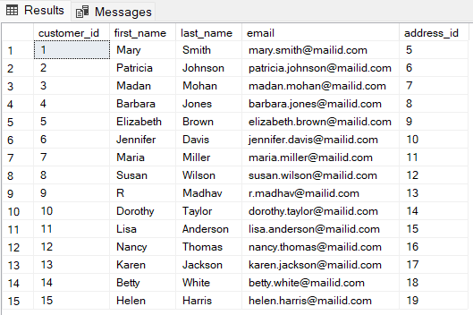

UPDATE – The UPDATE statement in SQL is used to update the data of an existing table in database. We can update single columns as well as multiple columns using UPDATE statement as per our requirement.

Syntax-
UPDATE table_name SET column1 = value1, column2 = value2,...
WHERE condition
table_name: name of the table
column1: name of first , second, third column....
value1: new value for first, second, third column....
condition: condition to select the rows for which the
values of columns needs to be updated ;

Example- Now set email = 'email@example.com' in customers table where
‘customer_id ‘ is 1
UPDATE customers
SET email = 'email@example.com'
WHERE customer_id = 1;

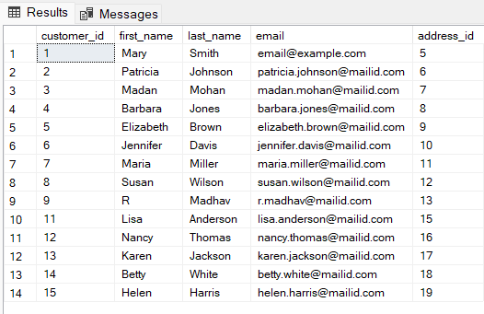
Output-

DELETE- Existing records in a table can be deleted using the SQL DELETE Statement. We can delete a single record or multiple records depending on the condition we specify in the WHERE clause.

Syntax-
DELETE FROM table_name WHERE some_condition
table_name: name of the table;

Example- Now delete from customers table where ‘address_id’ is 14
DELETE FROM customers
WHERE address_id = 14;

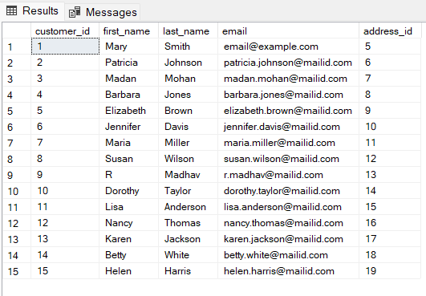
Output-

.

