Useful commands:

git init

git add (to add the file to staging area)

git status (to find the current status of the project)

git commit (to add file from staging area for checkpoint)

workflow: -

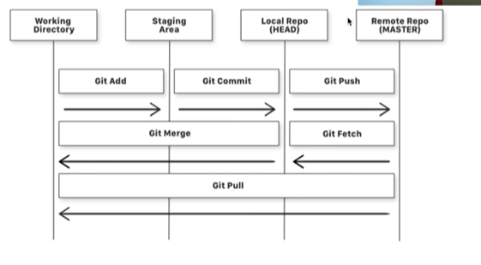

Branching:

git branch ‘branchname’ (to make a new branch)

git checkout ‘branchname’

move to master branch: git merge branchname (branchname branch will be merged to master or to the branch in which you are currently in)

teaching

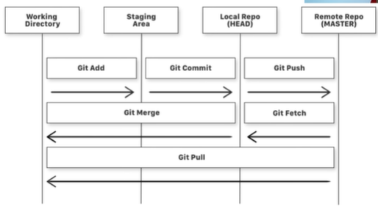

git ignore

make a file .gitignore

add name of the files which you don’t want to add to the server in the .gitignore.