## Python Identifiers

A Python identifier is a name used to identify a variable, function, class, module or other object. An identifier starts with a letter A to Z or a to z or an underscore (_) followed by zero or more letters, underscores and digits (0 to 9).

Python does not allow punctuation characters such as @, $, and % within identifiers. Python is a case sensitive programming language. Thus, **Test** and **test** are two different identifiers in Python.

Here are naming conventions for Python identifiers −

* Class names start with an uppercase letter. All other identifiers start with a lowercase letter.
* Starting an identifier with a single leading underscore indicates that the identifier is private.
* Starting an identifier with two leading underscores indicates a strongly private identifier.
* If the identifier also ends with two trailing underscores, the identifier is a language-defined special name.

## Lines and Indentation

Python provides no braces to indicate blocks of code for class and function definitions or flow control. Blocks of code are denoted by line indentation, which is rigidly enforced.

The number of spaces in the indentation is variable, but all statements within the block must be indented the same amount. For example −

if True:

print "True"

else:

print "False"

However, the following block generates an error −

if True:

print "Answer"

print "True"

else:

print "Answer"

print "False"

Thus, in Python all the continuous lines indented with same number of spaces would form a block.

**Note** − Do not try to understand the logic at this point of time. Just make sure you understood various blocks even if they are without braces.

.

## Reserved Words -

The following list shows the Python keywords. These are reserved words and you cannot use them as constant or variable or any other identifier names. All the Python keywords contain lowercase letters only.

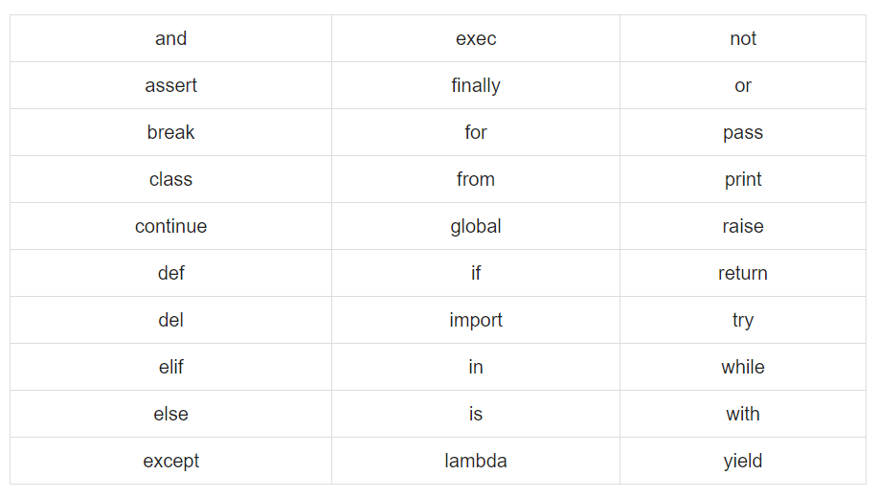

## Multi-Line Statements

Statements in Python typically end with a new line. Python does, however, allow the use of the line continuation character (\) to denote that the line should continue. For example −

total = item_one + \

item_two + \

item_three

Statements contained within the [], {}, or () brackets do not need to use the line continuation character. For example −

days = ['Monday', 'Tuesday', 'Wednesday',

'Thursday', 'Friday']

## Quotation in Python

Python accepts single ('), double (") and triple (''' or """) quotes to denote string literals, as long as the same type of quote starts and ends the string.

The triple quotes are used to span the string across multiple lines. For example, all the following are legal −

word = 'word'

sentence = "This is a sentence."

paragraph = """This is a paragraph. It is

made up of multiple lines and sentences."""

## Comments in Python

A hash sign (#) that is not inside a string literal begins a comment. All characters after the # and up to the end of the physical line are part of the comment and the Python interpreter ignores them.

#!/usr/bin/python

# First comment

print "Hello, Python!" # second comment

This produces the following result −

Hello, Python!

You can type a comment on the same line after a statement or expression −

name = "Madisetti" # This is again comment

You can comment multiple lines as follows −

# This is a comment.

# This is a comment, too.

# This is a comment, too.

# I said that already.

Following triple-quoted string is also ignored by Python interpreter and can be used as a multiline comments:

'''

This is a multiline

comment.

'''