**Multi-threading in Python**

**Definition -: Multithreading** is defined as the ability of a processor to execute multiple threads concurrently.

In computing, a **process** is an instance of a computer program that is being executed. Any process has 3 basic components:

* An executable program.
* The associated data needed by the program (variables, work space, buffers, etc.)
* The execution context of the program (State of process)

A **thread** is an entity within a process that can be scheduled for execution. Also, it is the smallest unit of processing that can be performed in an OS (Operating System).

In simple words, a **thread** is a sequence of such instructions within a program that can be executed independently of other code. For simplicity, you can assume that a thread is simply a subset of a process!

* To import the threading module, we do:
* import threading
* To create a new thread, we create an object of **Thread** class. It takes following arguments:
  + **target**: the function to be executed by thread
  + **args**: the arguments to be passed to the target function

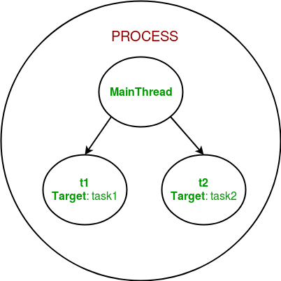

**Example -:**