Parking Lot

The basic purpose of the project is to create parking lot, when a vehicle enters the parking lot the nearest empty position is allocated to the vehicle, and when the vehicle leaves, the slot is made empty and ready for next vehicle to occupy this place. Also, we get various details of vehicle based on request for example registration number based on color and slot number.

Structure of the Project:

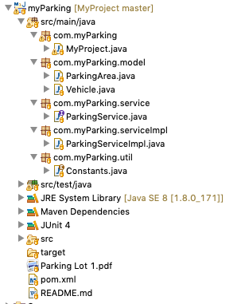

Flow Diagram: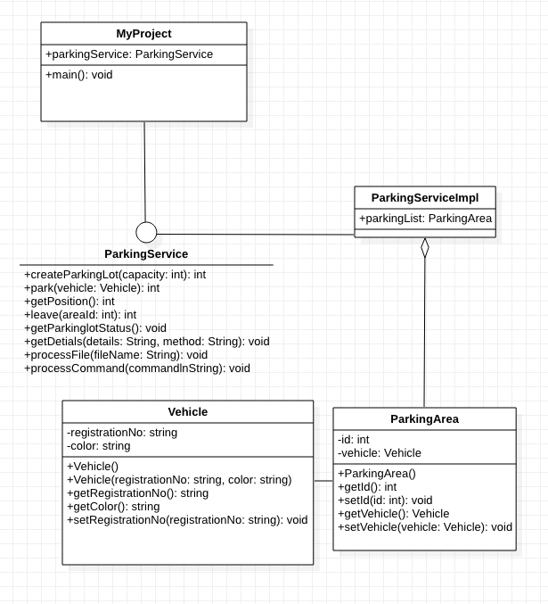

Model/POJO classes:

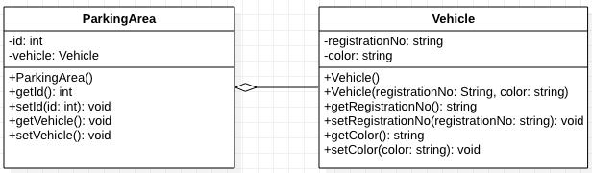

Vehicle Class:

Vehicle Class stores the data of a vehicle, here the attributes are registrationNo and color. Constructor, getters and setters also given.

Parking Area Class:

Parking Area class manages the slot numbers and the vehicle parked in that particular slot.

ParkingService:

createParkingLot: create new parking lot with the capacity given by user. If already created, the existing parking lot is updated with new capacity.

Park: park method is used to park the vehicle in the allotted slot.

getPosition: using this method we get the vacant slot available which is nearest to the entry.

Leave: when a vehicle leaves the parking lot, the slot becomes empty.

getSlotDetials: gives status of the parking lot, slot number, vehicle registration number and vehicle color are print.

getDetails: based on color, registration number and slot number details are fetched.

ProcessFile: process input file

processCommand: process command entered by user and maps to the method.

Code Coverage:

