Screenshots of Use Cases

1. Display Welcome Message:

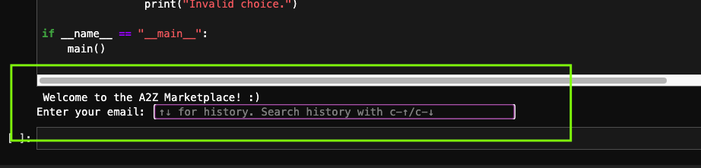

1. User Login Success and Fail

1. Display Categories, Product / Add Product to Cart / View Cart

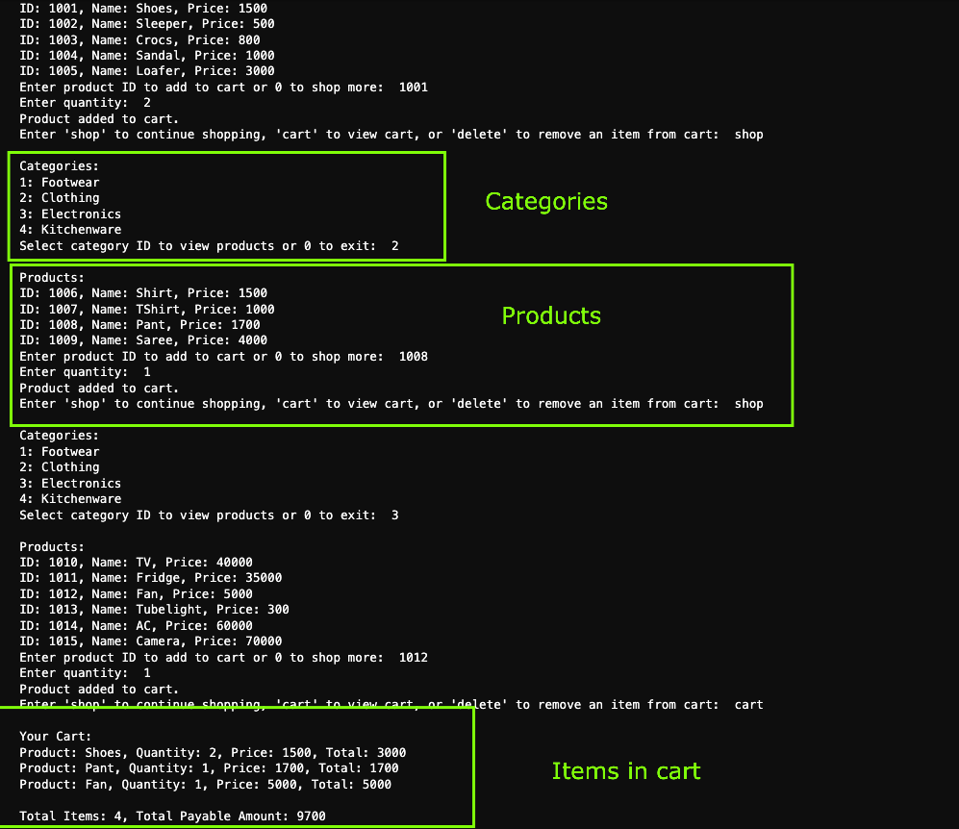

1. Choose the Payment method and checkout/order placed

1. Remove unrequired items from cart

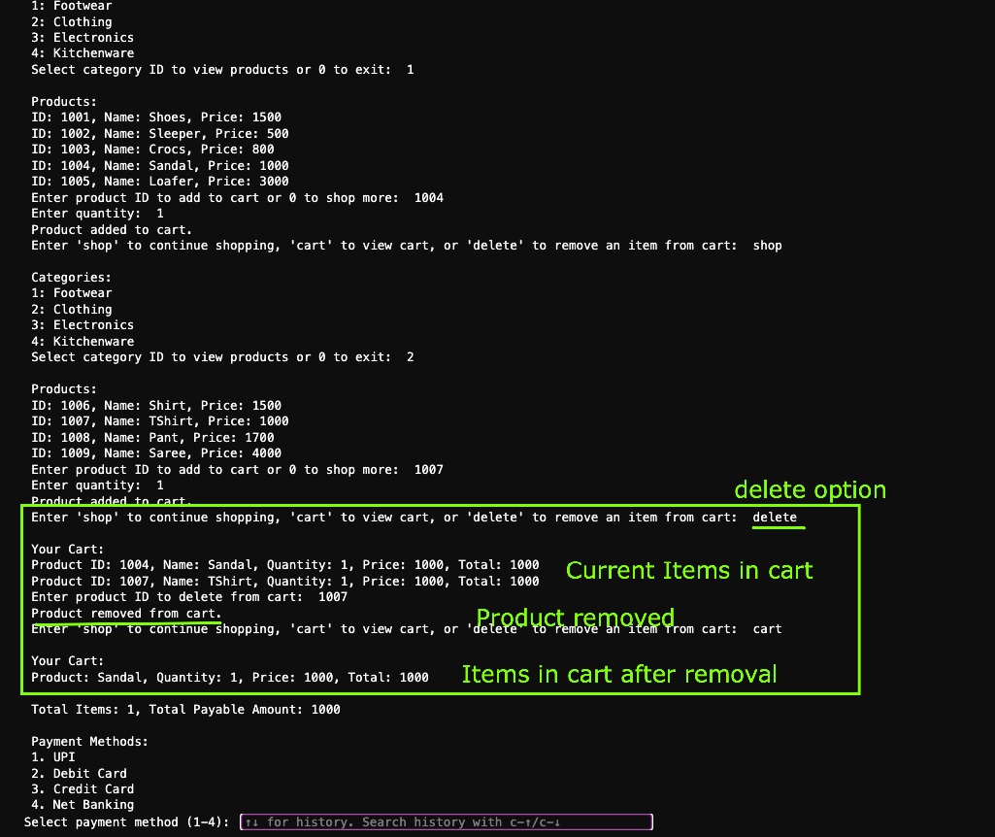

1. Admin logins fail and login passes and view available Admin actions

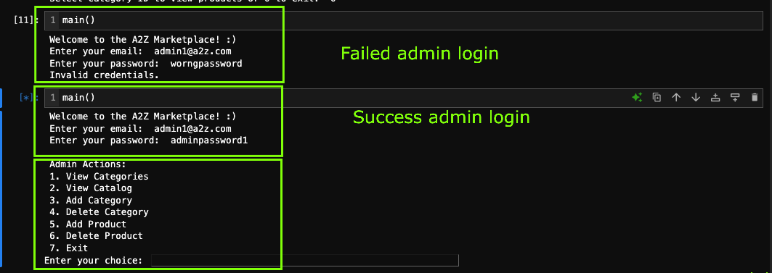

1. View available Categories and Products as Admin

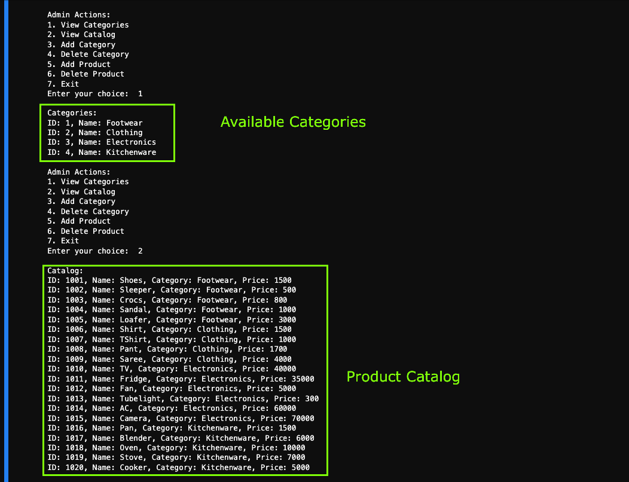

1. Add a new Category as admin

1. Add new products in catalog

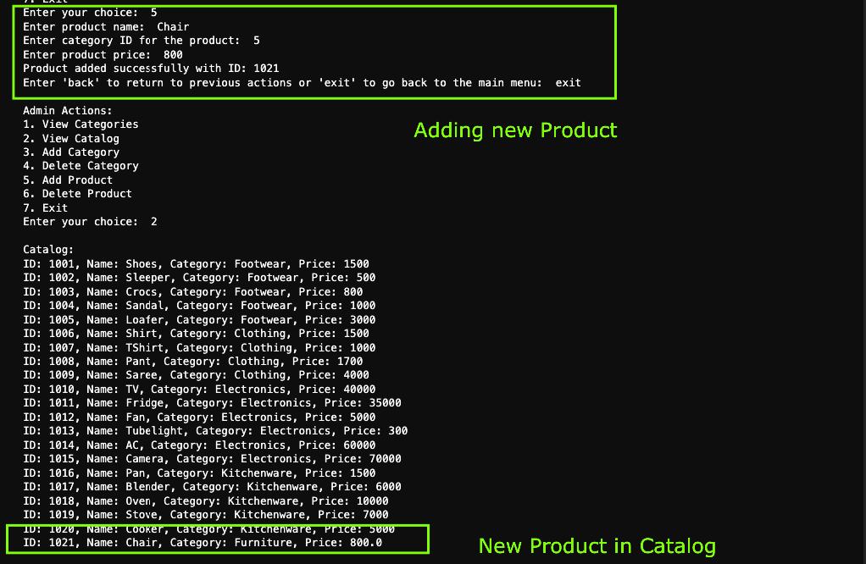

1. Delete product from Catalog as admin

1. Delete Category as admin

