ASSIGNMENT
Name: KIRAN PAVAN PAMIDI
Course: CSEB02
Enrollment No.: 260102006
Assignment: CO2_A3 Sentiment Analysis

Sentiment Analysis Pipeline with Social Media Data
Unit 2 – Activity 3

1. Introduction and Objective
The objective of this activity is to build an end-to-end sentiment analysis pipeline for large text datasets: acquiring data, preparing the text, classifying sentiment, running the analysis in a distributed environment, and interpreting the results responsibly. The pipeline was implemented with Python and Hadoop Streaming on a multi-node Hadoop cluster (master node and worker nodes with HDFS and YARN).
Two datasets were processed using the same MapReduce design (mapper → combiner/sort → reducer):
- News dataset: technology news headlines collected through the NewsAPI service. Sentiment is computed with TextBlob polarity scores (Positive, Negative, Neutral).
- Twitter dataset: a large labelled tweet file (about 1.6 million tweets, 238 MB) in which each record carries a sentiment label (0 = negative, 4 = positive). The pipeline counts tweets per sentiment class at scale.
All screenshots below are shown in the order the work was carried out: the news pipeline first, followed by the Twitter pipeline.

Part A – News Dataset Pipeline

A.1 Task 1: Data Acquisition
Data was collected programmatically using the Python requests library against the NewsAPI "everything" endpoint with the query "technology" and a page size of 100. The script authenticates with an API key, parses the JSON response, extracts the headline (title) of every article, and stores the headlines in a single-column CSV file (news_data.csv) using pandas. The script prints the number of headlines saved. The API key has been hidden in the screenshot below for security.
Because the free NewsAPI plan limits the number of results per request, a single request returns at most 100 articles, so the dataset is small. Larger collections would require paging through results, respecting the daily request limit, and waiting or retrying when the rate limit is reached.
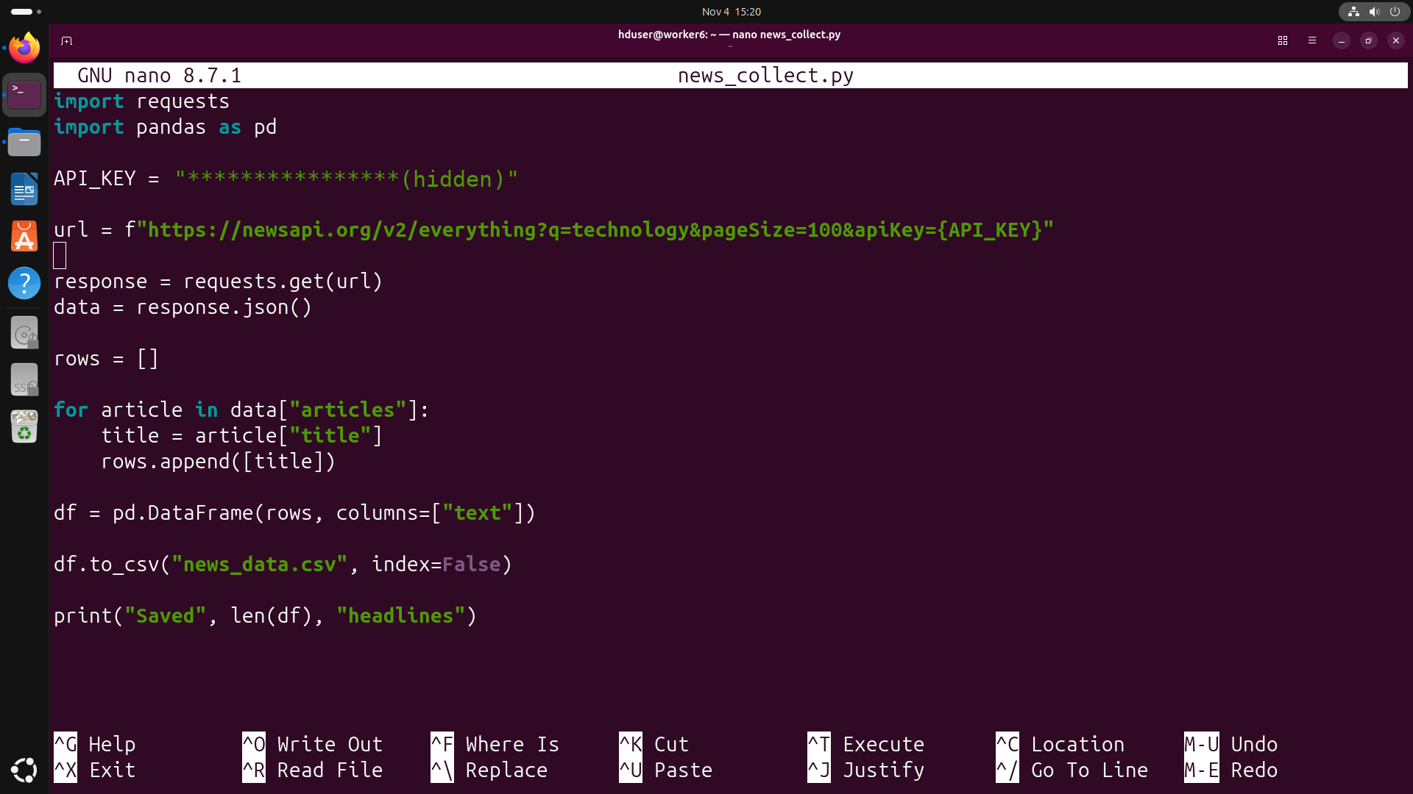
Figure 1: Data acquisition script (news_collect.py) using the NewsAPI endpoint
The first rows of the collected file are shown below. The file has a header line (text) followed by one headline per row.
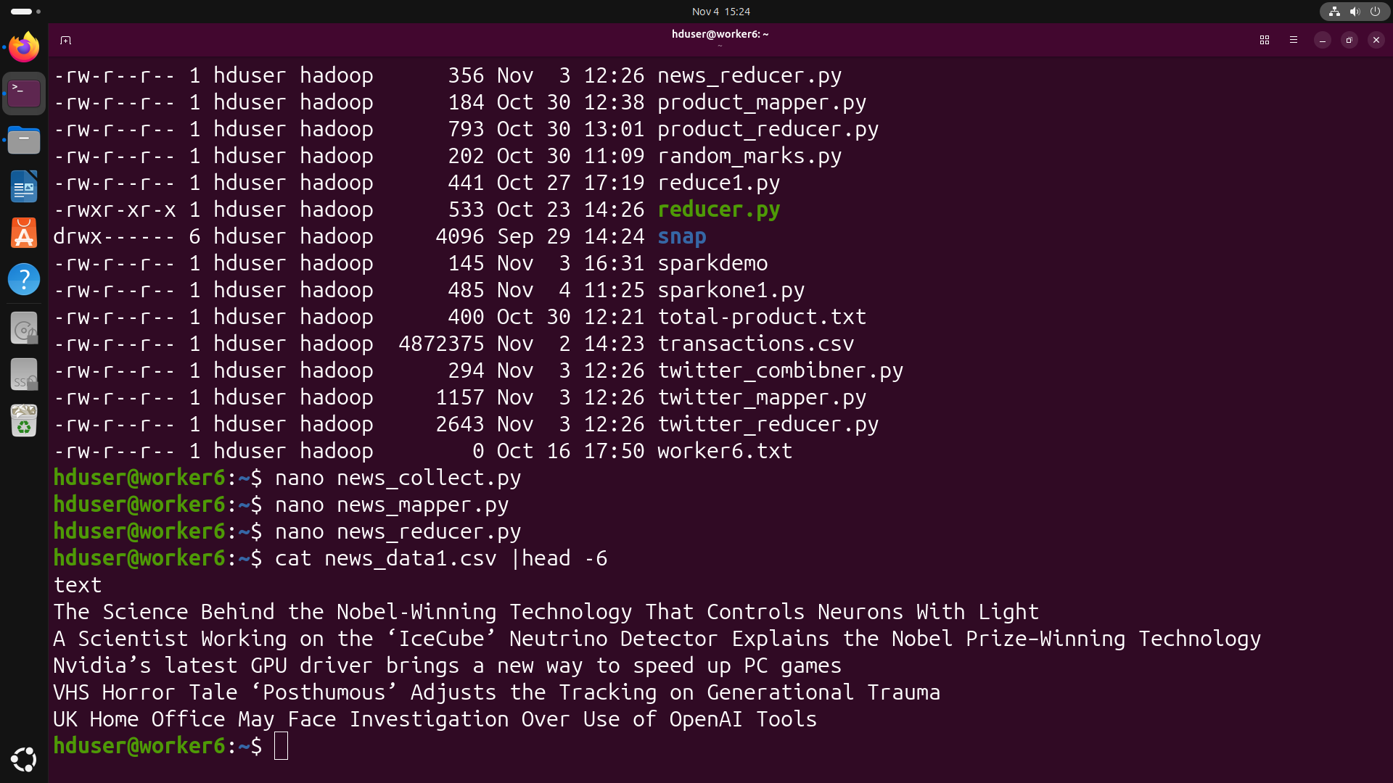
Figure 2: Collected news dataset (news_data1.csv) viewed with head

A.2 Tasks 2 and 3: Preprocessing and Sentiment Modelling
The mapper (news_mapper.py) reads headlines from standard input and performs light preprocessing: it skips the CSV header line, strips surrounding whitespace, and ignores empty lines. Each headline is then scored with TextBlob, a rule-based (lexicon-based) sentiment method that returns a polarity value between -1 and +1. A polarity above 0 is labelled Positive, below 0 is Negative, and exactly 0 is Neutral. The mapper emits the pair "label<TAB>1" for every headline.
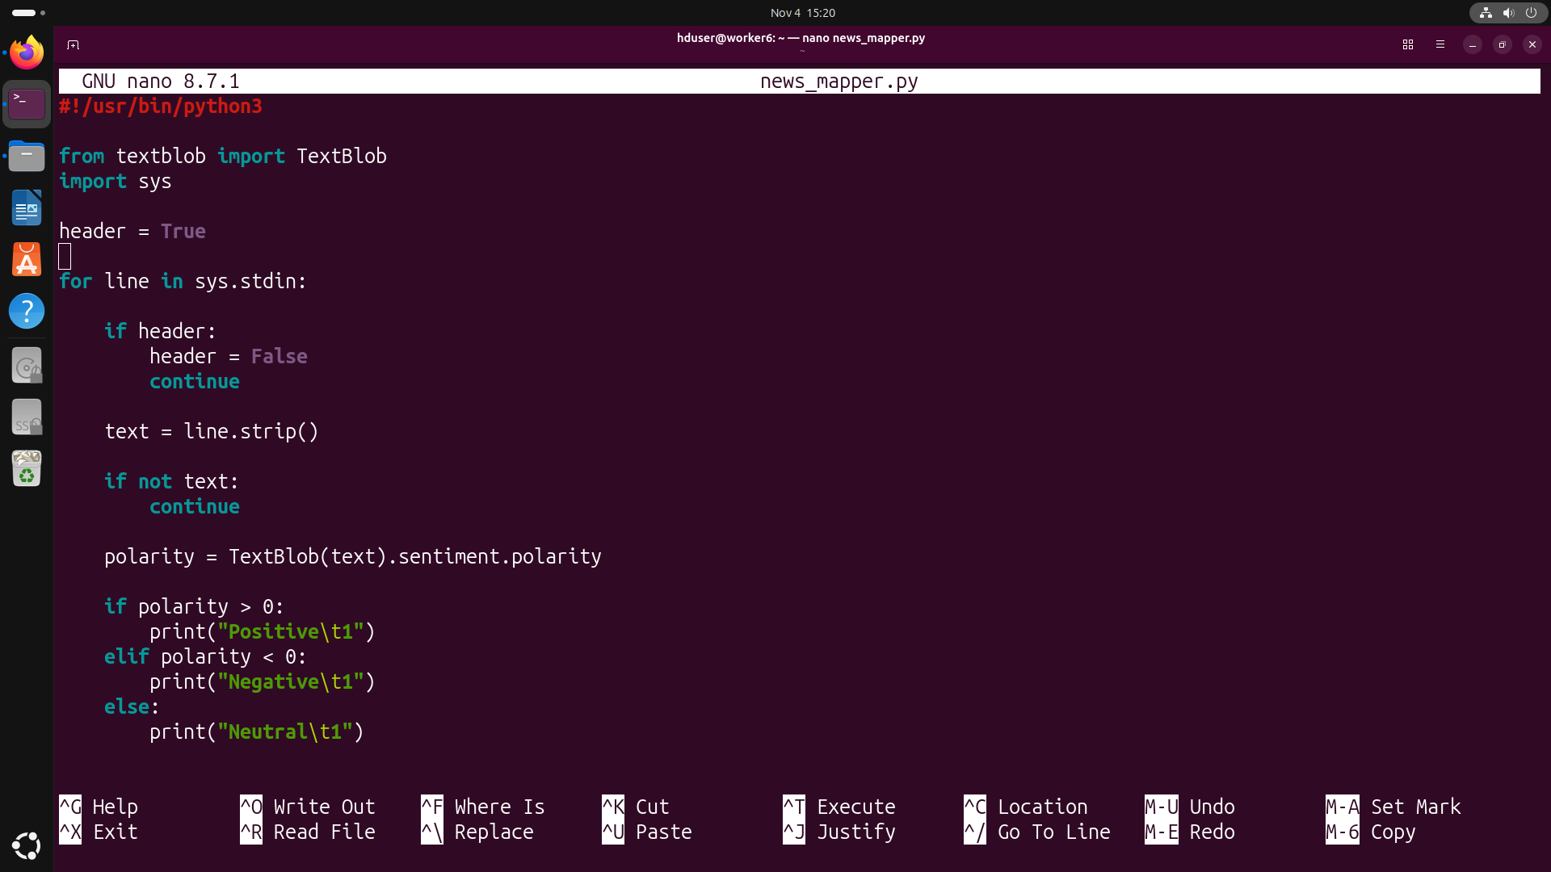
Figure 3: Mapper script (news_mapper.py) – TextBlob polarity classification
The reducer (news_reducer.py) receives the key-sorted output of the mapper. It keeps a running total for the current key, and whenever the key changes it prints the finished total, which gives the number of headlines per sentiment class.
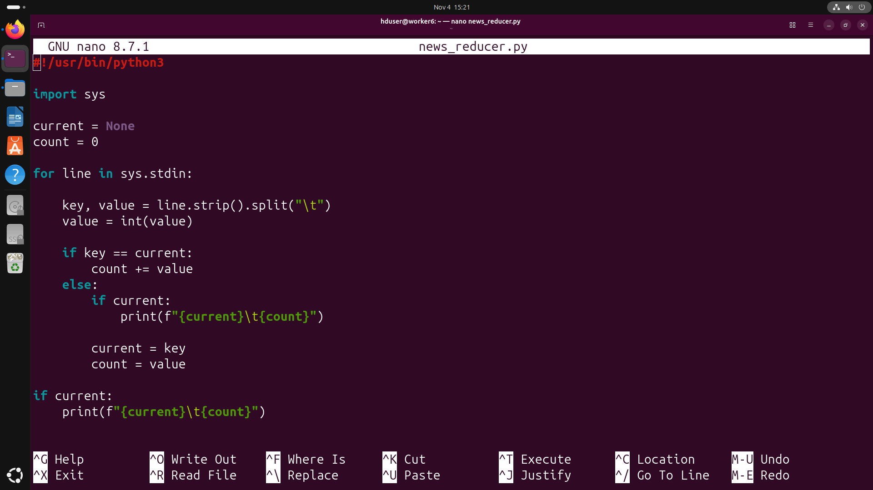
Figure 4: Reducer script (news_reducer.py) – aggregates counts per sentiment label
Before running on Hadoop, the mapper was tested on its own on the local machine. Every headline produces one line of the form "Sentiment 1", which confirms that the classification step works.
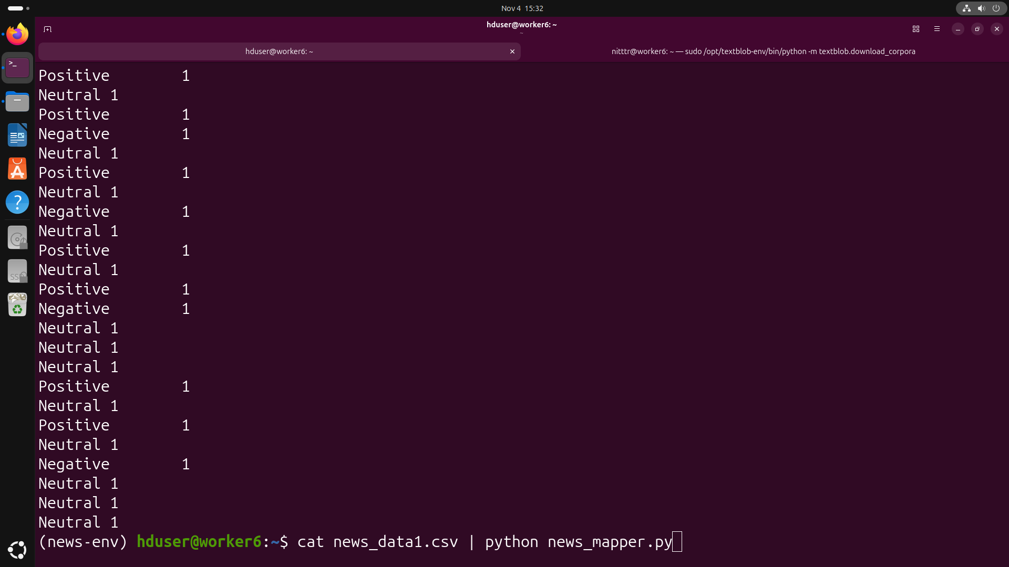
Figure 5: Local test of the mapper: cat news_data1.csv | python news_mapper.py
The complete pipeline (mapper → sort → reducer) was then tested locally. The result was Negative = 10, Neutral = 37 and Positive = 25 headlines.
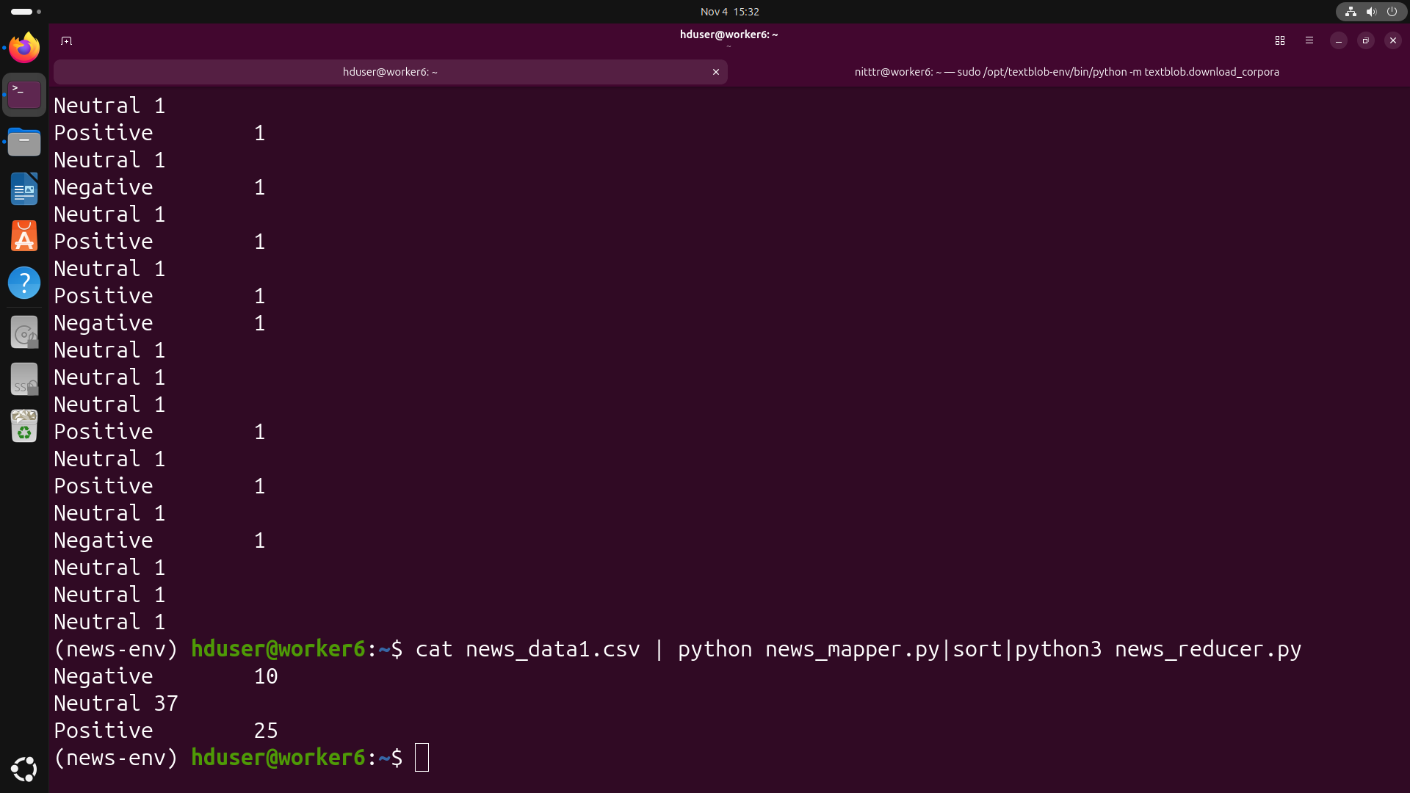
Figure 6: Local test of the full pipeline: mapper | sort | reducer

A.3 Task 4: Distributed Execution on Hadoop
The same scripts were submitted to the cluster with Hadoop Streaming (hadoop-streaming-3.3.6.jar). The mapper and reducer scripts and a zipped Python environment (myenv.zip, which provides TextBlob to the worker nodes) were shipped with the -files option. The input file was read from HDFS (/newsdata/newsdata_kiran.csv) and the output was written to /newsdata/output_k1. The job was split into 2 input splits, ran on YARN, reached map 100% and reduce 100%, and completed successfully in roughly 23 seconds.
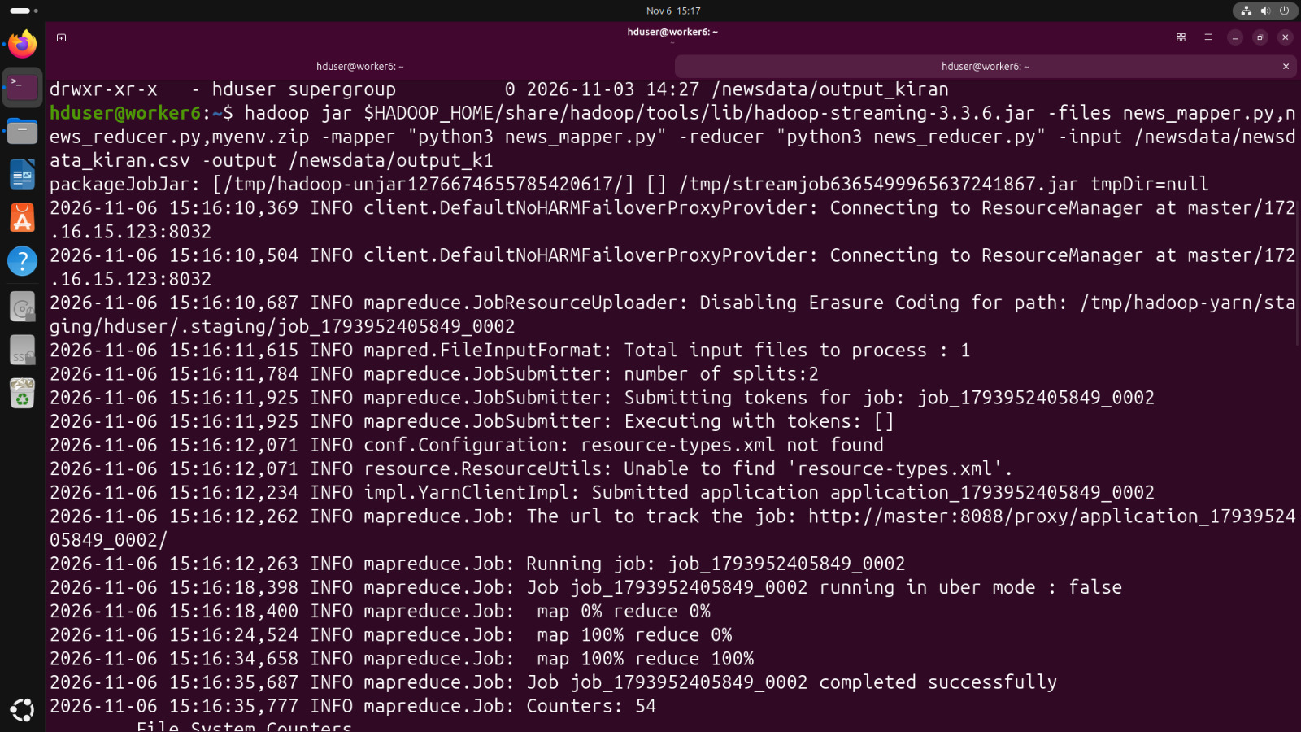
Figure 7: Hadoop Streaming job execution for the news dataset (job completed successfully)
The HDFS listing shows the output directory contains a _SUCCESS marker and the result file part-00000 (35 bytes). Reading the file with hdfs dfs -cat gives Negative = 10, Neutral = 37 and Positive = 24. (The first attempt to read the file used a mistyped name, "park-00000", and failed; the corrected command succeeded.)
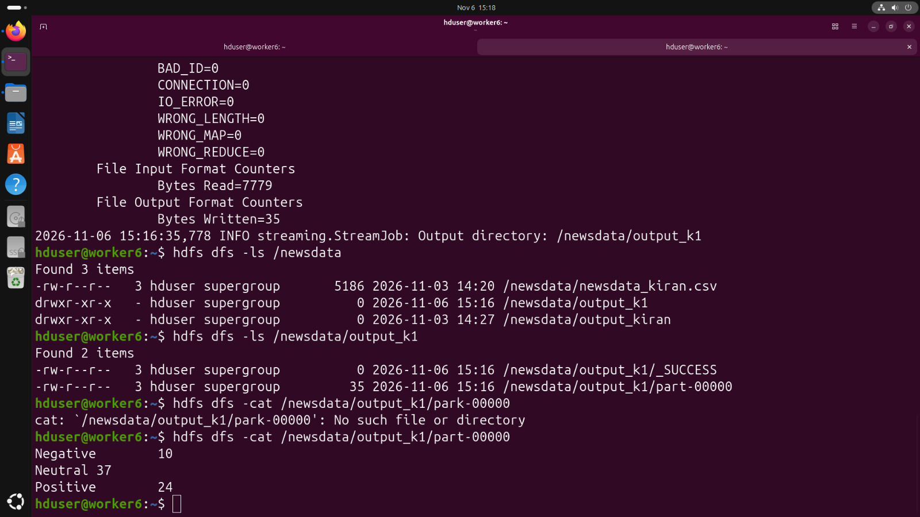
Figure 8: Output of the news job stored in HDFS (/newsdata/output_k1)
Observation: the Hadoop result shows 24 Positive headlines, while the local run showed 25. A likely reason is that the mapper skips the first line it receives as a "header". Locally there is one input stream, so only the real header is skipped. On Hadoop the file was divided into 2 splits and each mapper runs the same logic, so the first line of the second split is also skipped and one headline is lost. This could be fixed by skipping only a line that equals the header text ("text") instead of the first line of each split.

Part B – Twitter Dataset Pipeline

B.1 Task 1: Data Acquisition and Loading into HDFS
For the Twitter experiment a pre-collected, labelled dataset of about 1.6 million tweets (twitter_k.csv, 238,803,811 bytes) was used instead of live streaming. Each record contains the sentiment label, tweet ID, timestamp, query flag, username and tweet text. The file was inspected with head and then copied to HDFS with hdfs dfs -mkdir /twitter and hdfs dfs -put. The HDFS listing confirms the file is stored in /twitter. Because Twitter/Reddit API access is rate-limited and restricted, using a ready-made large dataset makes it possible to test scalability on millions of records; Tweepy or PRAW would be the tools for live collection.
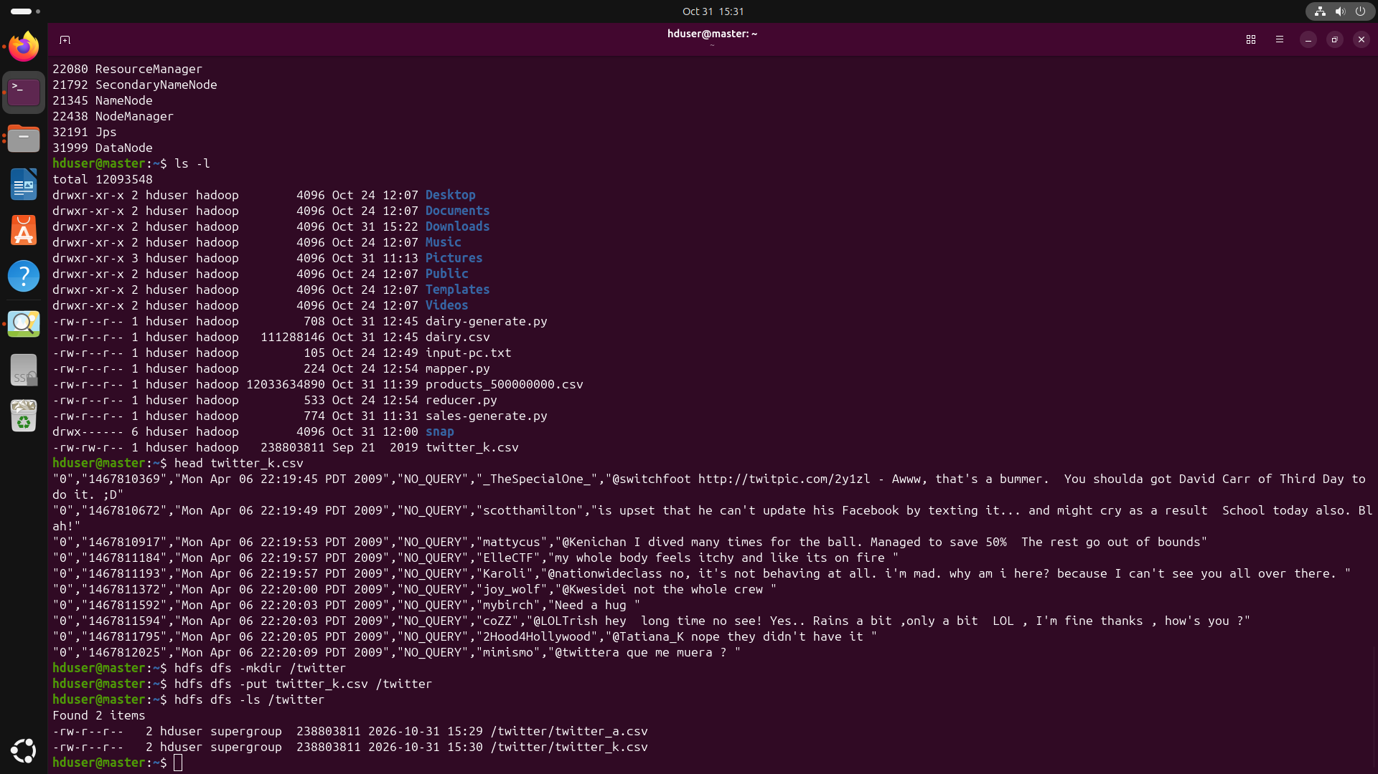
Figure 9: Twitter dataset preview and upload to HDFS (/twitter)

B.2 Tasks 2 and 3: Preprocessing and Sentiment Counting
The Twitter mapper (twitter_mapper.py) reads each line and first re-encodes it with errors ignored (encode("utf-8", "ignore") then decode), which discards characters that cannot be decoded, such as broken emoji or special symbols. The line is parsed with Python's csv module so that commas inside tweets do not break the columns. The first column holds the label: "0" is emitted as "Negative<TAB>1" and "4" as "Positive<TAB>1". Malformed lines are skipped using a try/except block. The dataset is pre-labelled, so no model has to be trained here.
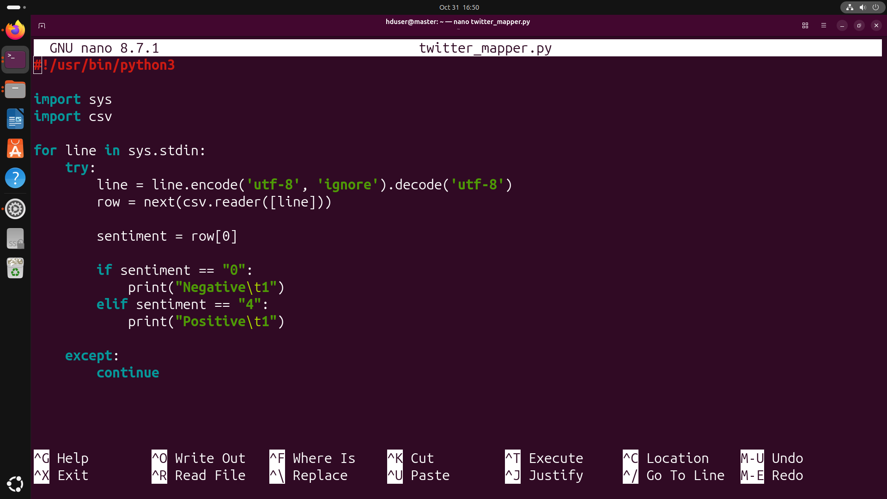
Figure 10: Mapper script (twitter_mapper.py)
The combiner (twitter_combiner.py) performs local aggregation on each mapper's sorted output. It sums the 1s for each key, so every mapper sends only a few totals instead of hundreds of thousands of individual records. This greatly reduces the data shuffled across the network.
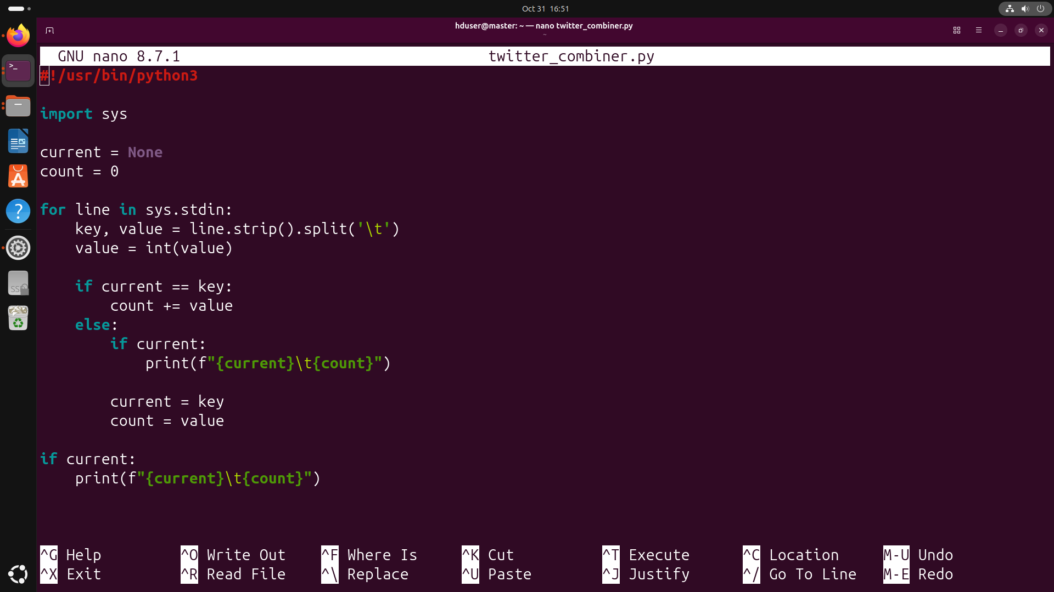
Figure 11: Combiner script (twitter_combiner.py)
The reducer (twitter_reducer.py) adds up the partial totals received from all combiners and prints the final count for each sentiment class.
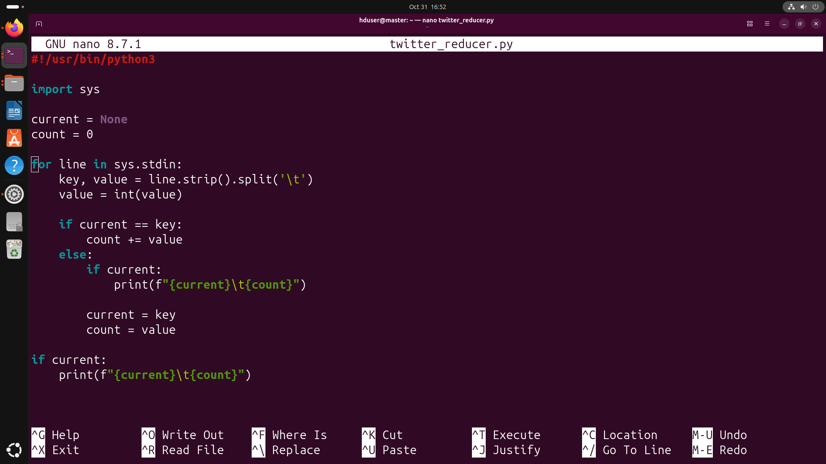
Figure 12: Reducer script (twitter_reducer.py)

B.3 Local Testing of the Pipeline
Before using the cluster, the file was converted from ISO-8859-1 to UTF-8 with iconv (output file twitter_K.csv) and the pipeline was tested with Unix pipes. Running mapper | sort | combiner gives 800,000 Negative and 800,000 Positive. Adding the reducer at the end gives the same final result, which shows that the combiner and reducer work together correctly.
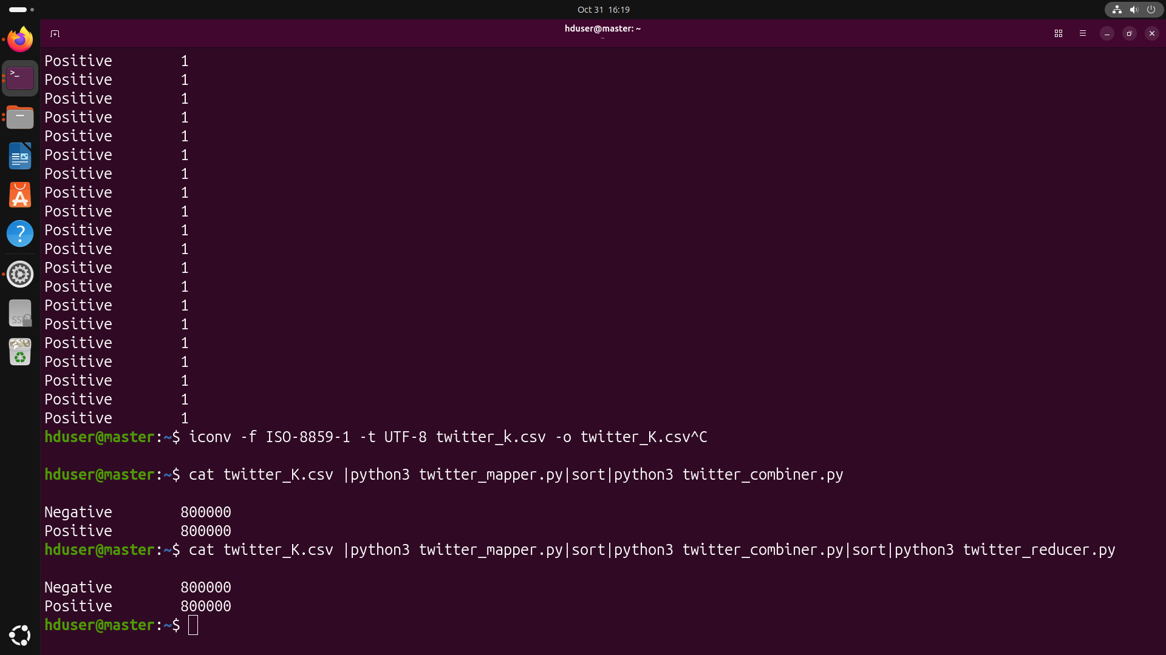
Figure 13: Local test: mapper | sort | combiner | sort | reducer

B.4 Task 4: Distributed Execution on Hadoop
The job was run on the cluster with Hadoop Streaming, using the mapper, combiner and reducer scripts, the input /twitter/twitter_K.csv and the output directory /twitter/outputKiran. The file was divided into 2 splits, and the job went from map 0% to map 100% and reduce 100% and completed successfully. Submission to completion took about 14 seconds for roughly 1.6 million records (about 238.9 MB read from HDFS), which is a throughput of roughly 110,000 records per second on this small cluster. The job wrote only 32 bytes to HDFS, which matches two result lines (Negative and Positive with their counts).
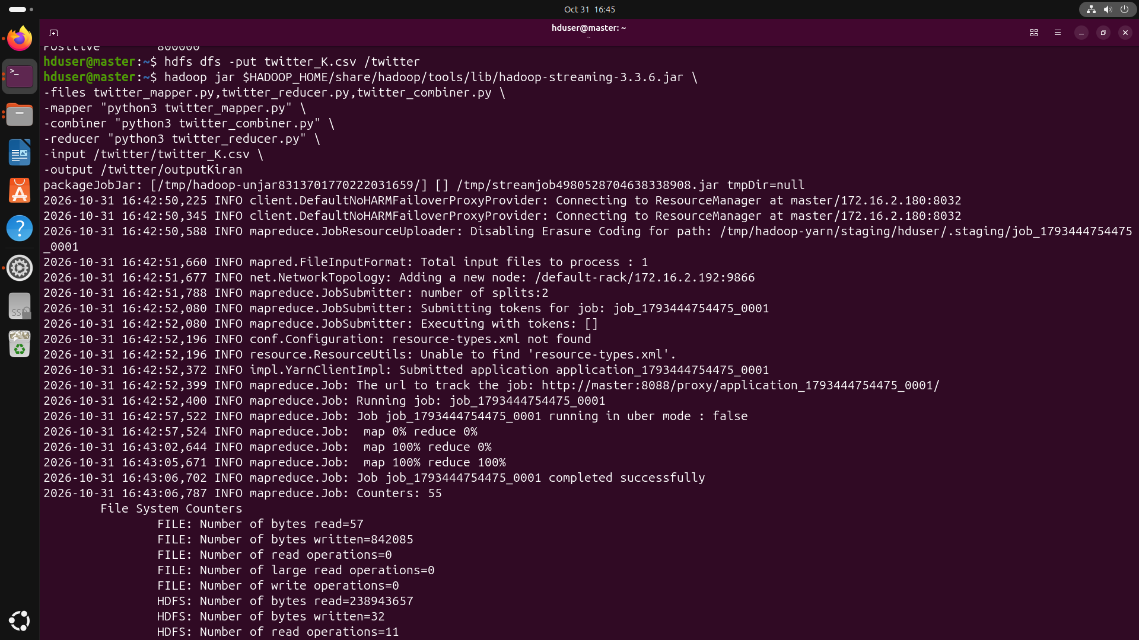
Figure 14: Hadoop Streaming job execution for the Twitter dataset

Part C – Results, Insights and Ethical Considerations

C.1 Summary of Results
Run | Records | Negative | Neutral | Positive | Time
News – local | 72 | 10 | 37 | 25 | –
News – Hadoop | 71 processed | 10 | 37 | 24 | ~23 s
Twitter – local | 1,600,000 | 800,000 | – | 800,000 | –
Twitter – Hadoop | 1,600,000 | – | – | – | ~14 s
Note: the counts of the Twitter Hadoop output are not visible in the screenshots; the job completed successfully and wrote a 32-byte output file, which is the size of two result lines.
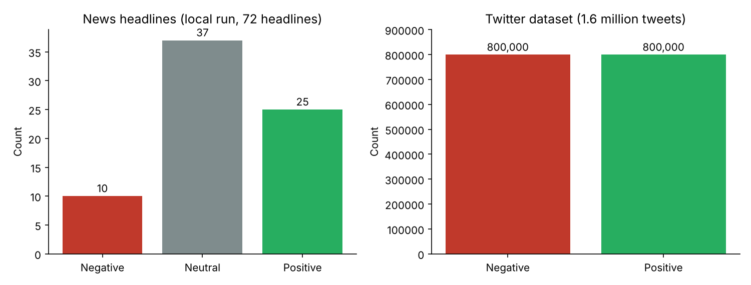
Figure 15: Sentiment distribution of the news headlines (local run) and the Twitter dataset

C.2 Interpretation of Insights
- News headlines are mostly neutral. About 51% of headlines are Neutral, about 35% Positive and about 14% Negative. Technology headlines tend to be factual and descriptive, and a lexicon-based tool such as TextBlob returns a polarity of exactly 0 when it finds no opinion words.
- The Twitter dataset is balanced. Exactly 800,000 tweets fall into each class, so the dataset was balanced by design. The counts show that the pipeline is correct and scales, but they do not describe the real-world share of positive and negative tweets.
- Scalability. The 14-second run on 1.6 million tweets shows that Hadoop handles large volumes well, while the 23-second run on only about 70 headlines shows that for tiny inputs the fixed job start-up cost dominates. The combiner was the main optimisation used, because it reduces the amount of data transferred between map and reduce.
- Limits of the method. TextBlob does not understand sarcasm, slang or context, and the news approach was not compared with any labelled reference, so no accuracy or F1-score could be reported for it.

C.3 Ethical Considerations
- Privacy: tweets contain usernames, tweet IDs and timestamps. Such data should be anonymised or removed before storing or sharing it, and only the information needed for the analysis should be kept. The pipeline here uses only the label column and discards the rest.
- Credential security: the API key used for data collection is a secret. It should be kept out of source code and screenshots, for example by using environment variables, and it should be regenerated if it has been exposed.
- Bias and fairness: the lexicon-based method is tuned for standard English and can misclassify dialects, slang and sarcasm, which can systematically under- or over-estimate sentiment for some groups. Automatically assigned labels in large tweet datasets may also contain errors. The news data comes from a single query and source set, so it may not represent all opinions.
- Mitigation: use multiple methods and compare them, validate against a manually labelled sample, report accuracy per group where possible, and be transparent about the limitations when presenting the results.

Conclusion
This activity demonstrated a complete sentiment analysis workflow on two datasets using Hadoop Streaming. For the news data, headlines were collected through the NewsAPI, classified as Positive, Negative or Neutral with TextBlob, and aggregated using a mapper and reducer. For the Twitter data, a large labelled file of about 1.6 million tweets was loaded into HDFS and processed with a mapper, combiner and reducer, producing 800,000 Negative and 800,000 Positive tweets in about 14 seconds.
The experiments showed that the MapReduce design scales to large datasets, that a combiner reduces network traffic, and that local testing with Unix pipes is a reliable way to validate the scripts before running them on the cluster. One issue was found: the header-skipping logic in the news mapper drops one record per extra input split, which explains the 24 versus 25 Positive difference. The work also highlighted the ethical responsibilities of handling social data, namely privacy, credential protection, and awareness of bias in sentiment tools. As future improvements, the pipeline can be extended with Tweepy or PRAW for live collection, richer preprocessing (stopwords, hashtags, URLs), model comparison using accuracy and F1-score, and Spark with caching and partitioning for further optimisation.

