Mock 2 for Milestone -2 Assessment
#Details
Q1: React Basics – ProductCard
Details
- Functional component that displays a product.
- Receives props: title, price, discount.
- Calculates final price = price − discount.
Features
- Reusable product card.
- Shows price breakdown.
- Dynamic props passed from parent.

Q2: Controlled + Uncontrolled – LoginForm
Details
- Login form capturing username (controlled) and password (uncontrolled).
- On submit, logs values to console.
Features
- Controlled input using useState.
- Uncontrolled input using useRef.
- Form submission logging.

Q3: Class Component + Lifecycle – UserStatus
Details
- Class component showing Fetching user status….
- Updates to Active User after 2 seconds.
- Accepts userId as PropTypes.
Features
- Class component lifecycle (componentDidMount).
- Prop validation with PropTypes.
- Basic styling.

Q4: React Router + API Integration – UserDetails
Details
- Fetches user data from backend by id route parameter.
- Route: /users/:id.
- Example JSON server endpoint: http://localhost:4000/users/:id.
Features
- React Router route parameter.
- Fetch user data using fetch.
- Displays name and email.

Q5: Reusability Using HOC – ResponsiveDisplay
Details
- Displays current window width.
- Updates dynamically on resize.
- Uses Higher-Order Component (HOC).
Features
- Reusable window width logic.
- Wraps any component.

Q6: Formik + Yup Validation – LoginFormik
Details
- Login form with Formik and Yup validation.
- Email format validated.
- Password minimum 6 characters.
Features
- Clean form UI.
- Validation messages.
- Logs values on submit.

# File Structure
/milestone2
/node_modules
/public
index.html
favicon.ico
/src
/components
ProductCard.js # Q1
LoginForm.js # Q2
UserStatus.js # Q3
UserDetails.js # Q4
DisplayWidth.js # Q5 (HOC child)
withWindowWidth.js # Q5 (HOC wrapper)
ResponsiveDisplay.js # Q5
LoginFormik.js # Q6
App.js
index.jsr
db.json
package.json
package-lock.json

# Execution
In terminal 1
>npm install
npm install react-router-dom formik yup prop-types
>npm start
In terminal 2
> npm install -g json-server
> json-server --watch db.json --port 4000
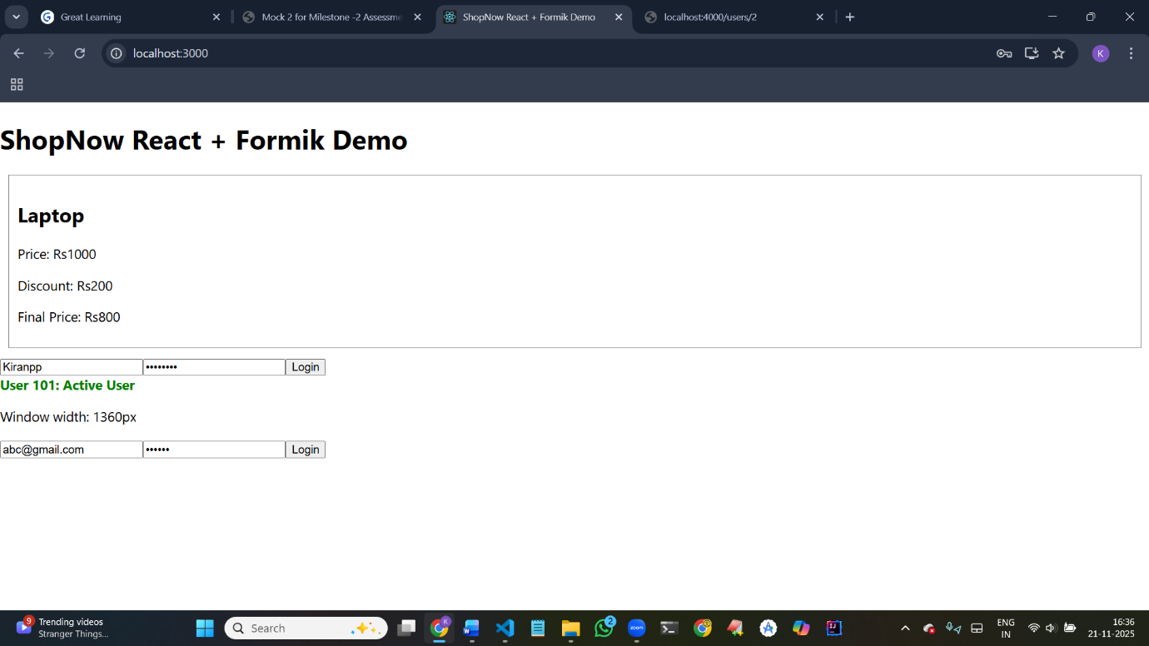
# Output
Output for Question 1,2,3,5
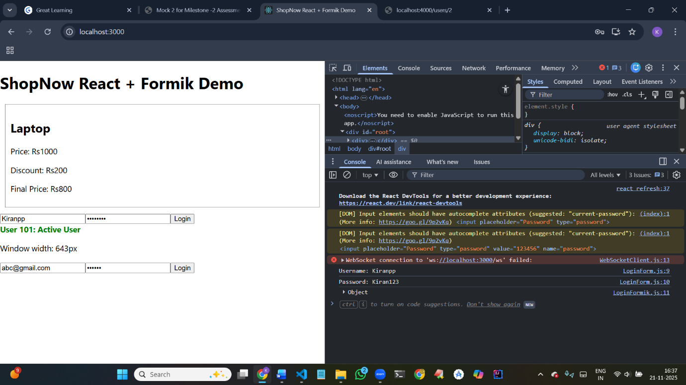
Output for Question 2,6 look at console

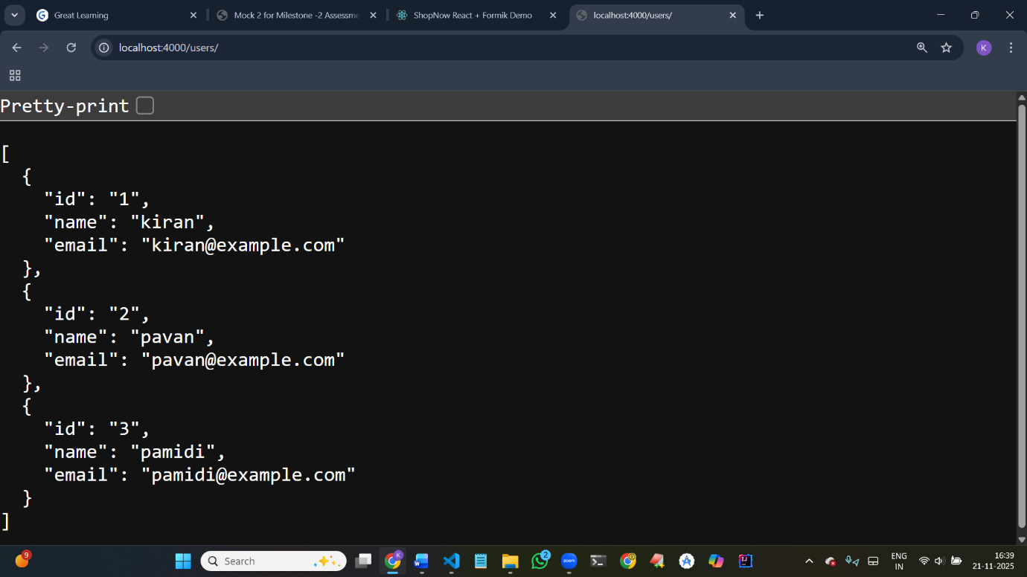
Output for Question 4

Q7: Node.js Core Modules – Logging & HTTP Server
Details
- CLI Node script.
- Writes App started into logs/app.log using fs.
- Starts a simple HTTP server returning { "status": "running" }.
- Uses only Node.js core modules (no external dependencies).
Features
- File logging.
- Simple JSON HTTP response.
- No NPM packages required.

Q8: Asynchronous JS – Callbacks → Promise → Async/Await
Details
- Refactor callback-based fetchData into Promise and Async/Await.
- Demonstrates modern async patterns.
Features
- Maintain same output.
- Shows three versions: callback, promise, async/await.

Q9: Express Routing + Middleware + Validation
Details
- Express server with /products GET and POST.
- Middleware logs method + URL.
- POST validates name and price using express-validator.
Features
- GET returns all products.
- POST validates and returns JSON.
- Middleware logs request info.

Q10: REST API + JWT Authentication
Details
- Login route /login returns JWT for static user.
- Protected route /dashboard accessible only with valid JWT.
Features
- JWT token generation & validation.
- Express middleware for protection.
- Demonstrates authentication workflow.

# Folder Stucture
/backend
/routes
products.js # Q9
/middleware
logger.js # Q9
auth.js # Q10
logs/ # Q7
server.js # Q7/Q9/Q10 combined
p+ackage.json

# Execution
>cd backend
>npm install express express-validator jsonwebtoken
>node server.js

#Try
>http://localhost:5000/status
>http://localhost:5000/async-demo
>http://localhost:5000/products
# output for Q7 – Q10