Day 7 Coding Assignment — MongoDB Data Modeling and CRUD Operations

// all Syntaxes to be executed in mongosh Shell
UserStory 1
Code
use BookVerseDB
db.createCollection('authors')
db.createCollection('books')
db.createCollection('users')
const a1 = ObjectId("64a100000000000000000001");
const a2 = ObjectId("64a100000000000000000002");
const a3 = ObjectId("64a100000000000000000003");
db.authors.insertMany([
{ _id: a1, name: "Asha Verma", nationality: "Indian", birthYear: 1980 },
{ _id: a2, name: "Michael Stone", nationality: "British", birthYear: 1972 },
{ _id: a3, name: "Lina Garcia", nationality: "Spanish", birthYear: 1990 }
]);
db.books.insertMany([
{
_id: ObjectId("64c300000000000000000a01"),
title: "Stars Beyond",
genre: "Science Fiction",
publicationYear: 2018,
authorId: a2,
ratings: [
{ user: "ravi@example.com", score: 5, comment: "Loved it!" },
{ user: "sara@example.com", score: 4, comment: "Great worldbuilding." }
]
},
{
_id: ObjectId("64c300000000000000000a02"),
title: "The Last Orchard",
genre: "Fantasy",
publicationYear: 2012,
authorId: a1,
ratings: [
{ user: "omar@example.com", score: 4, comment: "Emotional." }
]
},
{
_id: ObjectId("64c300000000000000000a03"),
title: "Quantum Drift",
genre: "Science Fiction",
publicationYear: 2021,
authorId: a2,
ratings: [
{ user: "ravi@example.com", score: 5, comment: "Mind-blowing." },
{ user: "omar@example.com", score: 5, comment: "A must-read." },
{ user: "sara@example.com", score: 4, comment: "Complex but good." }
]
},
{
_id: ObjectId("64c300000000000000000a04"),
title: "Wind of the Wild",
genre: "Fantasy",
publicationYear: 2019,
authorId: a3,
ratings: []
},
{
_id: ObjectId("64c300000000000000000a05"),
title: "City of Echoes",
genre: "Mystery",
publicationYear: 2016,
authorId: a1,
ratings: [
{ user: "sara@example.com", score: 3, comment: "Okay." }
]
}
]);
db.authors.find().pretty();
db.books.find().pretty();
Output:- 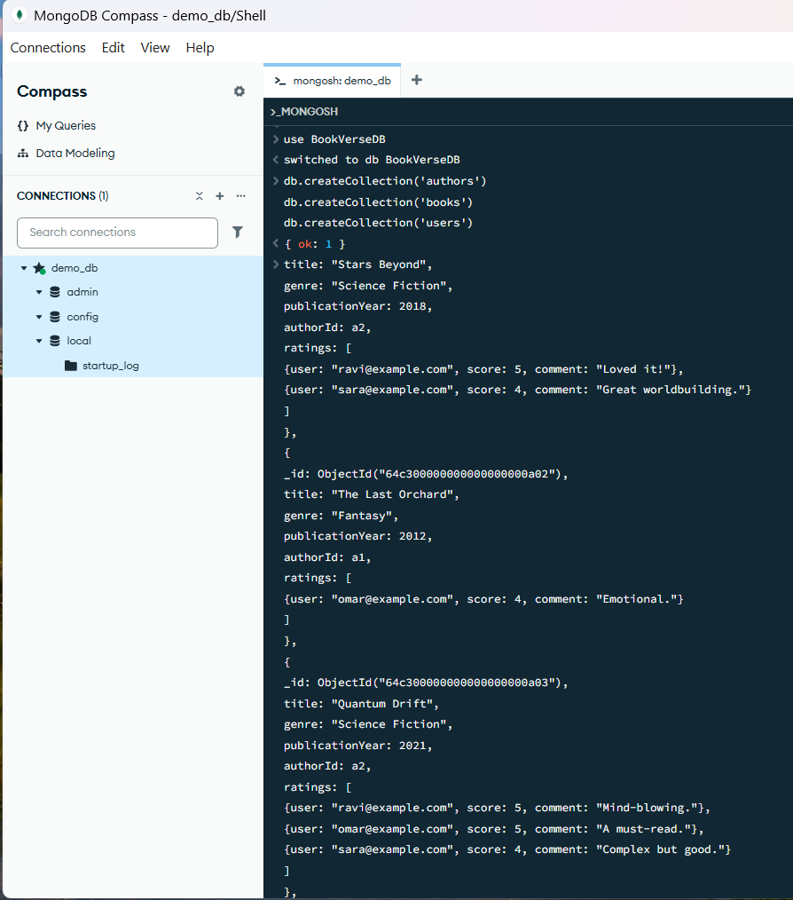
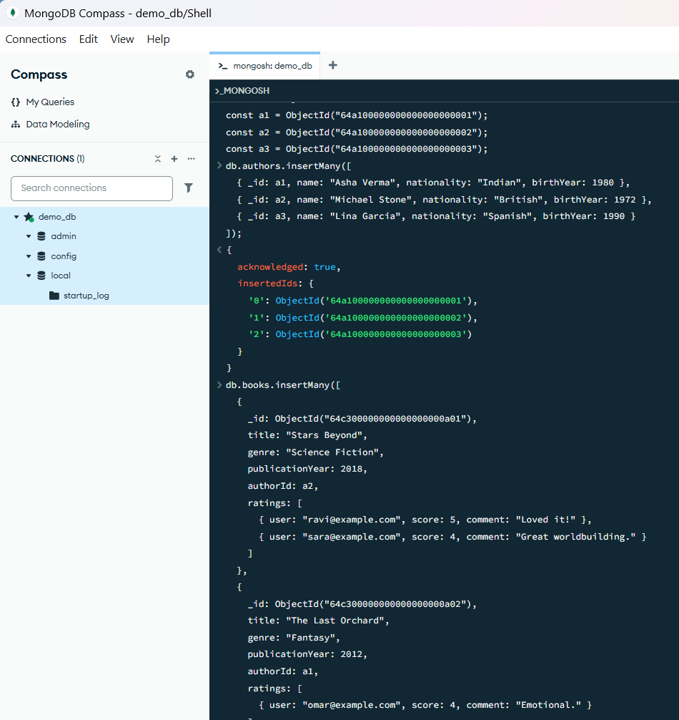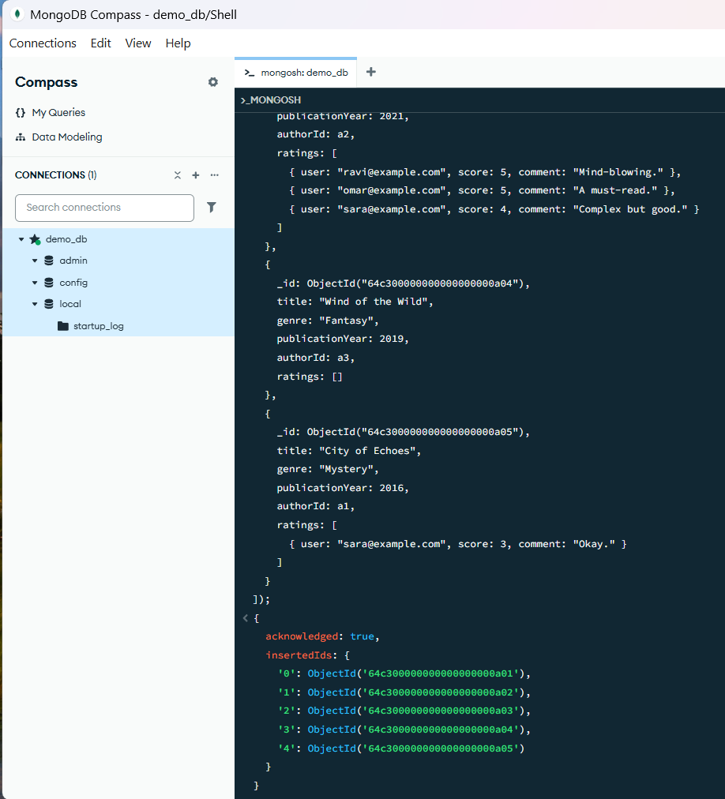

UserStory 2
Code:-
db.users.insertMany([
{ _id: ObjectId("64b200000000000000000011"), name: "Ravi Kumar", email: "ravi@example.com", joinDate: new Date("2025-05-10") },
{ _id: ObjectId("64b200000000000000000012"), name: "Sara Lee", email: "sara@example.com", joinDate: new Date("2025-09-01") },
{ _id: ObjectId("64b200000000000000000013"), name: "Omar Ali", email: "omar@example.com", joinDate: new Date("2024-12-20") }
]);
db.users.find().pretty();
db.users.insertOne({
name: "Neha Patel",
email: "neha@example.com",
joinDate: new Date()
});

db.books.insertOne({
title: "Tides of Tomorrow",
genre: "Science Fiction",
publicationYear: 2024,
authorId: a3,
ratings: []
});
db.books.find({ genre: "Science Fiction" }).pretty();
db.books.updateOne(
{ title: "City of Echoes" },
{ $set: { publicationYear: 2017 } }
);
db.users.deleteOne({ email: "omar@example.com" });
db.books.updateOne(
{ title: "Quantum Drift" },
{ $push: { ratings: { user: "neha@example.com", score: 5, comment: "Amazing read!" } } }
);
Output:- 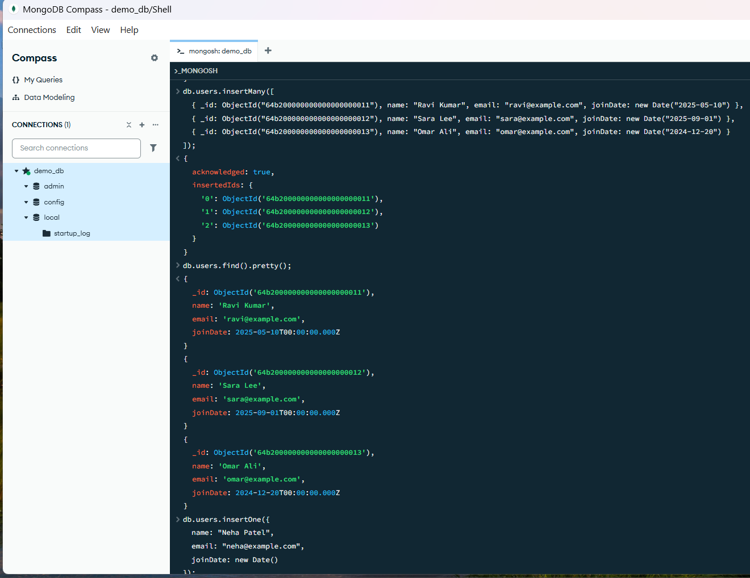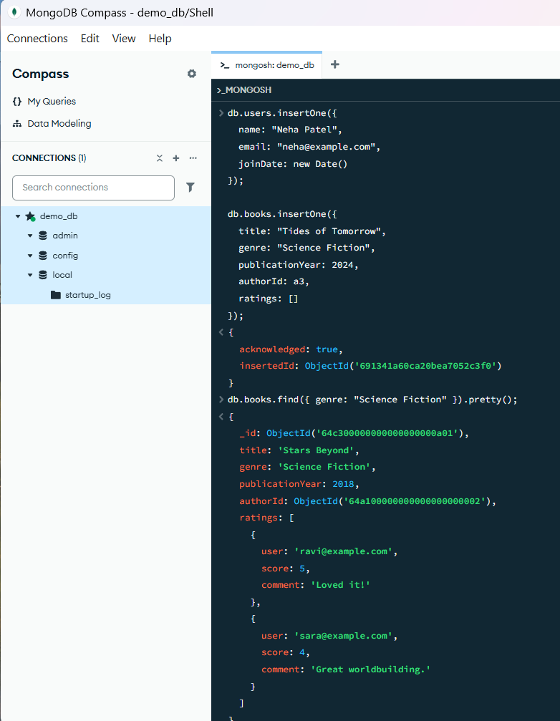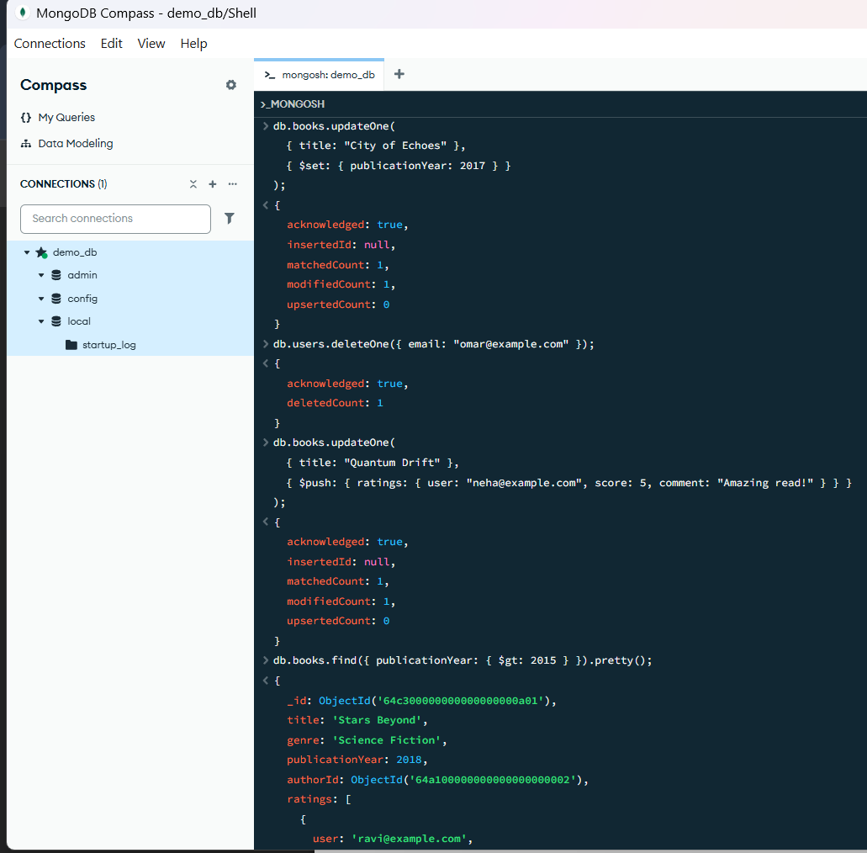
UserStory 3
Code:-
db.books.find({ publicationYear: { $gt: 2015 } }).pretty();
const fantasyAuthorIds = db.books.distinct("authorId", { genre: "Fantasy" });
db.authors.find({ _id: { $in: fantasyAuthorIds } }).pretty();
let sixMonthsAgo = new Date();
sixMonthsAgo.setMonth(sixMonthsAgo.getMonth() - 6);
db.users.find({ joinDate: { $gte: sixMonthsAgo } }).pretty();
Output:-
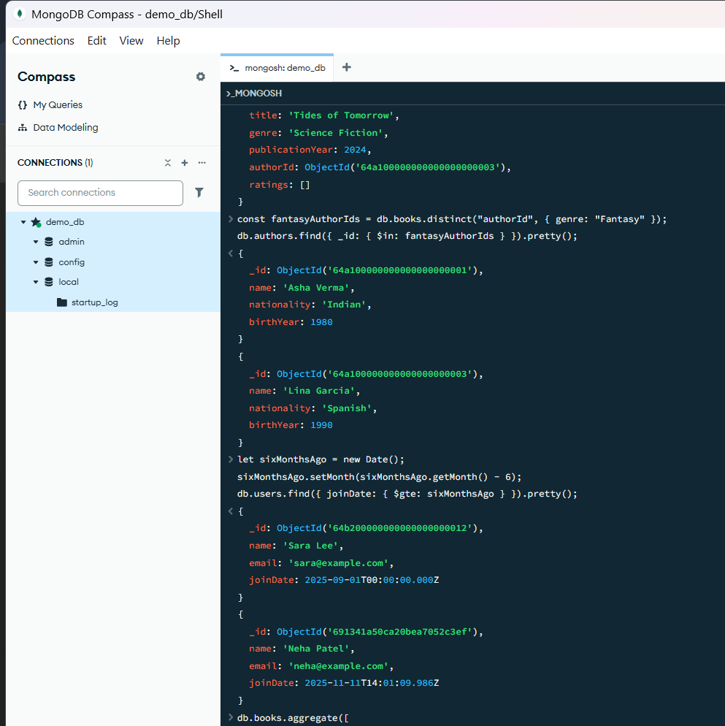
Bonus Challenge (Optional)
Code :-
db.books.aggregate([
{ $unwind: { path: "$ratings", preserveNullAndEmptyArrays: true } },
{
$group: {
_id: "$_id",
title: { $first: "$title" },
avgRating: { $avg: "$ratings.score" },
ratingsCount: { $sum: { $cond: [{ $ifNull: ["$ratings", false] }, 1, 0] } }
}
},
{ $match: { avgRating: { $gt: 4 } } },
{ $sort: { avgRating: -1 } }
]);
db.books.aggregate([
{ $project: { title: 1, ratingsCount: { $size: { $ifNull: ["$ratings", []] } } } },
{ $sort: { ratingsCount: -1 } },
{ $limit: 3 }
]);
Output:-
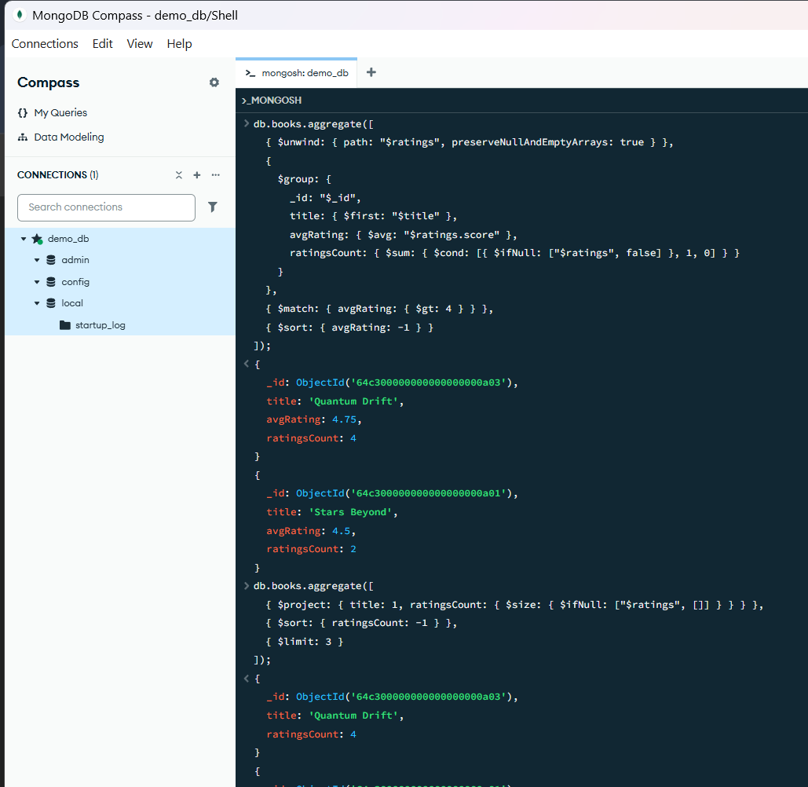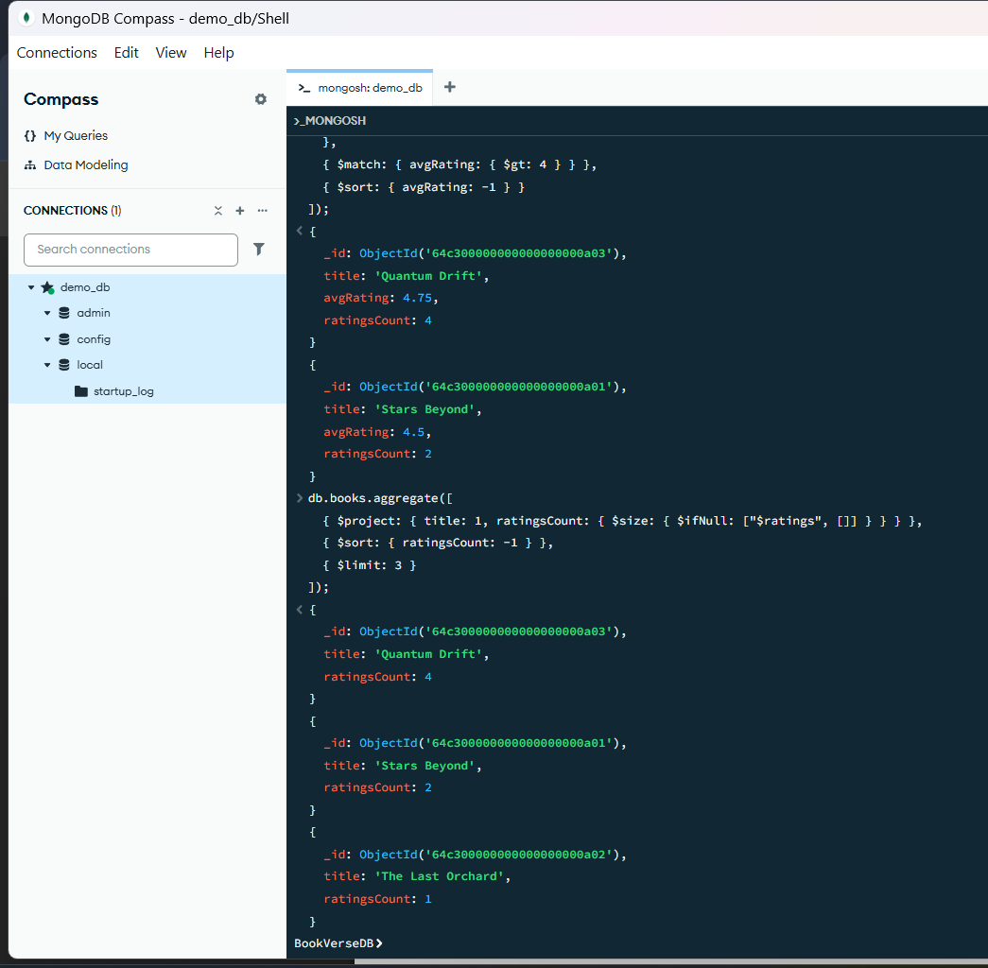
# script using Node.js and Mongoose to insert data into the collections
Folder Setup
- Inside the folder bookverse-seed.
- Inside that folder, there are two files:
  - package.json
  - seed.js
Run the Seeder
## In the Terminal
>node seed.js
## You will see
> Data successfully seeded into BookVerseDB
## Execute this is Mongosh Shell
>use BookVerseDB
>show collections
>db.books.find().pretty();
Output:-
This script seeds all three collections:
- authors (3 documents)
- books (5 documents)
- users (3 documents)

