Kiran Pawar

CS1550 Project 3 Writeup

After running the algorithms, it was immediately noticed that FIFO consistently performed the worst with the highest number of page faults. What’s more, due to Belady’s Phenomenon, it performed worse with the increase of page frames until a certain point (between 64 and 128 frames) where it began to finally decrease with additional frames. At times it seems as if it will begin to drop; this was proven to be untrue with more trials.

Ideally, the optimal algorithm is the best algorithm to use in terms of having the fewest page faults. However, as we have learned this is impossible to implement in a real world scenario (also my implementation of the optimal algorithm is flawed, and because of this there is a drastically higher number of page faults than expected. That being said, knowledge of how the algorithm is supposed to work is what tells me that optimal is supposed to have the fewest page faults).

Fifo is consistently the worst performing algorithm, with it becoming worse with an increase in frame size, so it seems as if the only reason to use it is for a simple page replacement implementation. The ideal algorithm to implement would be between NRU and clock, though it depends on the number of traces that are written to memory to determine which would be better. Though NRU seems to perform more efficiently than clock initially with fewer frames, it appears that clock ends up being more efficient than clock as the frame size increases, so it would be advised to use the clock algorithm when doing page replacement.

The information for each algorithm is provided at the end of this document.

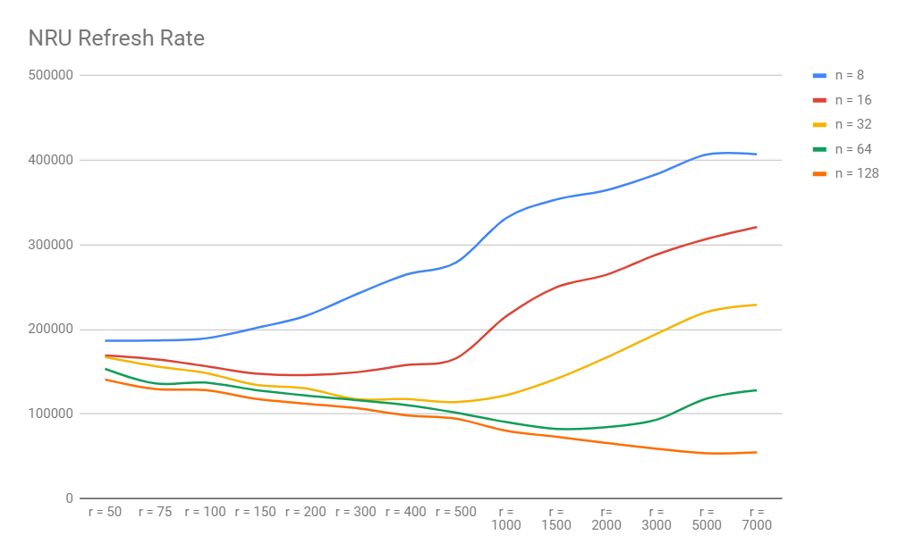

When trying to determine what the best NRU refresh rate would be, it was discovered that the answer is it depends on the frame size. For a frame size of 8, a refresh rate of 70 was ideal. For 16 frames, it was a refresh rate somewhere between 150-180. For 32 frames, it was somewhere between 300-350. For 64, it was somewhere between 2000-2200. A last implementation of 128 frames found that 5500-6500 was ideal.

With this in mind, somewhere in the middle (500-1000) refresh rate would be the best. It should be noted that the statistics provided below used the ideal refresh rate for each frame size.

NRU Refresh Rate Observation (gcc.trace)

|  |  |  |  |  |  |  |  |  |  |  |  |  |  |  |
| --- | --- | --- | --- | --- | --- | --- | --- | --- | --- | --- | --- | --- | --- | --- |
| NRU Refresh Value | r = 50 | r = 75 | r = 100 | r = 150 | r = 200 | r = 300 | r = 400 | r = 500 | r = 1000 | r = 1500 | r= 2000 | r = 3000 | r = 5000 | r = 7000 |
| Frames(n) |  |  |  |  |  |  |  |  |  |  |  |  |  |  |
| n = 8 | 186717 | 187039 | 189485 | 201625 | 215992 | 241342 | 264859 | 279250 | 331638 | 353686 | 364588 | 383625 | 406880 | 407226 |
| n = 16 | 169382 | 164880 | 156756 | 147981 | 146188 | 149375 | 157906 | 165870 | 215649 | 249854 | 264759 | 288597 | 307060 | 320984 |
| n = 32 | 167491 | 156669 | 148660 | 134694 | 130386 | 117770 | 117771 | 114224 | 122412 | 141685 | 166877 | 194757 | 220668 | 229223 |
| n = 64 | 153484 | 136226 | 137279 | 128491 | 121989 | 116637 | 110721 | 101657 | 90553 | 82543 | 84618 | 93382 | 118395 | 128189 |
| n = 128 | 140858 | 129667 | 128357 | 118207 | 112258 | 107184 | 98677 | 94512 | 80289 | 73266 | 65841 | 59095 | 53745 | 54698 |

FIFO Belady’s Observation

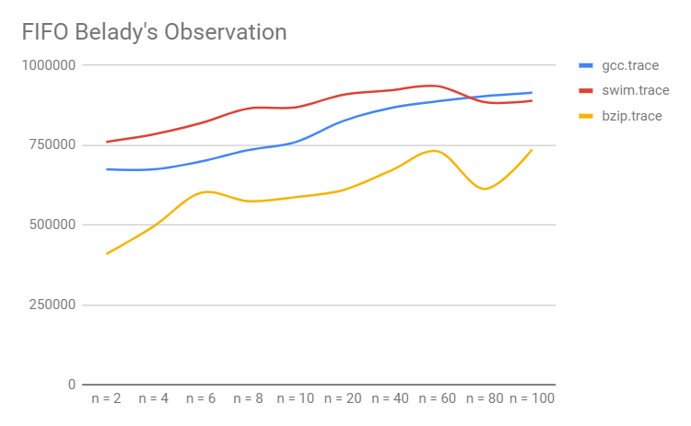

|  |  |  |  |
| --- | --- | --- | --- |
|  | gcc.trace | swim.trace | bzip.trace |
| n = 2 | 674393 | 760762 | 409389 |
| n = 4 | 674361 | 784096 | 495655 |
| n = 6 | 699092 | 819420 | 601207 |
| n = 8 | 734885 | 865154 | 574722 |
| n = 10 | 759958 | 868521 | 587502 |
| n = 20 | 825816 | 908095 | 609292 |
| n = 40 | 866591 | 922097 | 669398 |
| n = 60 | 887717 | 935210 | 731242 |
| n = 80 | 903905 | 884983 | 612997 |
| n = 100 | 914484 | 889204 | 736750 |

Algorithm Comparison

|  |  |  |  |  |
| --- | --- | --- | --- | --- |
| GCC |  |  |  |  |
| Algorithm | FIFO | NRU(best ref) | Clock | Optimal |
| Frames(n) |  |  |  |  |
| n = 8 | 734885 | 186436 | 172494 | 209614 |
| n = 16 | 803329 | 145215 | 118487 | 156112 |
| n = 32 | 853087 | 118056 | 85569 | 119652 |
| n = 64 | 982724 | 83753 | 58662 | 92390 |
| n = 128 | 920877 | 52735 | 41047 | 69334 |
|  |  |  |  |  |
| SWIM |  |  |  |  |
| Algorithm | FIFO | NRU(best ref) | Clock | Optimal |
| Frames(n) |  |  |  |  |
| n = 8 | 865154 | 236873 | 282213 | 303388 |
| n = 16 | 894588 | 131042 | 150731 | 183395 |
| n = 32 | 915042 | 95596 | 46666 | 91216 |
| n = 64 | 929010 | 69503 | 21680 | 50104 |
| n = 128 | 897392 | 42913 | 13611 | 29389 |
|  |  |  |  |  |
| BZIP |  |  |  |  |
| Algorithm | FIFO | NRU(best ref) | Clock | Optimal |
| Frames(n) |  |  |  |  |
| n = 8 | 574722 | 28643 | 38376 | 52207 |
| n = 16 | 626712 | 10359 | 3940 | 6680 |
| n = 32 | 670831 | 7684 | 2267 | 4862 |
| n = 64 | 773323 | 3609 | 1435 | 3481 |
| n = 128 | 98041 | 1665 | 883 | 2678 |
|  |  |  |  |  |
|  |  |  |  |  |
|  |  |  |  |  |

Algorithm Comparison Graphs

