Azure VM Provisioning

**Using Powershell:**

**Commands:**

Check Connection: Connect-AzAccount

Run command: New-AzVm ` -ResourceGroupName "lab-rg1" ` -Name "VMFromPoweshell" ` -Location "East US" ` -VirtualNetworkName "myVnet" ` -SubnetName "mySubnet" ` -SecurityGroupName "myNetworkSecurityGroup" ` -PublicIpAddressName "myPublicIpAddress" ` -OpenPorts 80,3389

VM Successfully Launched from Powershell.

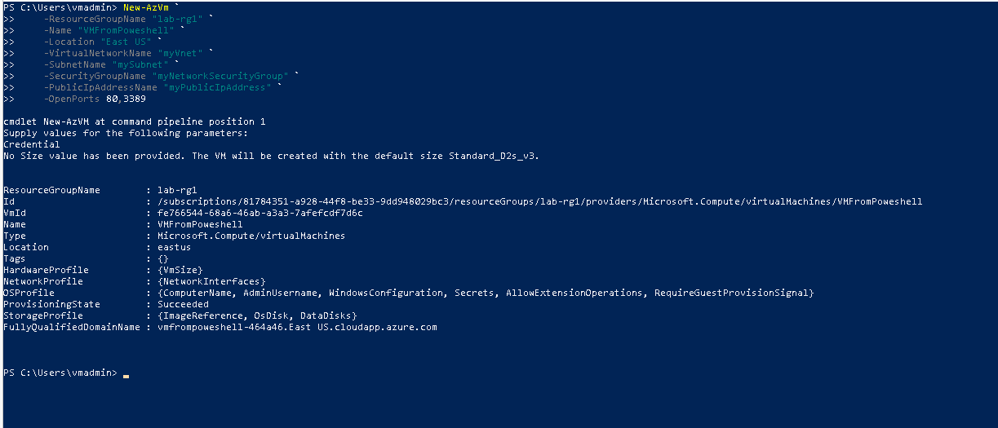

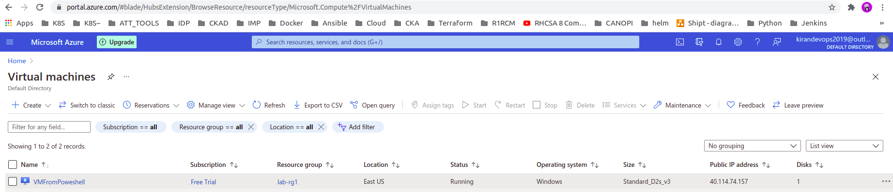

**Using Azure CLI:**

**Command:**

Run command: az vm create --resource-group lab-rg1--name VMFromCLI --image UbuntuLTS --admin-username azureuser --generate-ssh-keys

VM Successfully Launched.

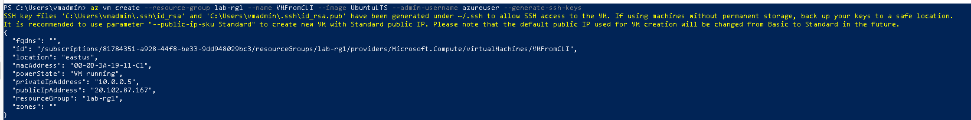

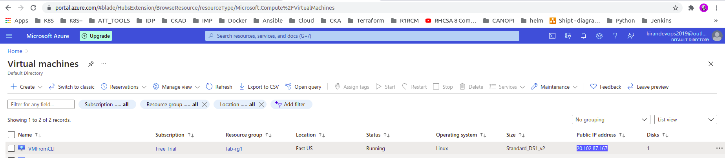

SSH into server successfully.

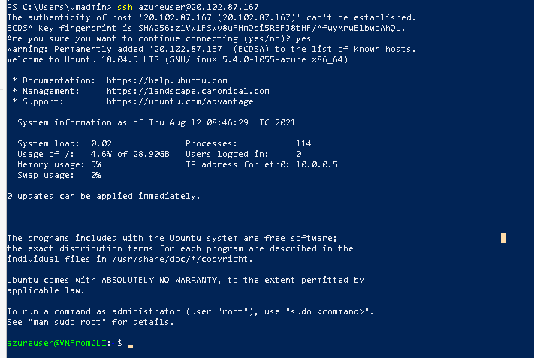

**Using ARM Template:**

# **Template Used:** **Deploy a simple Ubuntu Linux VM 18.04-LTS.**

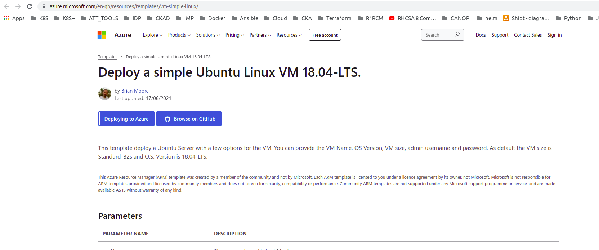

Clicked on “Deploying To Azure” button

Template opened with below details

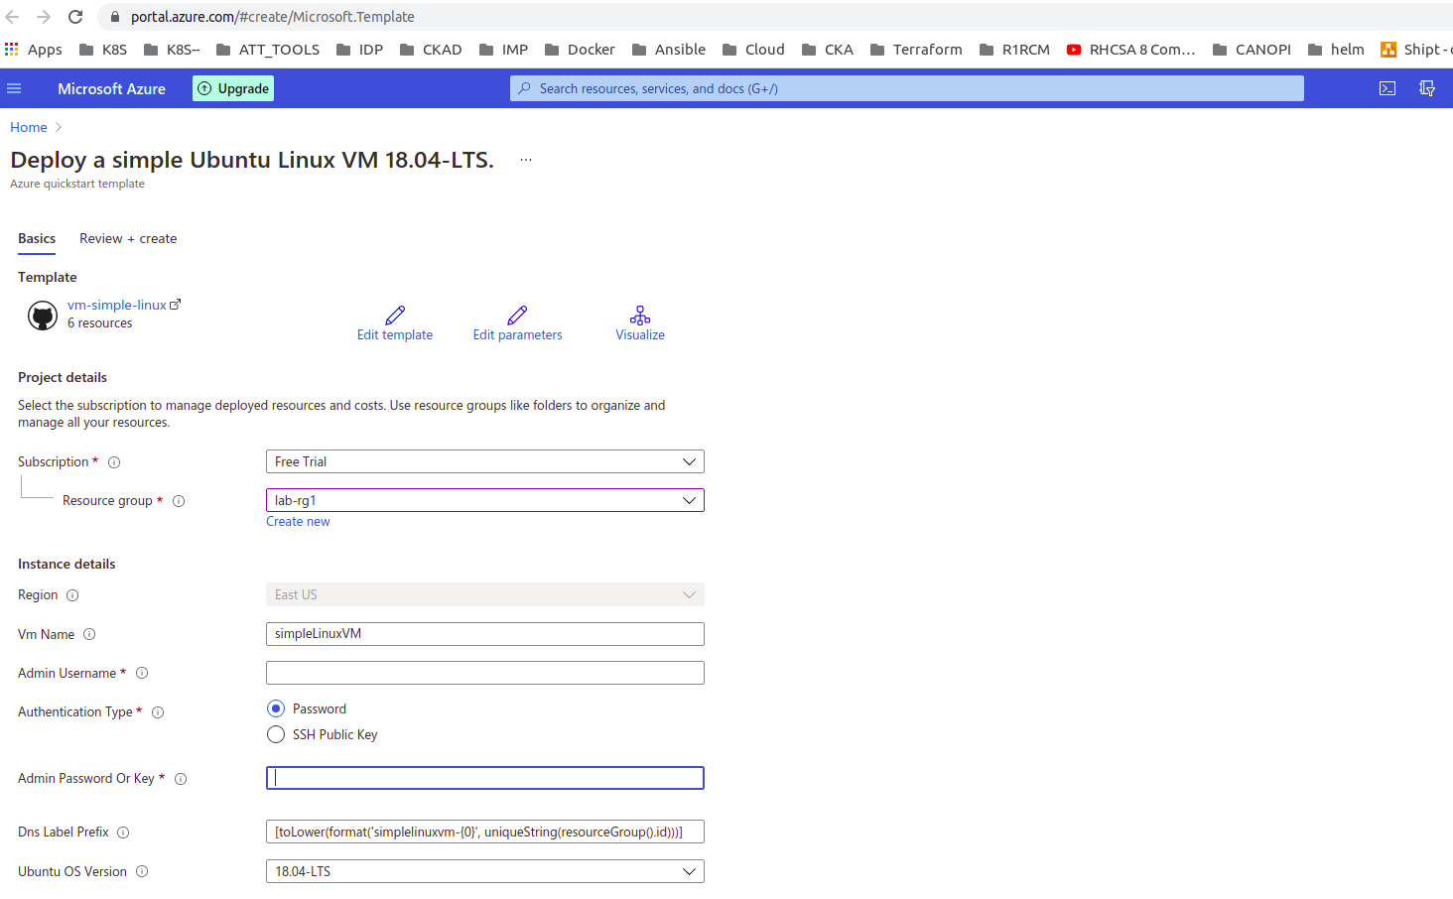

Provided Details and clicked on “Review + Create”. Validation successful.

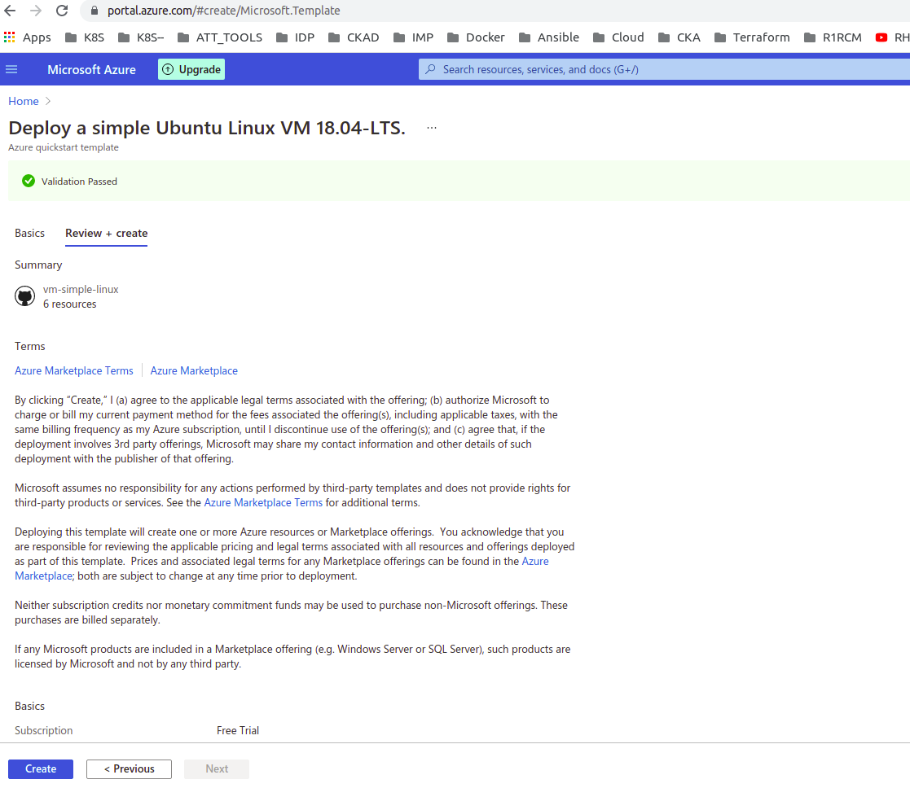

Finally clicked on “Create”. VM Launched successfully.

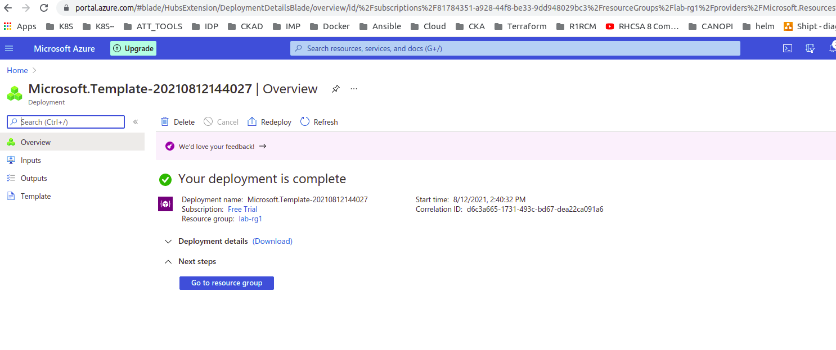

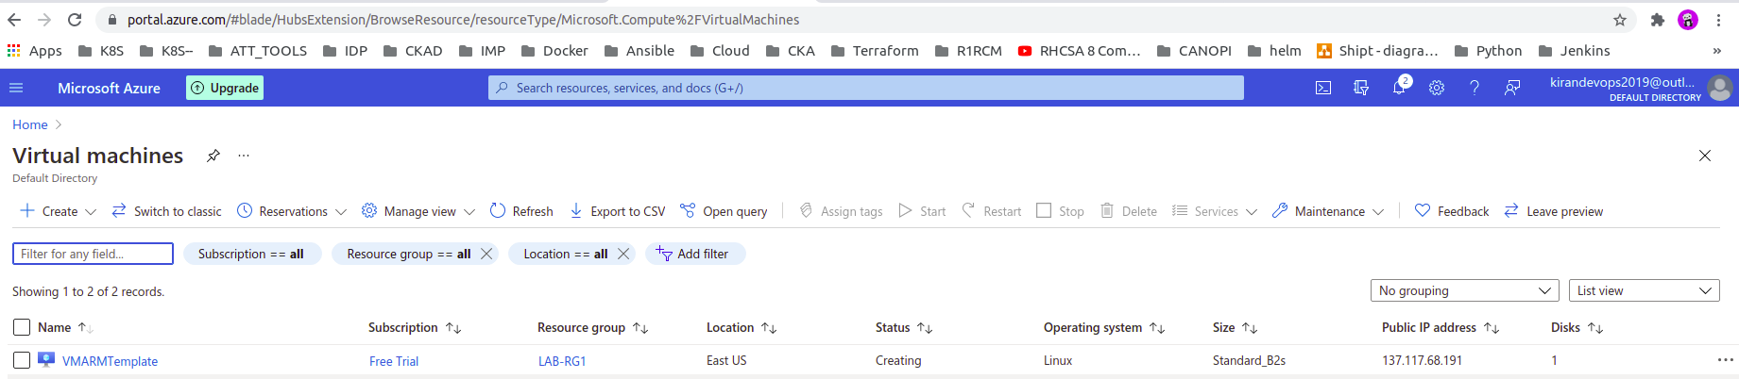

SSH into Server successfully.

