GIT TASKS:

Task1:

Creating repo in GitHub

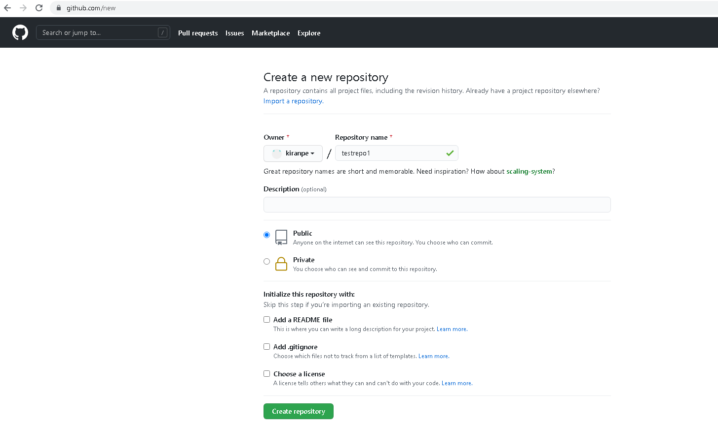

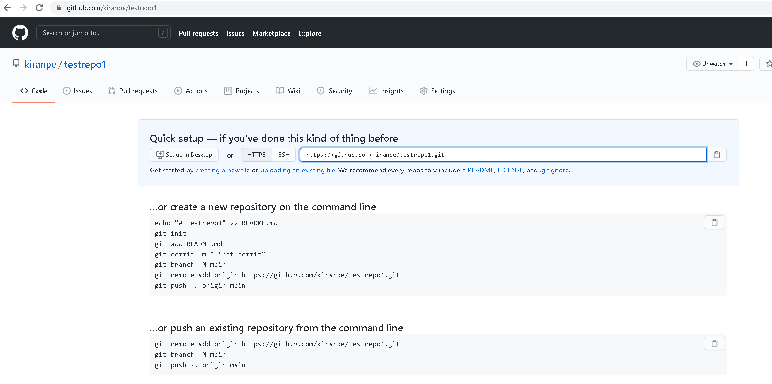

Cloning into “localrepos” folder using eclipse

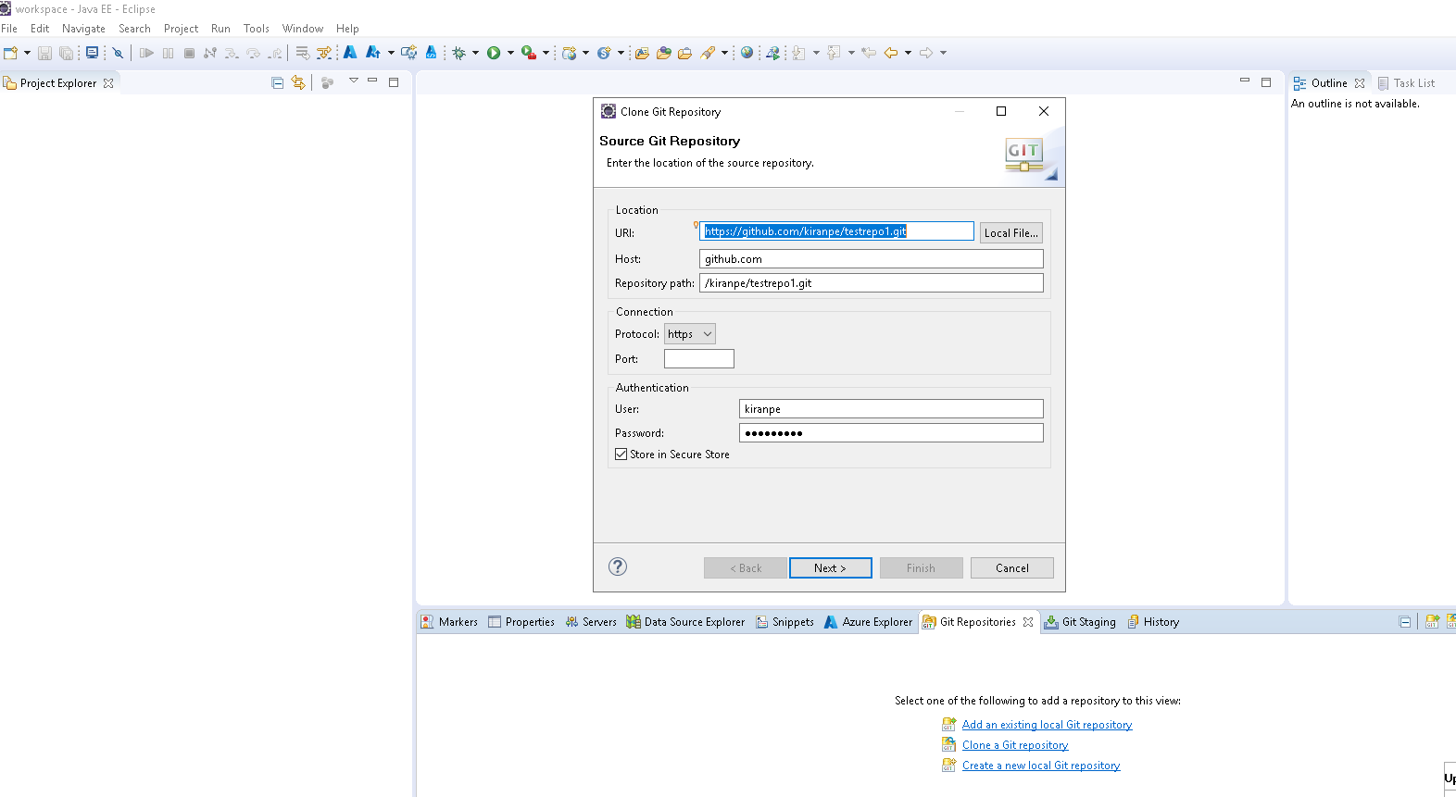

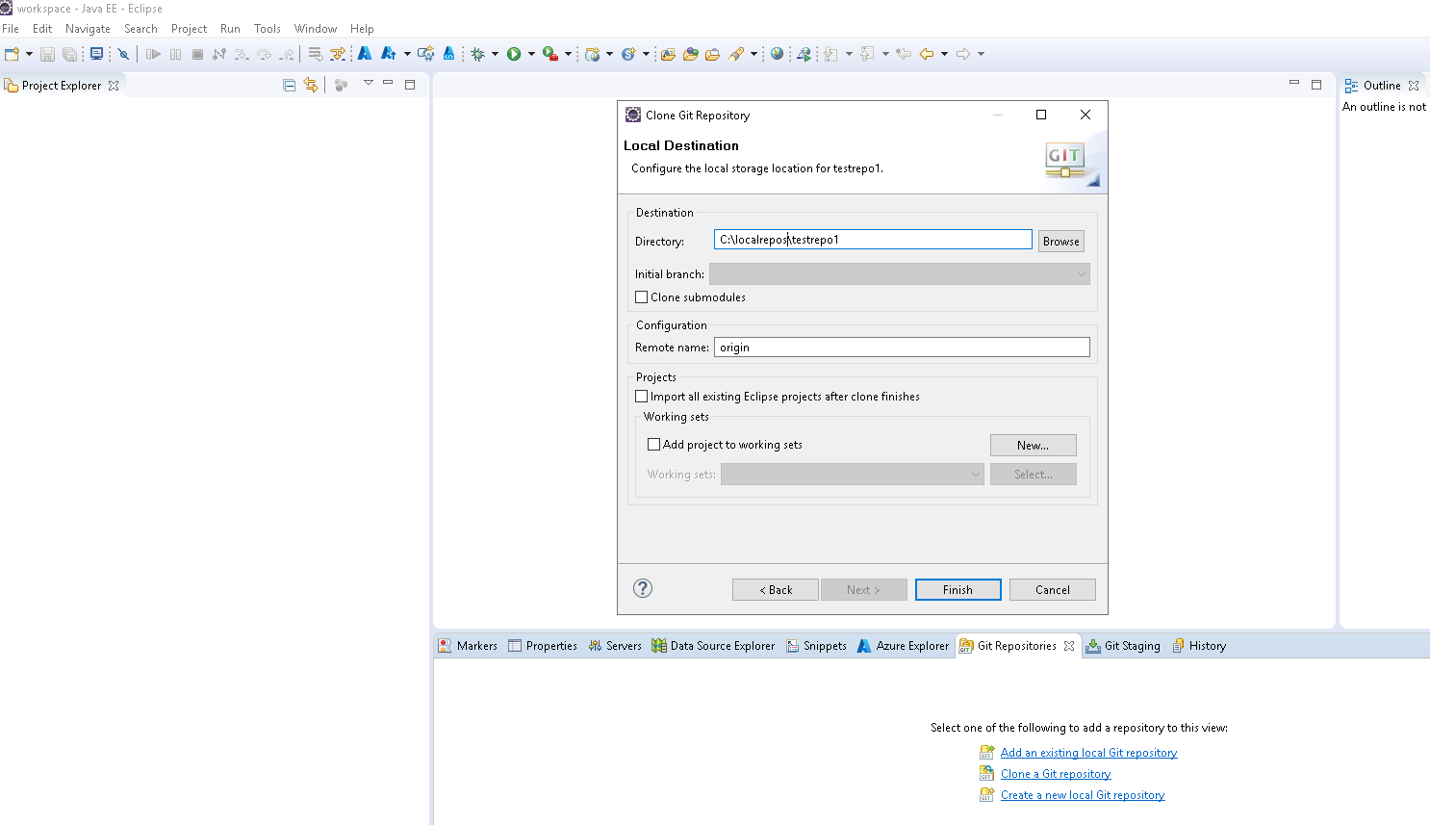

Cloning Completed

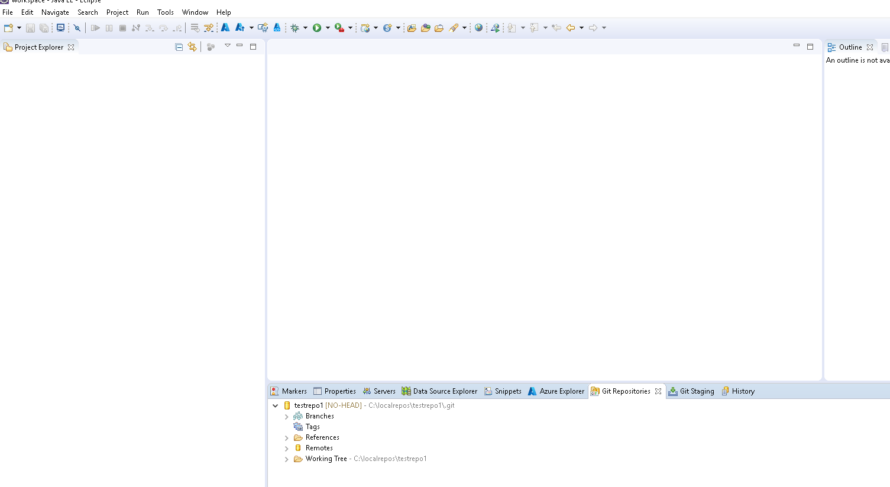

Created Dynamic web project in eclipse

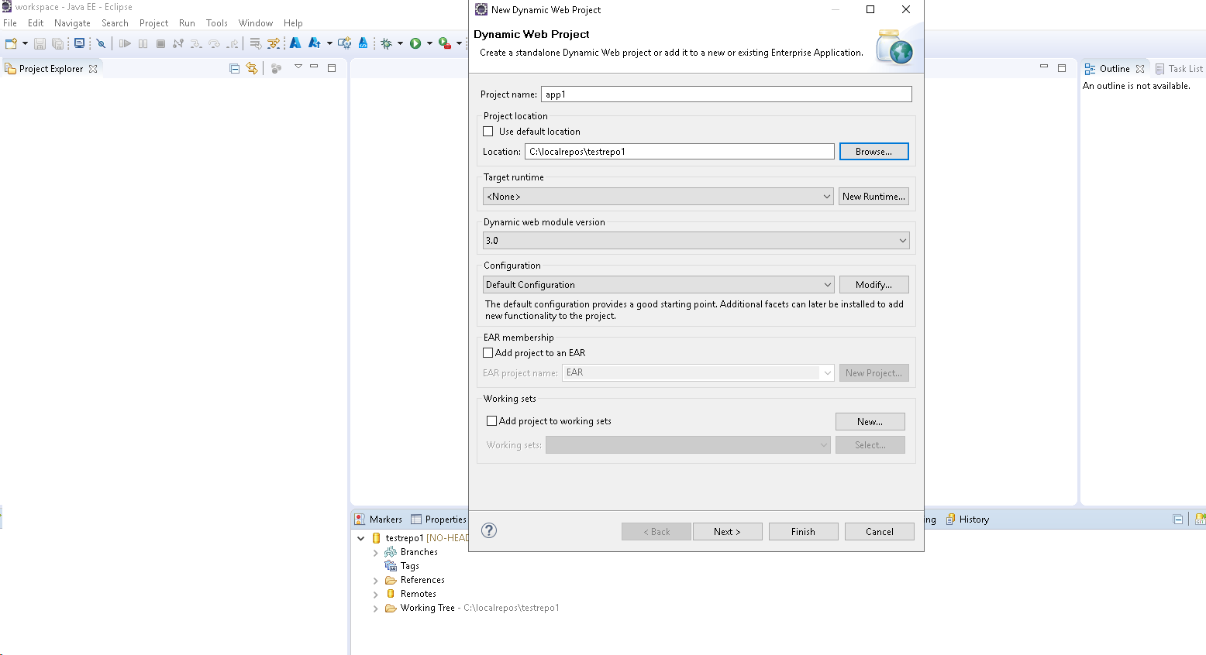

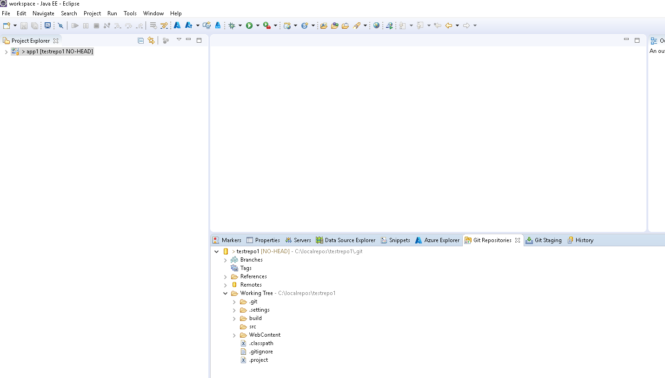

Created three commits on master branch

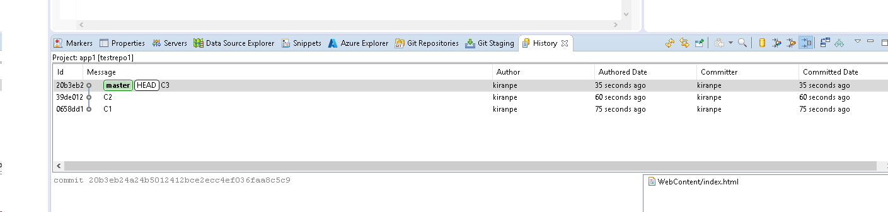

Created feature branch

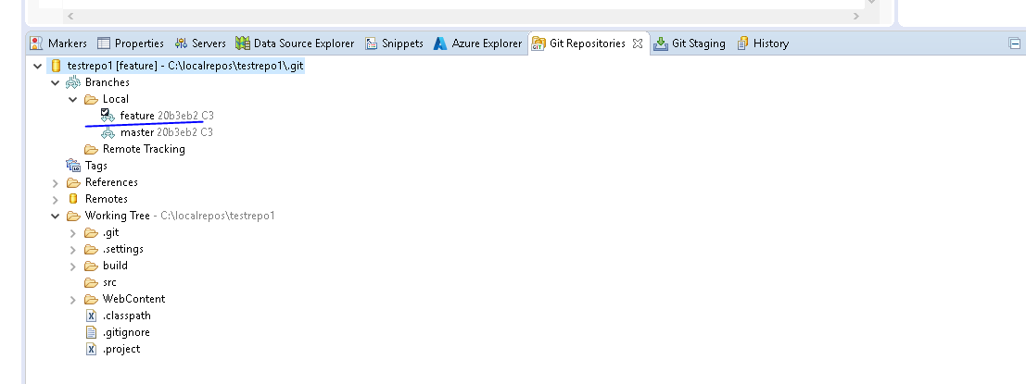

Added new Module in feature branch

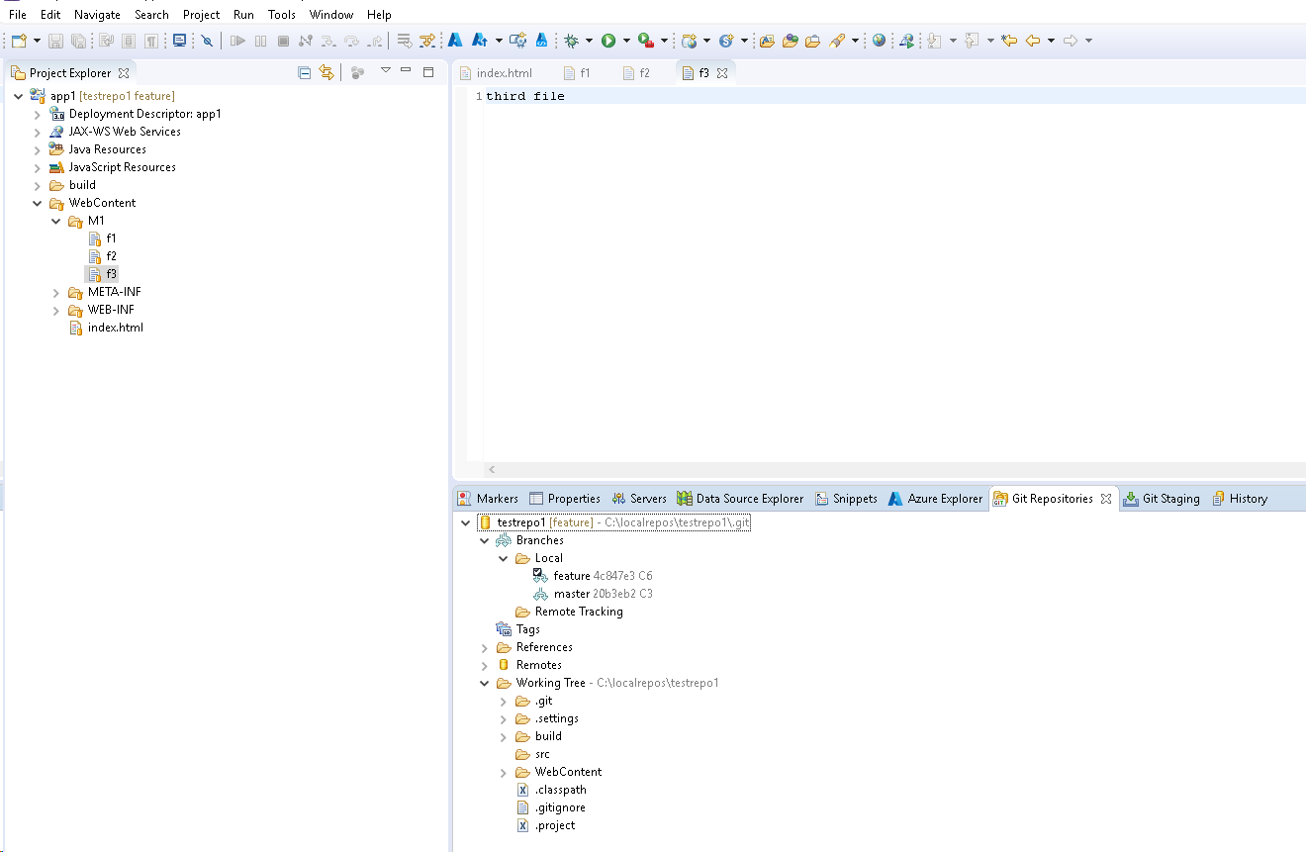

Added three commits in new branch

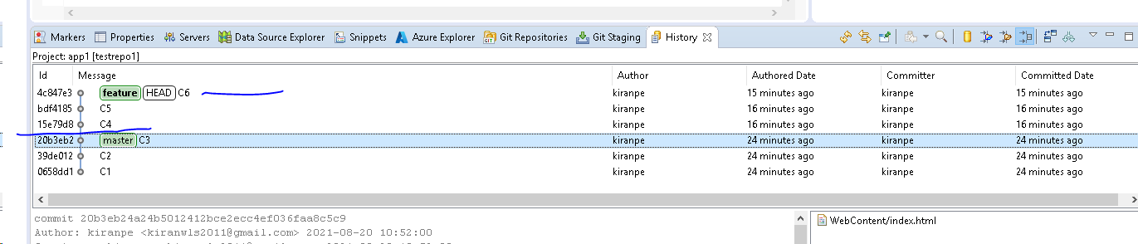

Merged code into Master branch

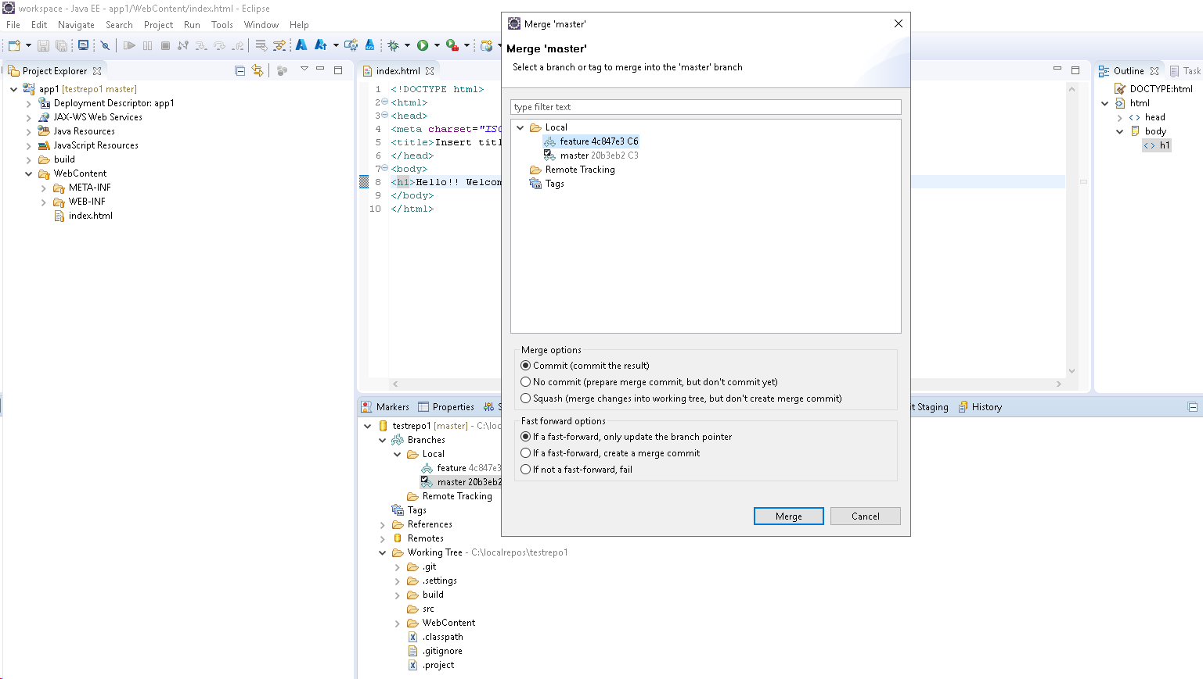

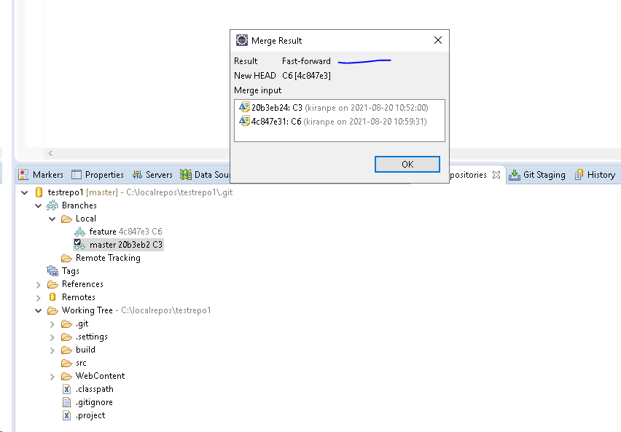

After Merge master branch is also at C6

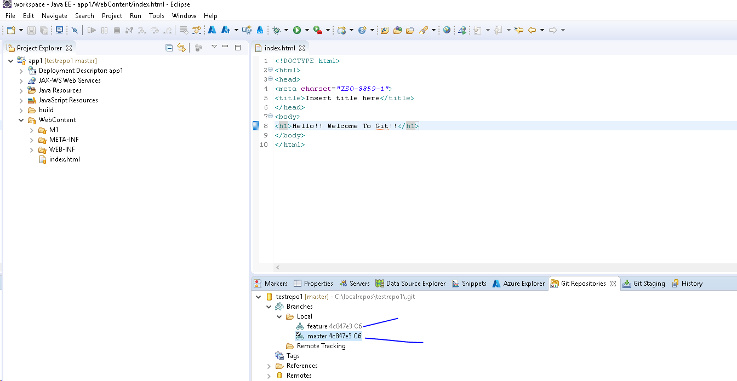

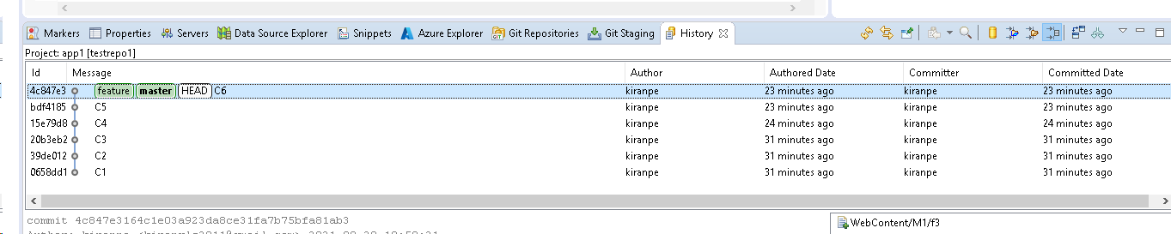

Task2:

Created new GitHub repo “testrepo2”

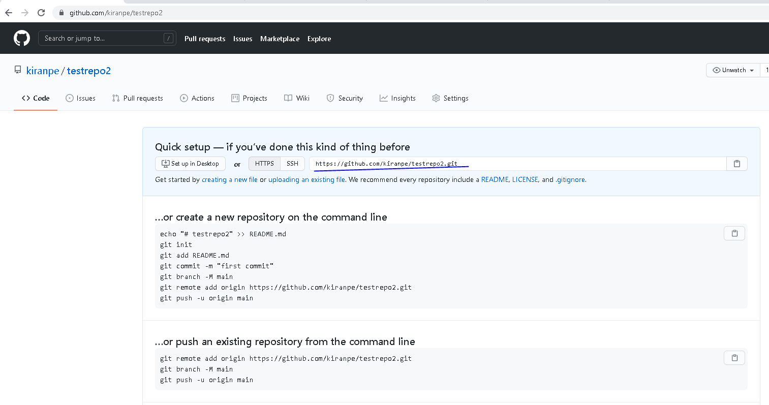

Cloned in two diff locations on local system

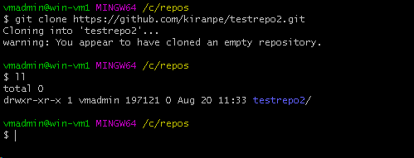

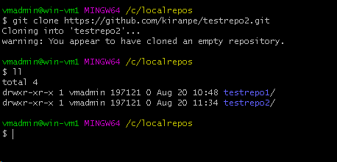

Pushed a text file to remote repo from “localrepos”

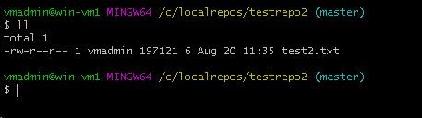

Ran “fetch” from “repos” and it fetches the branch, tags, objects and refs from remote branch and didn’t overwrite local branch

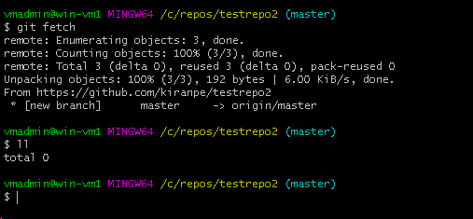

Now ran “pull” command and it merges remote changes and fetches objects and refs from remote branch

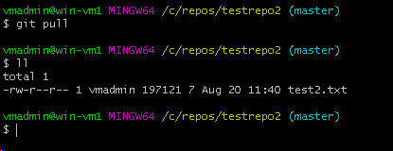

Task3:

Created new remote repo “testrepo3” in GitHub

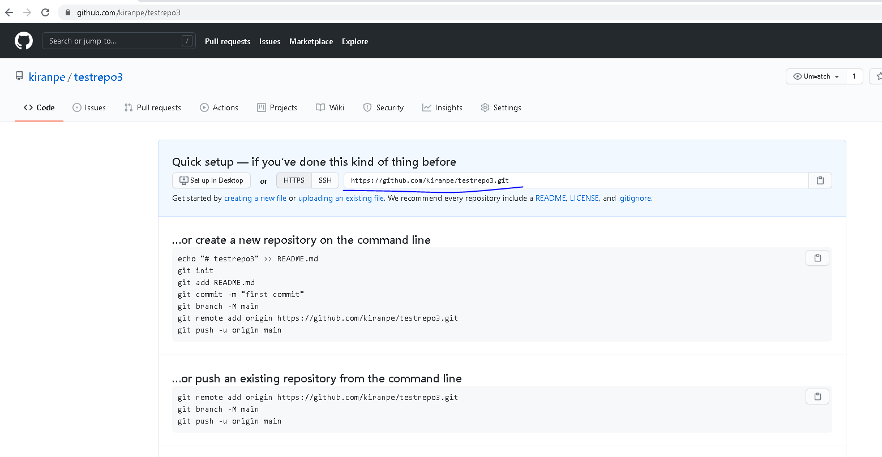

Cloned in eclipse

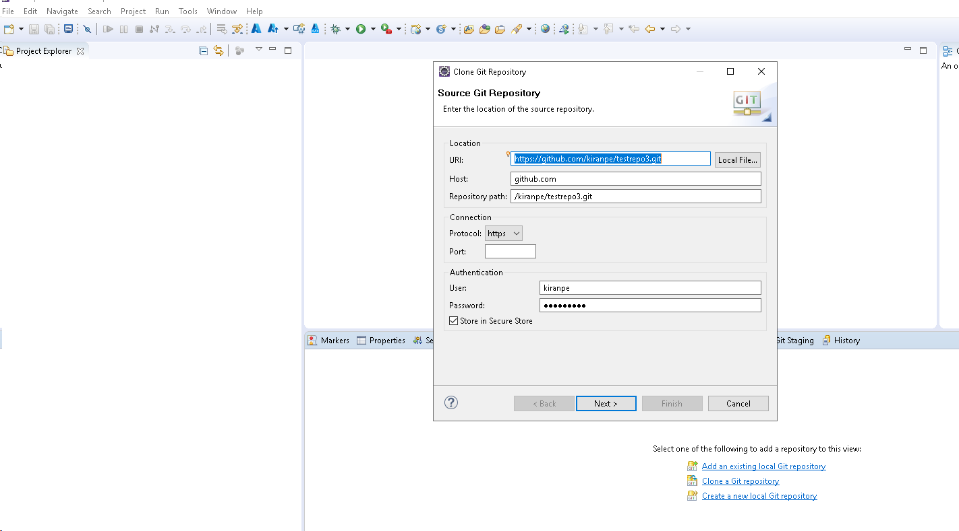

Created Dynamic web project

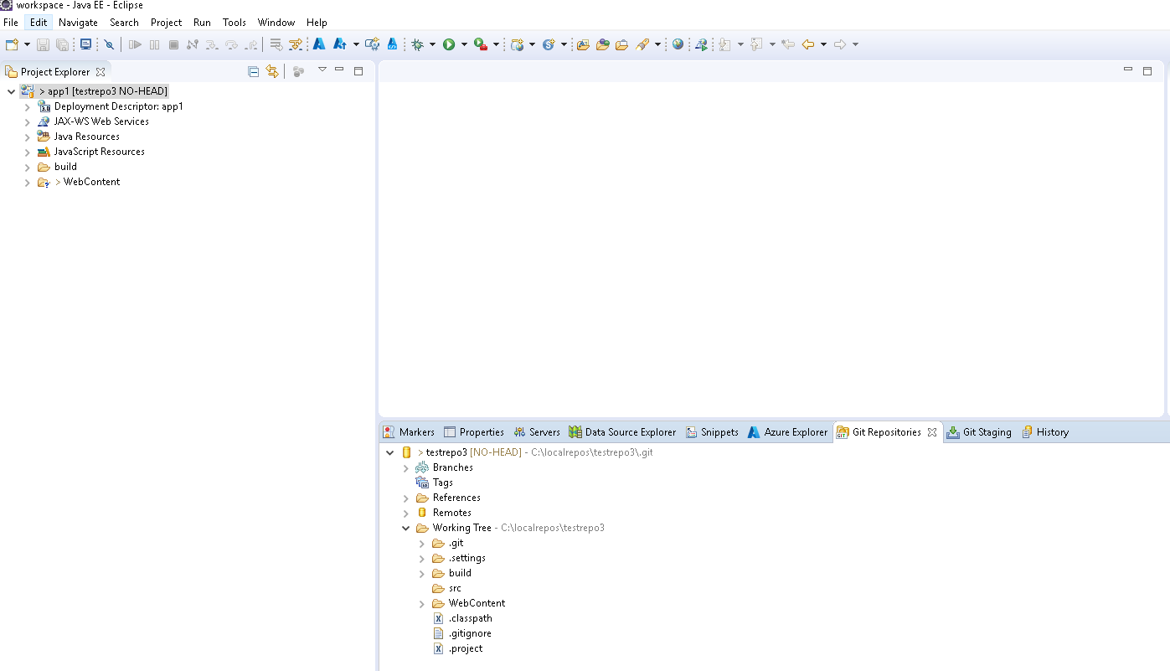

Completed three commits

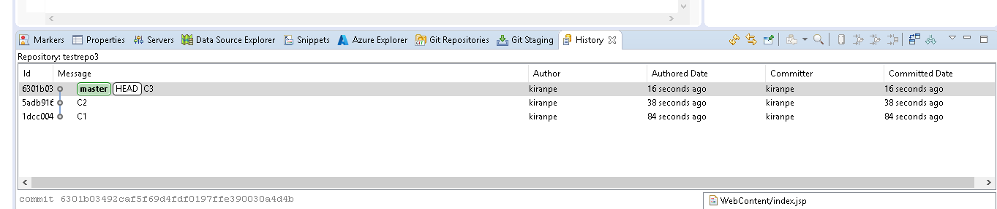

Created new branch called “f1” and created new folder called “Module1”

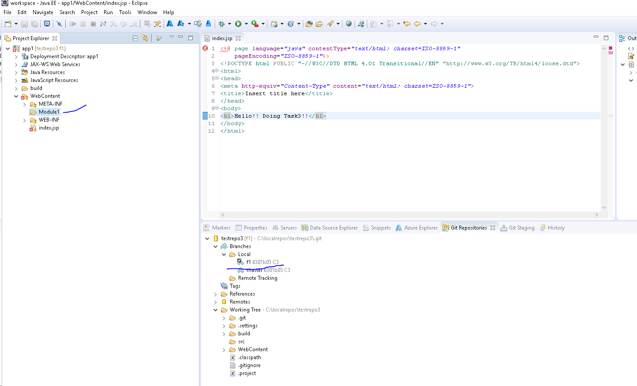

Added three commits into “f1” branch

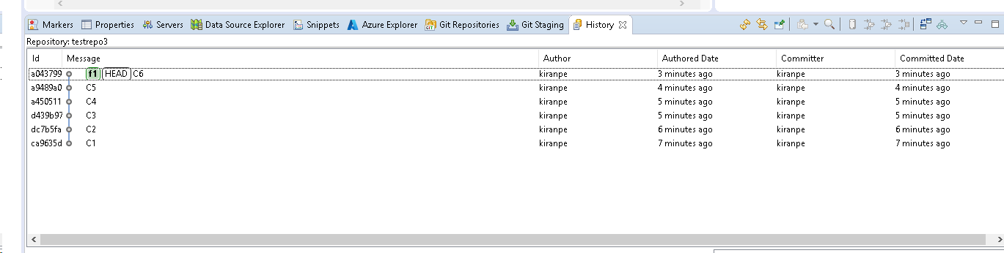

Created new branch “f2” and created folder “Module2”

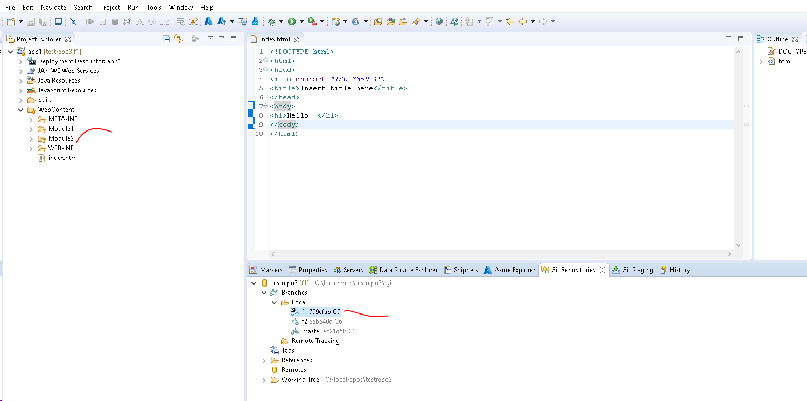

Did three commits in “f2” as well

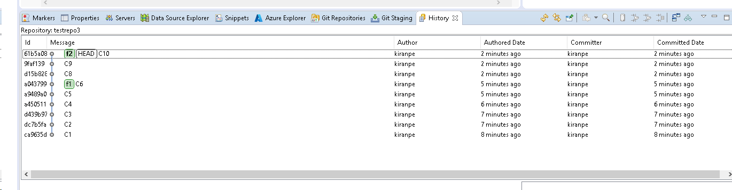

Now did the merge “master” and “f1”

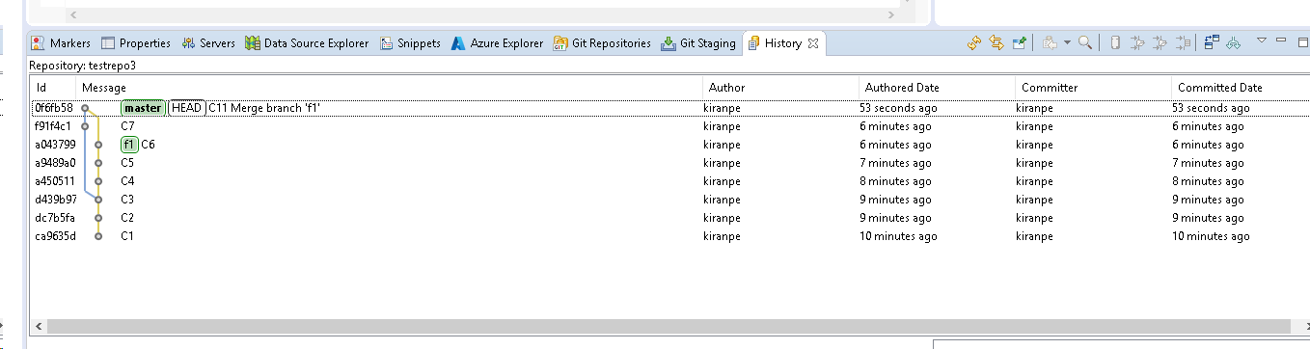

Now did the rebase “master” and “f2”

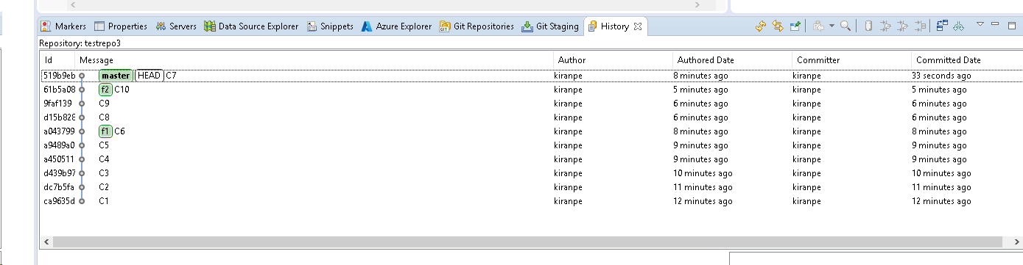

**Merge:**

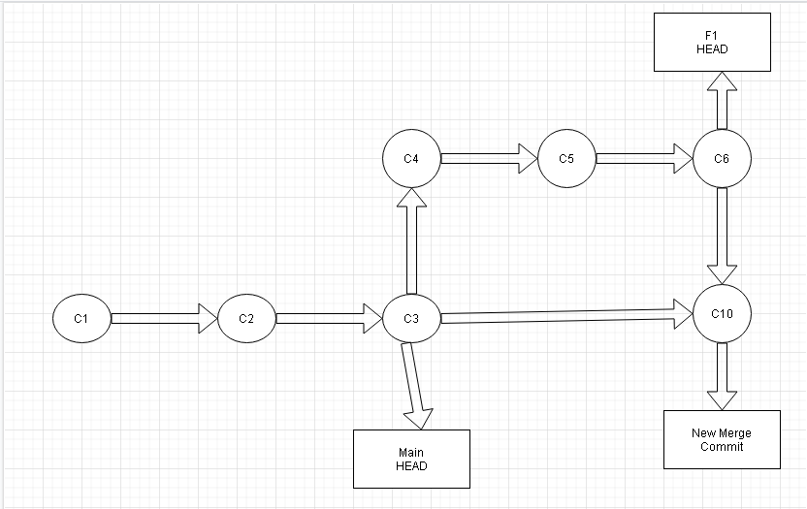

**Rebase:**

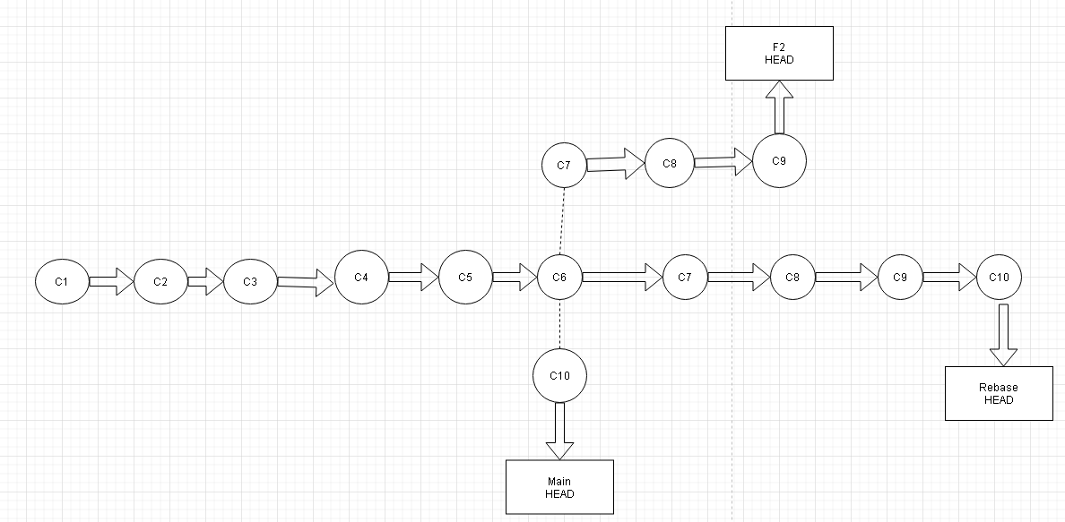

Task4:

Created local repo using command line

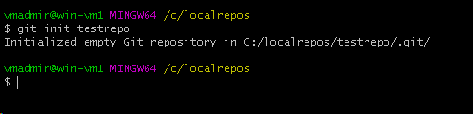

Created files in local repo

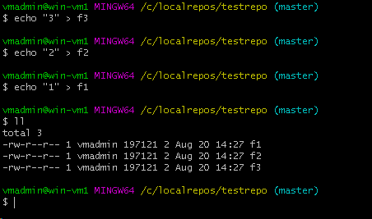

Added files to staging area

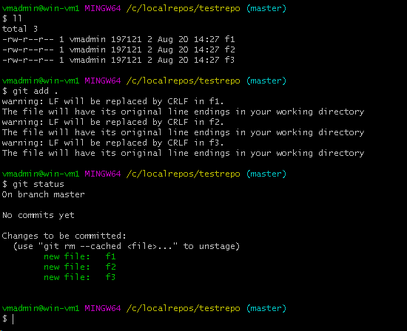

Committed files to local repo

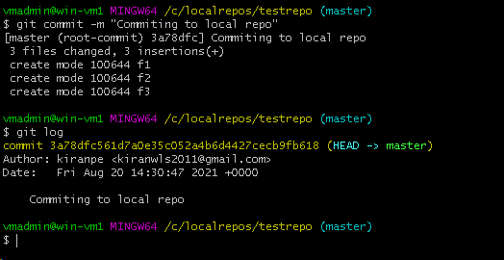

Created remote repo from local repo

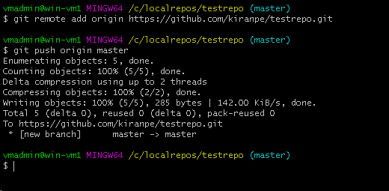

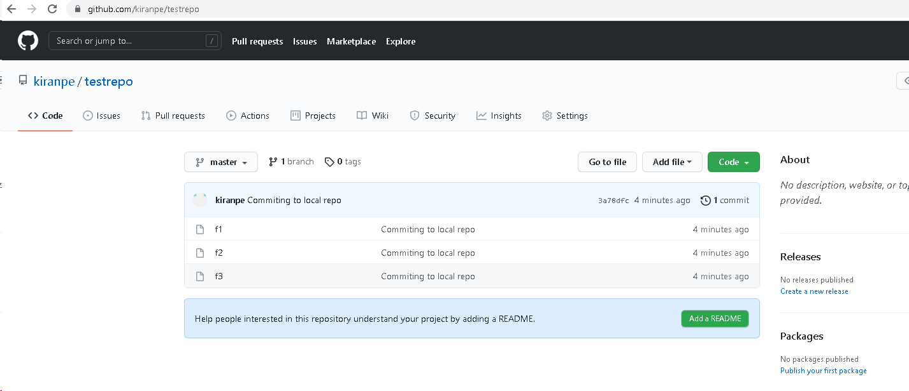

Performed multiple commits and pushes from cmd line

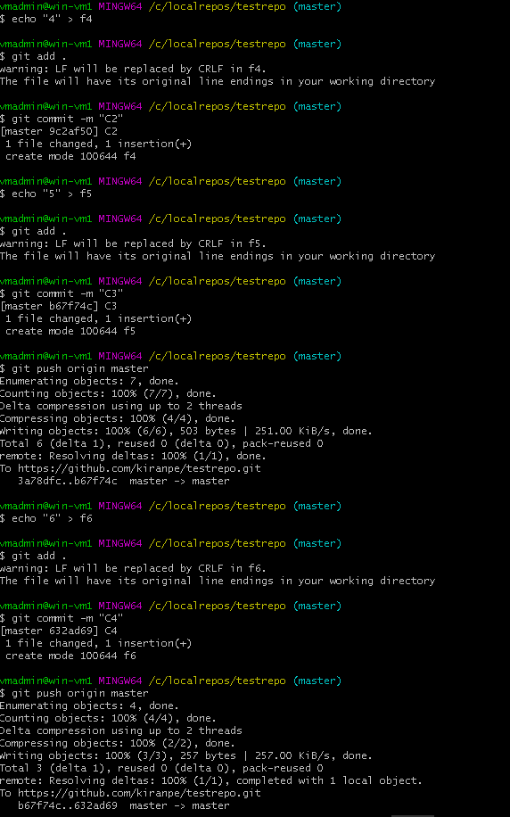

And diff b/w two commits

