**Task 2**

**Task1: Explain and Demonstrate Git Fast Forward Merge:**

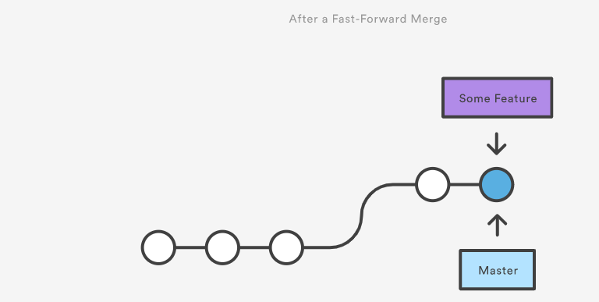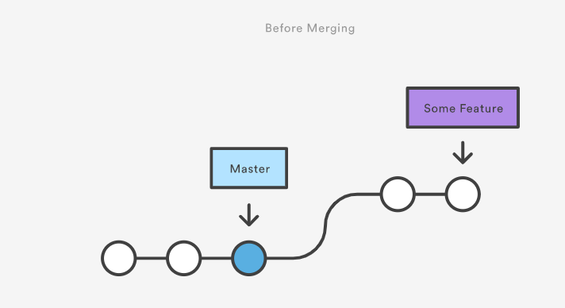

Create a GitHub repo and clone it in eclipse. Create a main dynamic web project in eclipse and make it as base project. Create three commits on master branch. Create a feature branch with additional module in web project. Create three commits on feature branch. And finally create fastforward merge between master branch and feature branch.

At each step create a screenshot and write the complete procedure.

**Task2: Explain and demonstrate the difference between Git Pull and Git fetch using command line.**

Create a GitHub repository. Clone it twice under wo different locations on your development system’s C drive. From one local repository push the changes and from the other local repository pull and fetch the changes and identify the differences with screenshots at each step.

**Task3: Explain and demonstrate the difference between Git Merge commit and Git rebase.**

Create a GitHub repo and clone it in eclipse. Create a main dynamic web project in eclipse and make it as base project. Create three commits on master branch. Create a 1st feature branch with additional module1 folder in web project. Create three commits on 1st feature branch. Create a 2nd feature branch with additional module2 folder in web project. Create three commits on 2nd feature branch. Now preform **Git merge** between master branch and 1st Feature branch. And then perform **GIT Rebase** between master branch and 2nd Feature branch with screenshots at each step.

Finally Identify the difference and draw a **flowchart of commits** for both.

**Task4: Explain and Demonstrate Git Lifecycle.**

Start creating a local repo using command line. Create files in local repo’s working directory in command line. Add those new files to Staging area using command line. Commit those staged files to local repo. Get commit history. Identify Git head. Finally create remote repo from the local repo. Perform multiple commits and pushes using command line. Show the difference between any two commits.

At each stage take a screenshot. The whole task should be completed in command line.