**Terraform Tasks**

**Task1: Create Linux VM using Terraform**

Code Repo Url: <https://github.com/kiranpe/AzureTasks/tree/master/Task3/LinuxVM>

Linux VM Created:

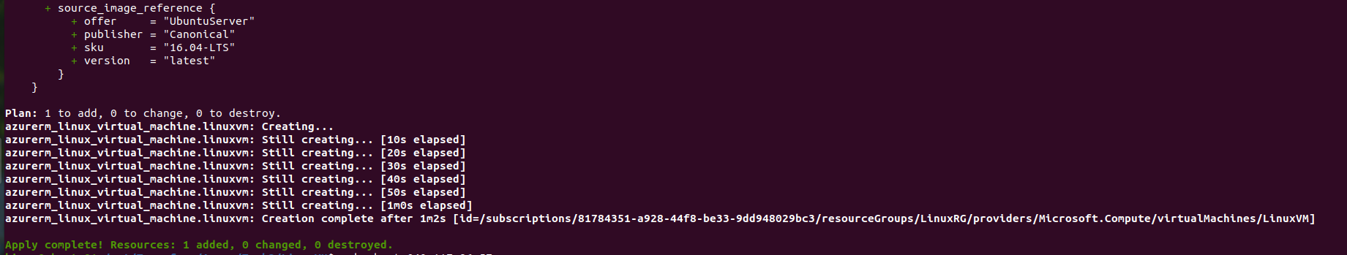

SSH is Successful.

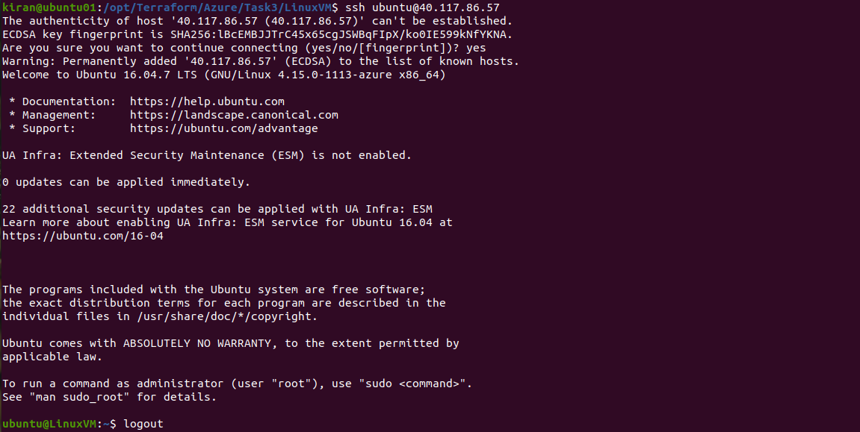

**Task2: Create Windows VM using Terraform**

Code Repo Url:

<https://github.com/kiranpe/AzureTasks/tree/master/Task3/WindowsVM>

Created Windows VM:

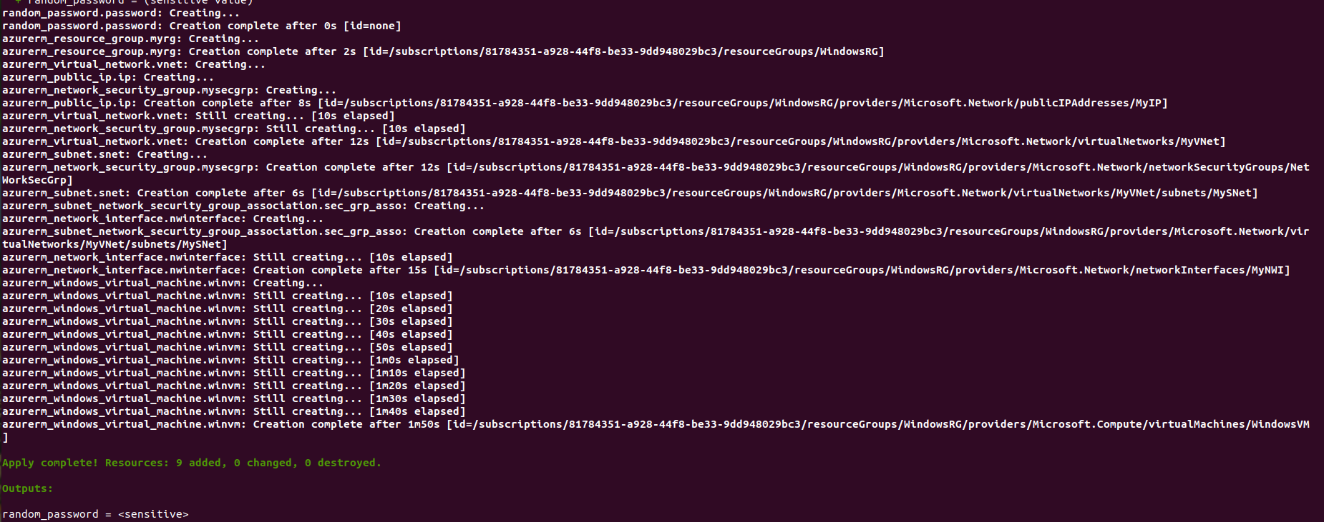

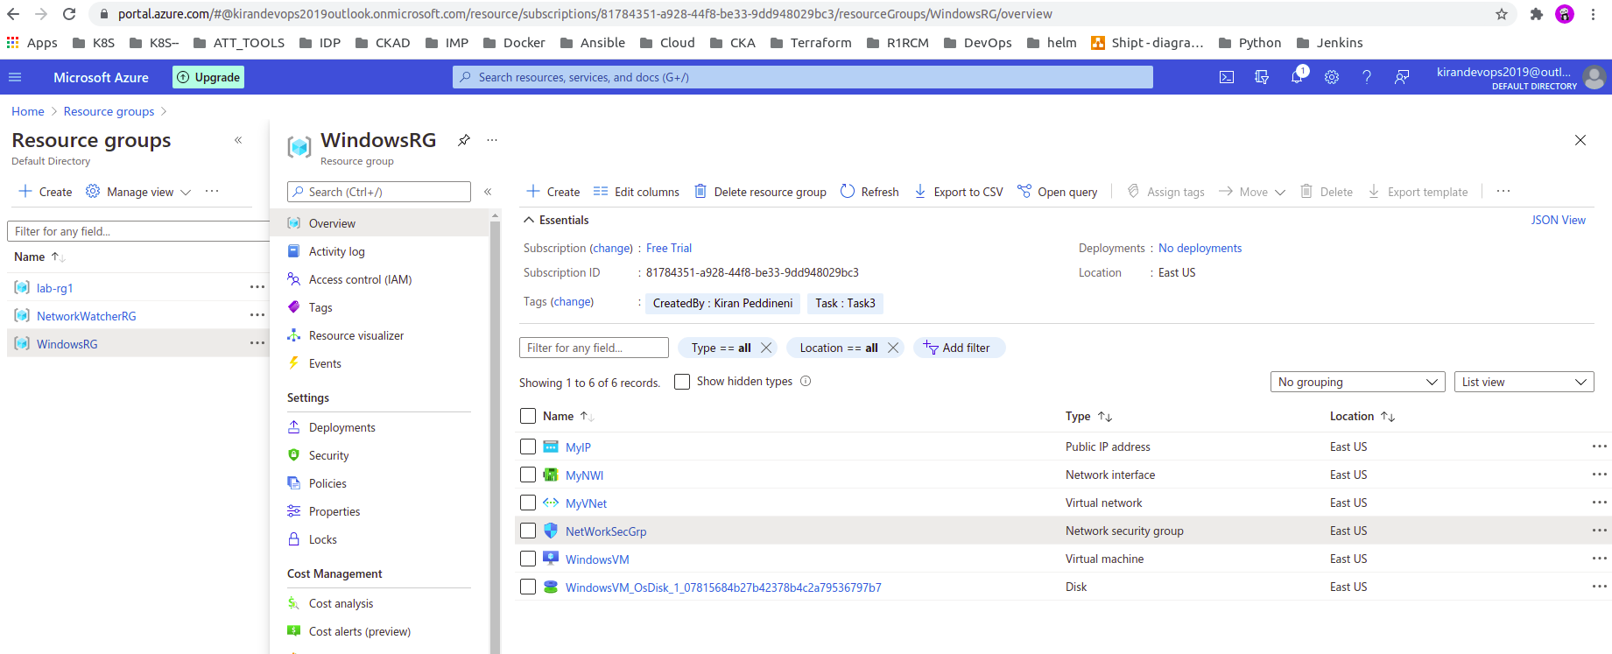

**Task3: Create a Virtual Network in Azure with Terraform**

Code Repo Url:

<https://github.com/kiranpe/AzureTasks/tree/master/Task3/VirtualNetwork>

Created Virtual Network:

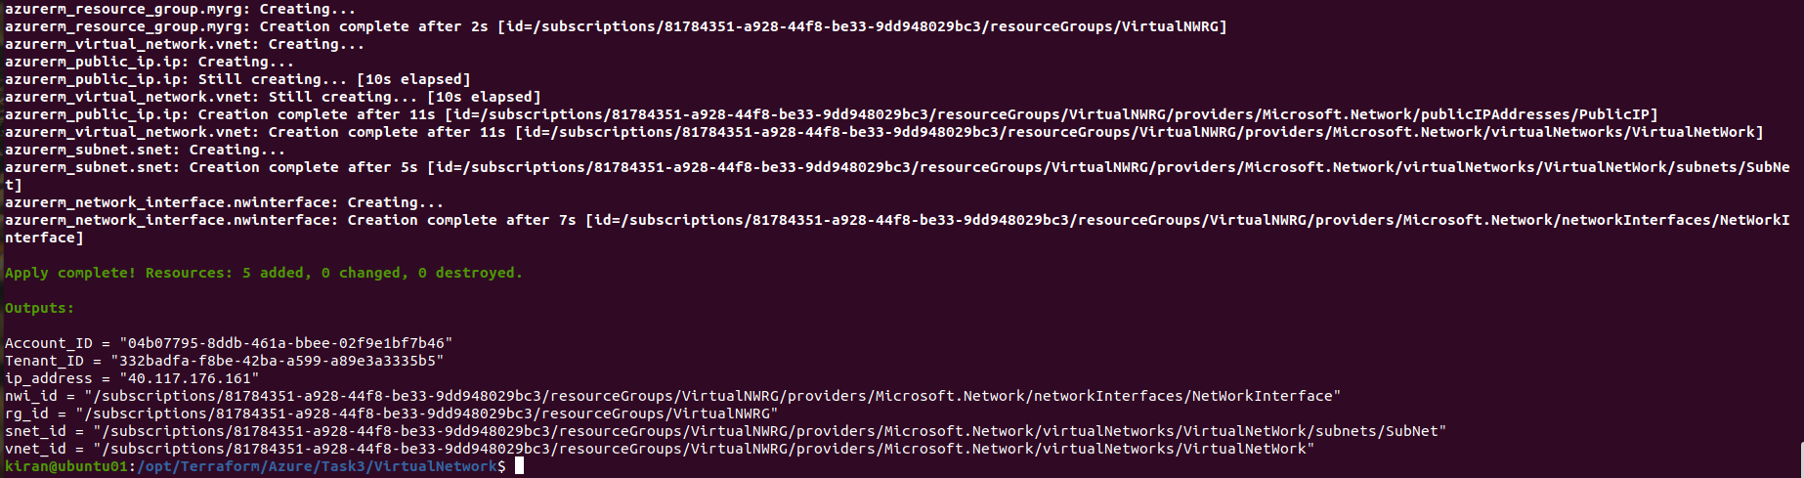

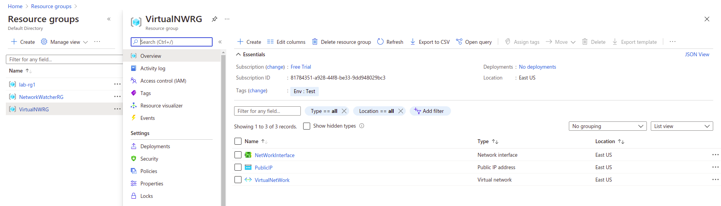

**Task4: Create a Static Website on Azure with Terraform**

Code Repo Url:

https://github.com/kiranpe/AzureTasks/tree/master/Task3/StaticWebsite

Created Static Web Site:

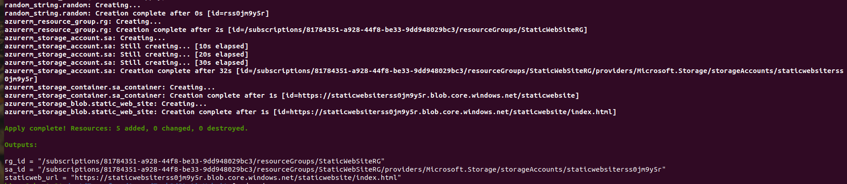

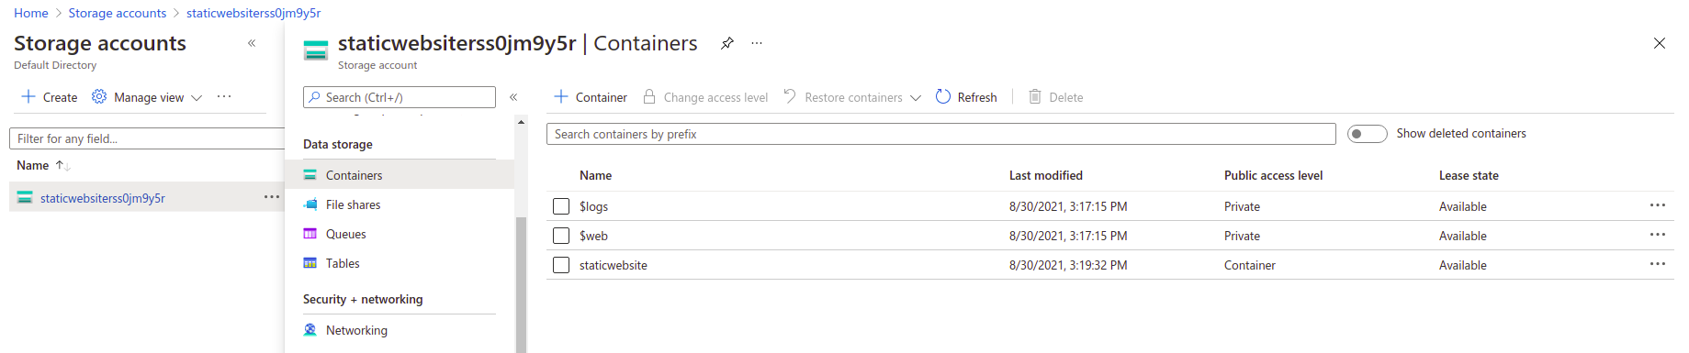

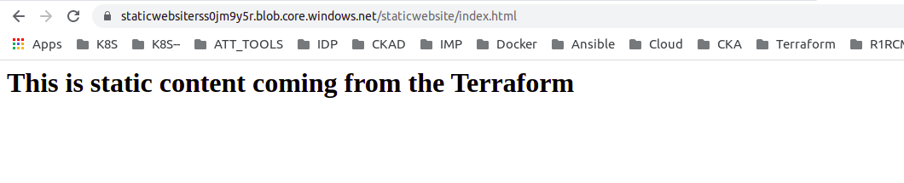

**Task5: Create Multiple Resources using for_each, count**

Code Repo Url:

<https://github.com/kiranpe/AzureTasks/tree/master/Task3/Resource_Multi_Region>

Created Resource Groups, Virtual Network, 2 Subnets and Network Security Group in Multiple Regions:

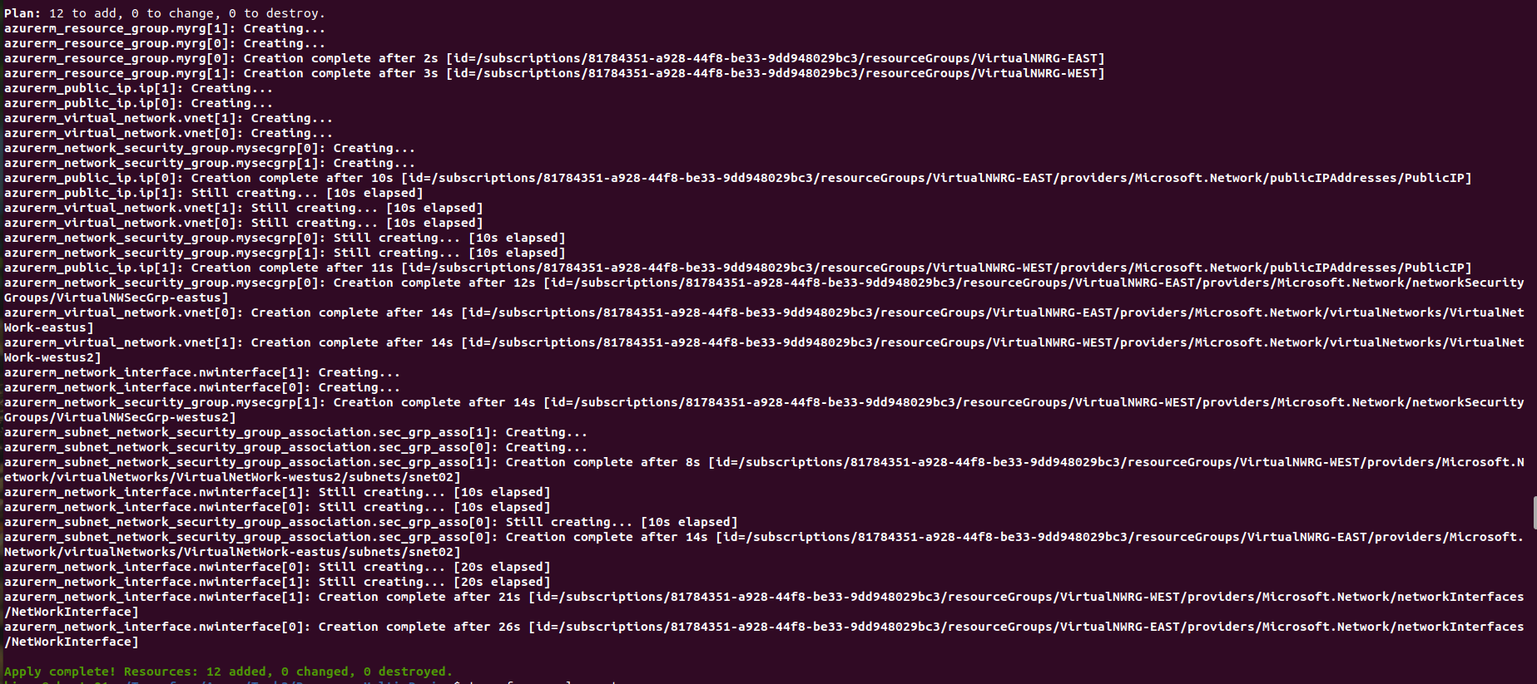

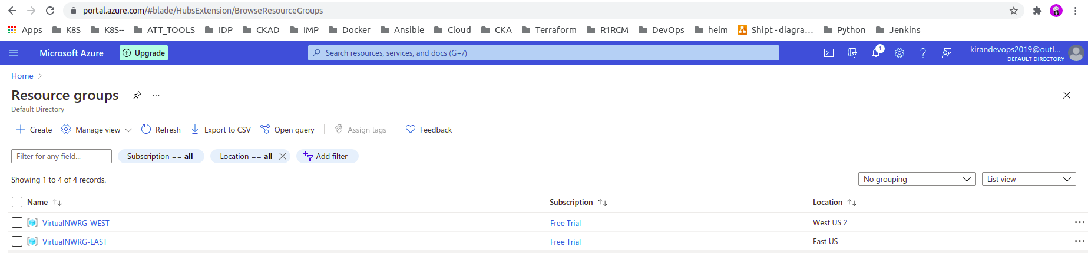

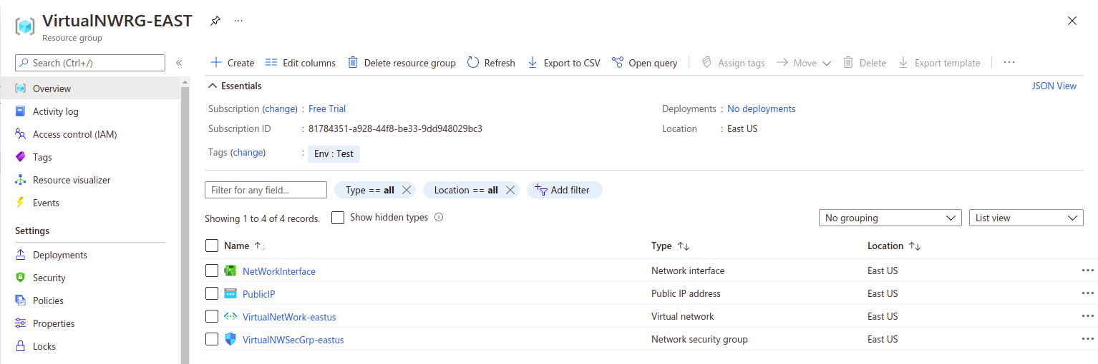

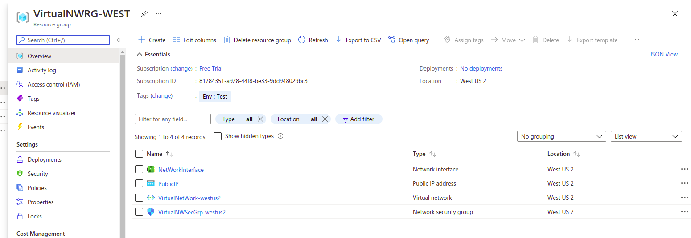

**Task6: AKS Cluster with Container Monitoring enabled using Terraform**

Code Repo Url:

<https://github.com/kiranpe/AzureTasks/tree/master/Task3/Aks_Cluster>

Created Resource Group, Virtual Network with Subnet, Network Security Group, Subnet and NSG Association, AKS Cluster, Route Tabels, Log Analytics Workspace and Container Monitoring Solution for Log Analytics.

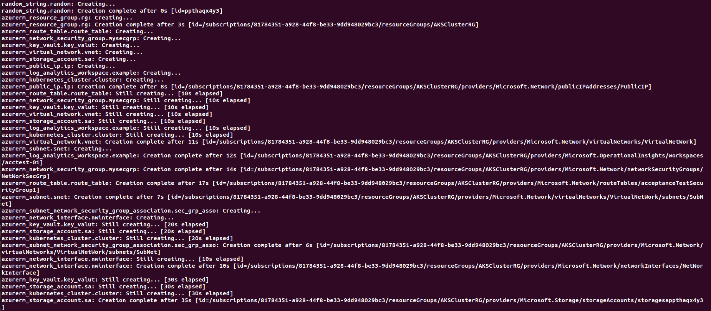

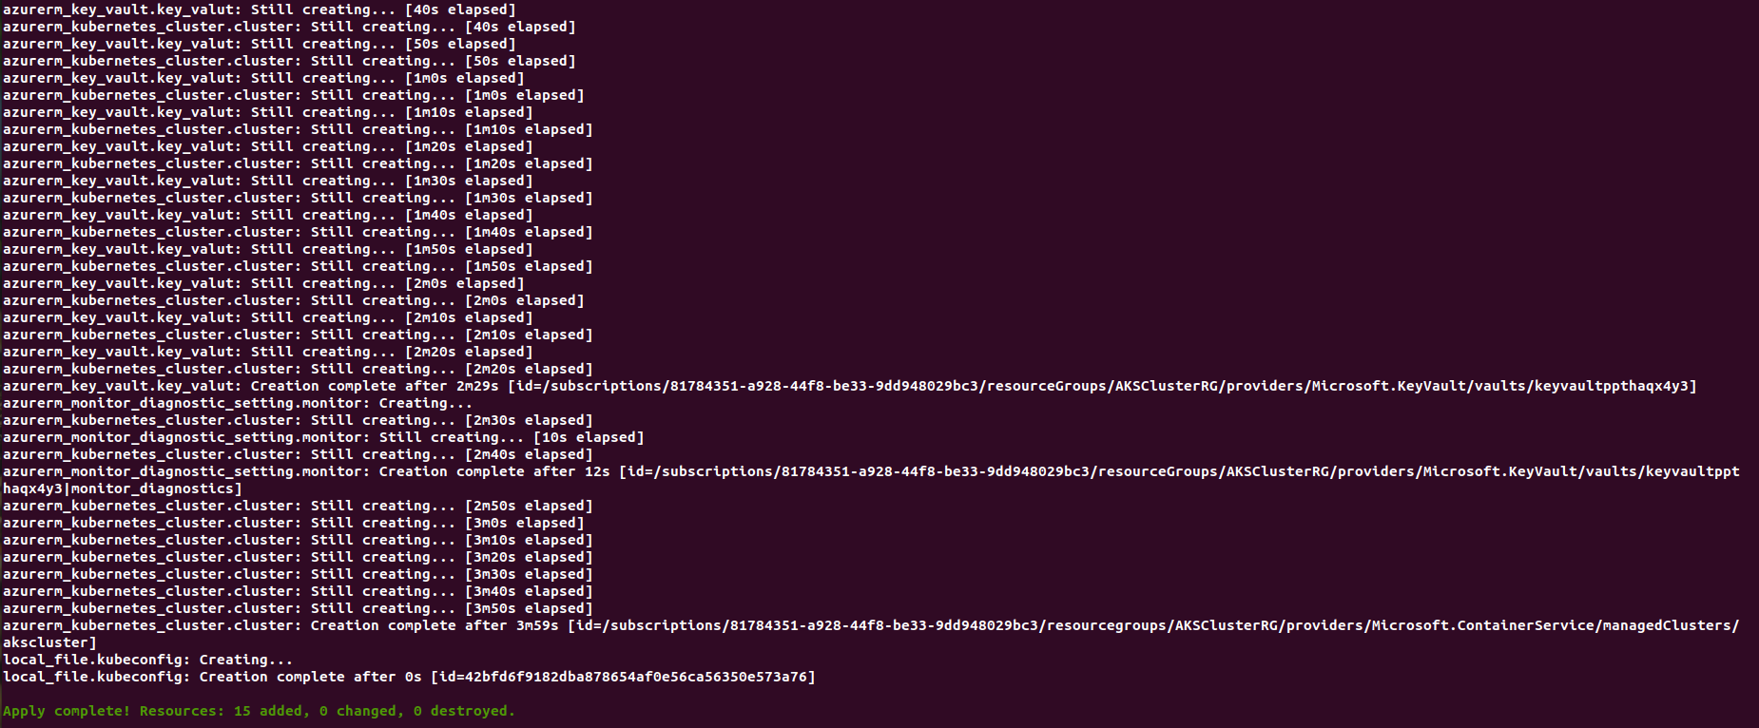

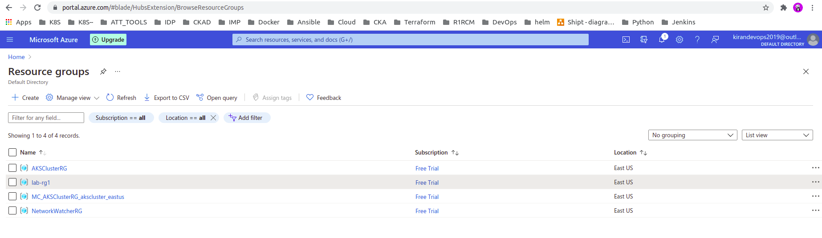

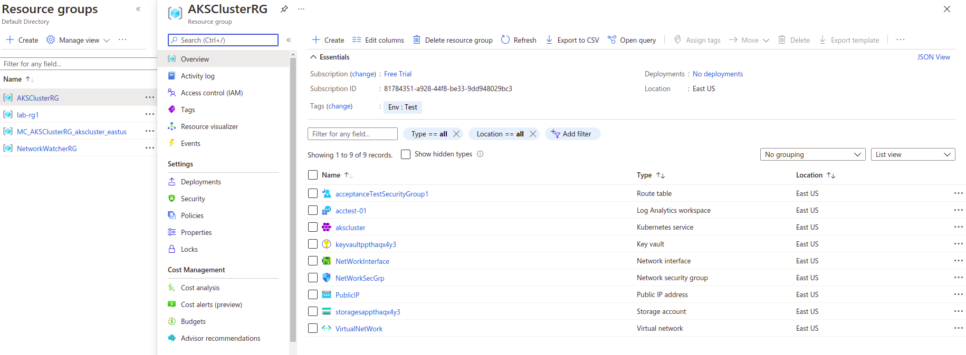

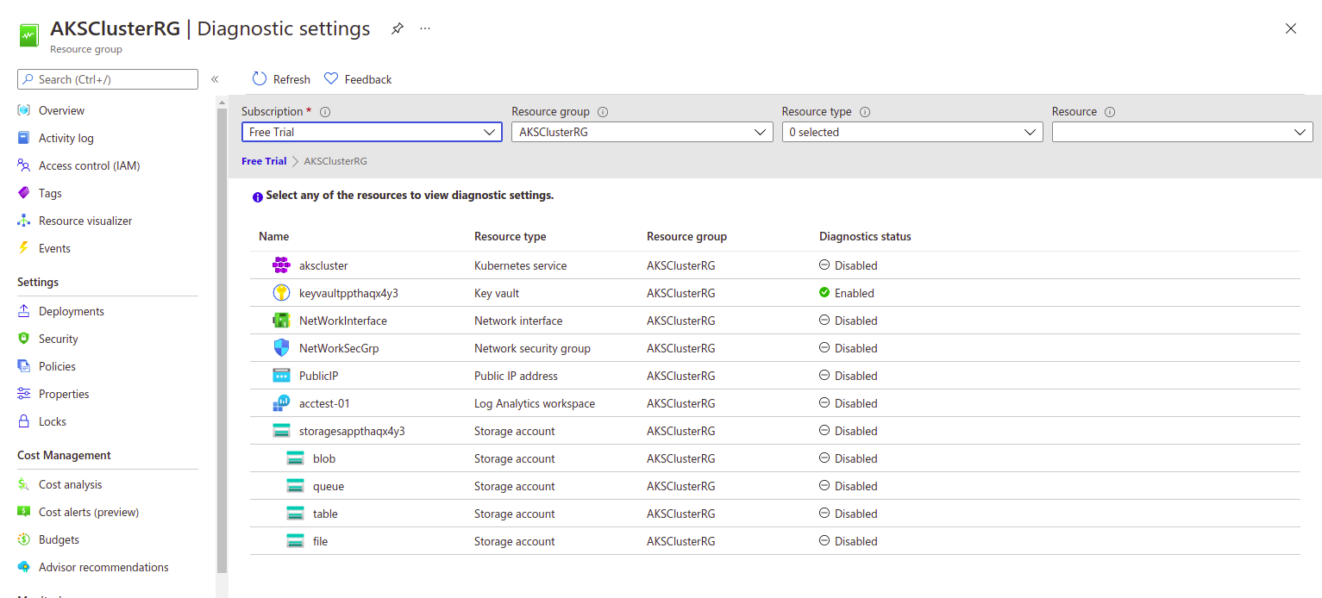

Cluster Monitoring

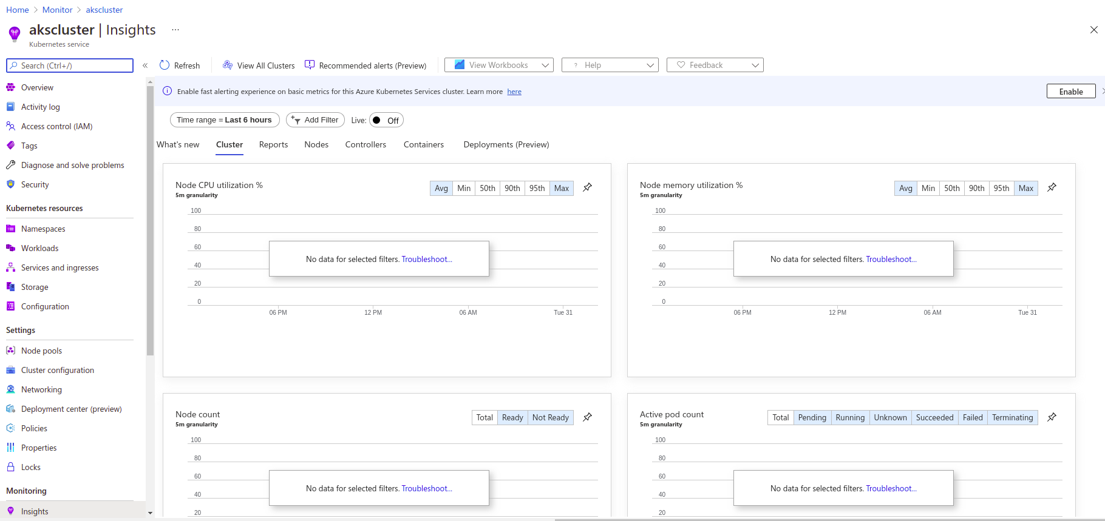

Deployed a POD on Cluster

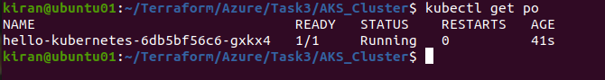

Exposed Deployment



Application Accessible

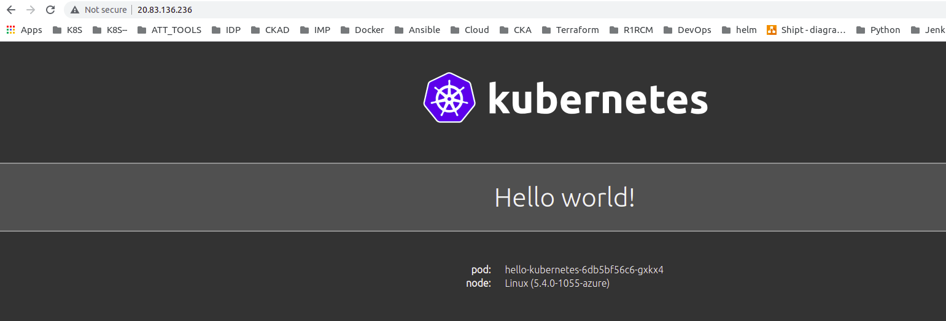

**AKS Cluster**

